**INTERFERENCE AND DIFFRACTION**

**Exercises**

**Section 32.2 Double-Slit Interference**

**10. Interpret** This problem involves interference from a double-slit arrangement. Given the parameters of the arrangement, we are to find the wavelength of the illuminating light.

**Develop** Because *d*  *L*, we can apply Equation 32.2a with *d* = 15 μm, *L* = 2.2 m, *m* = 1, and *y* = 7.1 cm to find the wavelength *λ*. We may also approximate sin*θ* by *y*/*L* because *y*  *L* (i.e., it’s a small angle).

**Evaluate**  The wavelength is

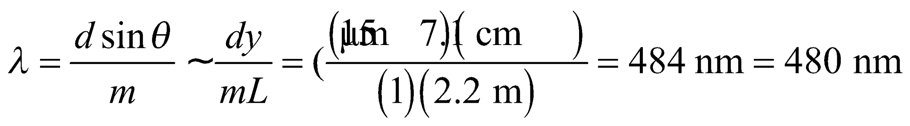

to two significant figures.

**Assess** The exact formula is

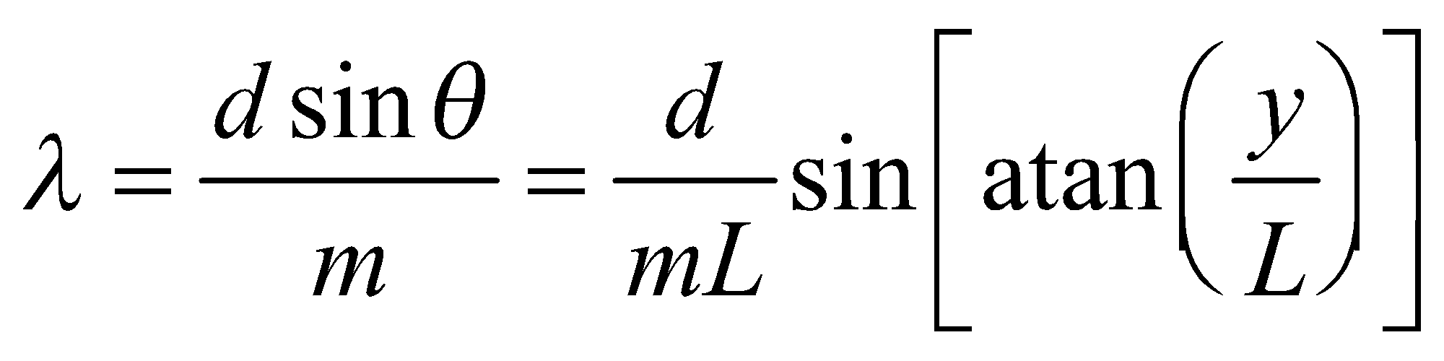

which differs by 0.05% from the result above (i.e., ± 0.2 nm, which is much less than the precision of the data).

**11. Interpret** This problem is about double-slit interference. We are to find the spacing between adjacent bright fringes given the wavelength of the light, the slit spacing, and the slit-screen distance.

**Develop** The geometrical parameters of the source, slits, and screen satisfy the conditions for which Equations 32.2a and 32.2b apply (i.e., *d*  *L* and *λ*  *d*). The locations of bright fringes are given by

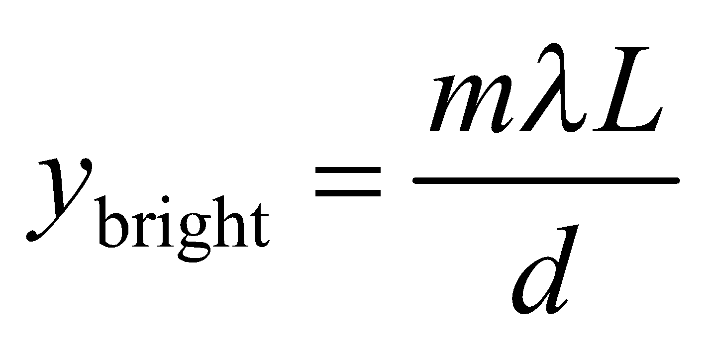

where *m* is the order number.

**Evaluate** The spacing of bright fringes is

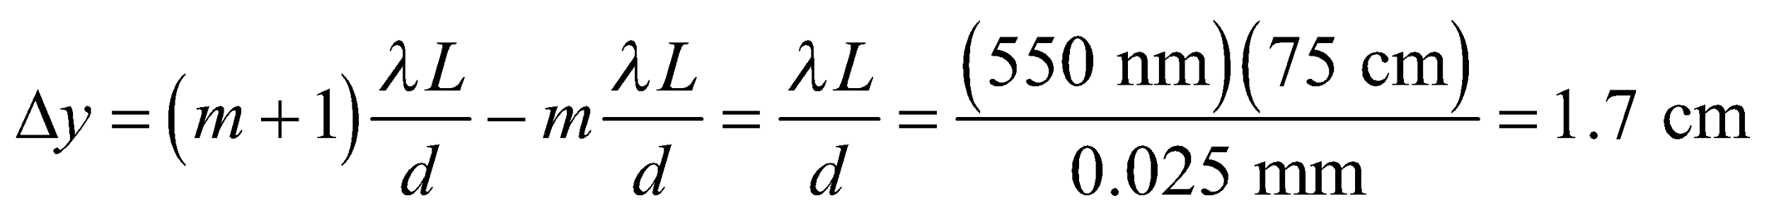

**Assess** Since 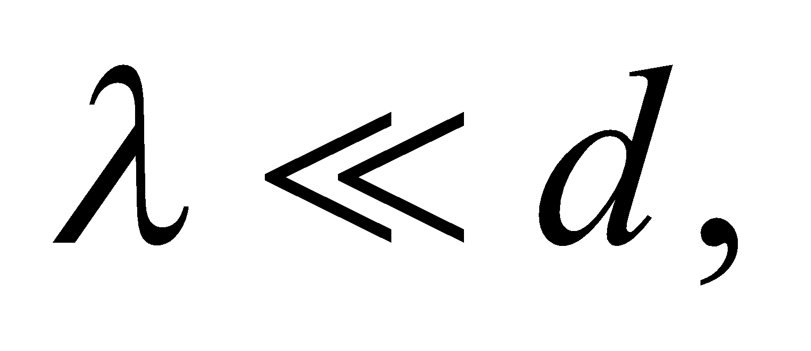 the spacing between bright fringes is much smaller than *L*, as it should be.

**12.** **Interpret** For a double-slit interference arrangement, we are to find the slit-to-screen distance given the wavelength, the slit spacing, and the spacing between bright fringes.

**Develop** We will assume that the particular geometry of this type of double-slit experiment satisfies the conditions for using Equations 32.2a and 32.2b (i.e., *d*  *L* and *λ*  *L*), and verify afterwards.

**Evaluate** **(a)** The slit-to-screen spacing on the screen is

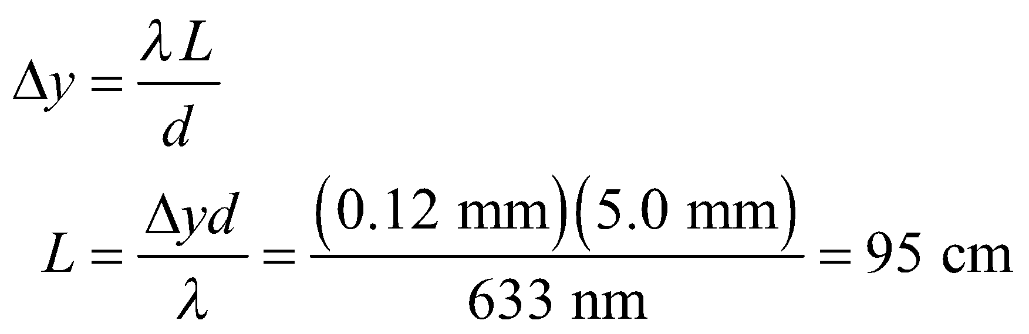

**(b)** For two different wavelengths, the ratio of the spacings is 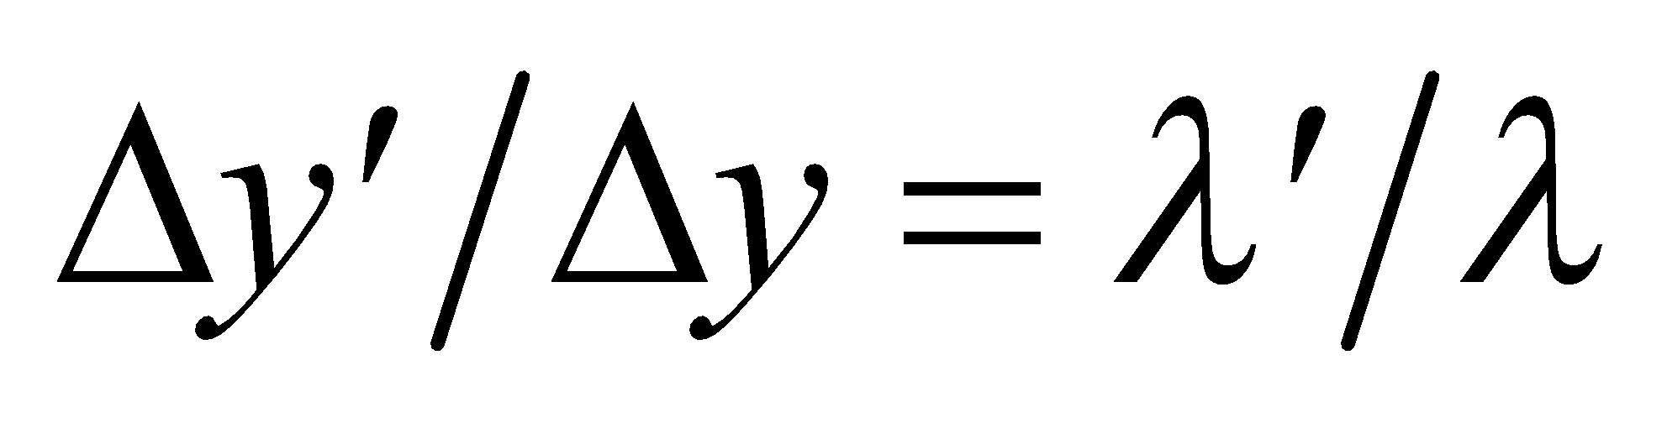; therefore 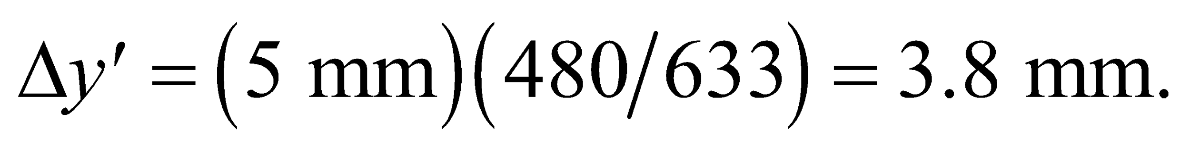

**Assess** Note that the conditions *d*  *L* and *λ*  *L* are indeed met, so we are justified in using Equation 32.2a. The fringe spacing for 480 nm may also be found by applying Equation 32.2a with *L* = 95 cm. The result is the same.

**13. Interpret** This problem is about double-slit interference. We are interested in the wavelength of the light source.

**Develop** For small angles, we may approximate sin*θ* ~ *θ*, so Equation 32.1 gives 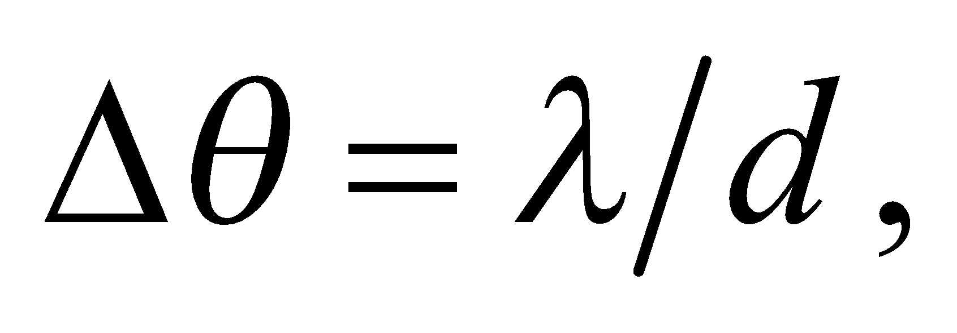 and the interference fringes are evenly spaced.

**Evaluate** Substituting the values given, we obtain 

**Assess** The wavelength *λ* is much smaller than the slit spacing *d*, as needed for using Equation 32.1a.

**14.** **Interpret** Given the angular position of the 5th dark fringe and the wavelength of the light, we are to find the slit separation in a double-slit experiment.

**Develop** The interference minima fall at angles given by Equation 32.1b. The ratio *y*dark/*L* = tan*θ*, so Equation 32.1b can be written as

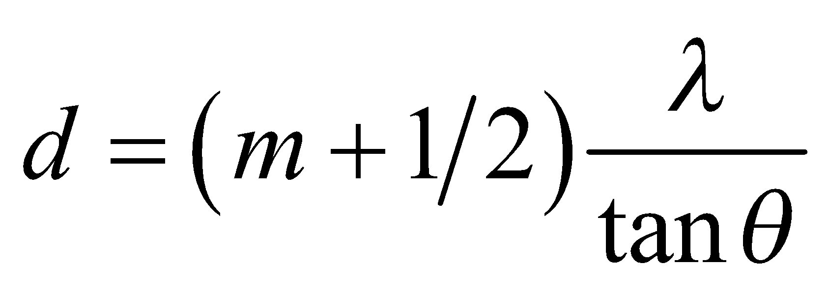

Notice that the order *m* is defined as the number of the bright fringe, with *m* = 0 corresponding to the central (bright) fringe. Thus, the 5th dark fringe corresponds to *m* = 5.

**Evaluate** For *m* = 5, Equation 32.1b gives

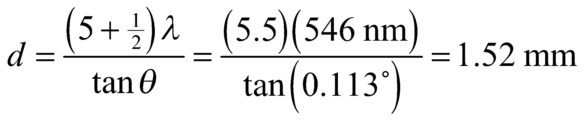

**Assess** The condition *λ*  *d* is met, so we are justified in using Equation 32.2b. Note that the significant figures are determined by the wavelength and the angle—not by the order number (which are defined as integers and so have infinite accuracy).

**Section 32.3 Multiple-Slit Interference and Diffraction Gratings**

**15. Interpret** The setup is a multiple-slit interference experiment. We want to know the number of minima (destructive interferences) between two adjacent maxima.

**Develop** In an *N*-slit system with slit separation *d* (illuminated by normally incident plane waves), the main maxima occur for angles (see Equation 32.1a) 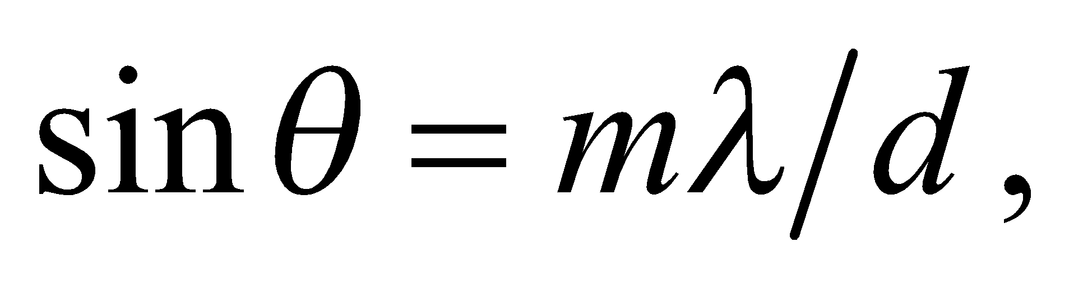 and minima for angles (see Equation 32.4) 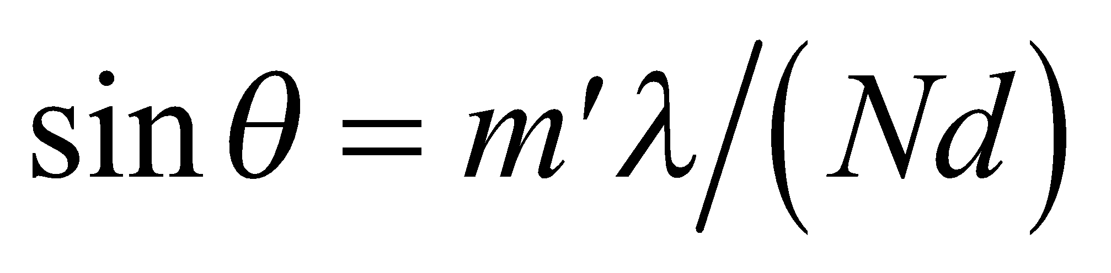 (excluding *m*′ = 0 or multiples of *N*).

**Evaluate** Between two adjacent maxima, say 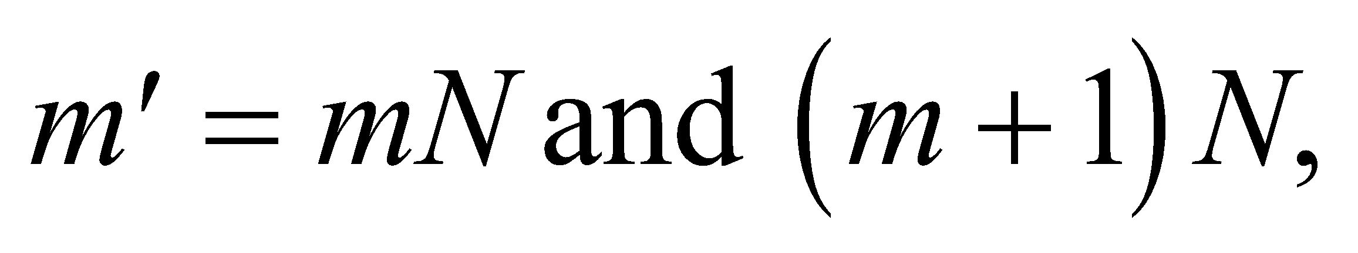 there are *N* − 1 minima. The number of integers between 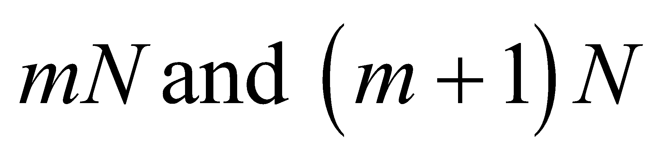 is

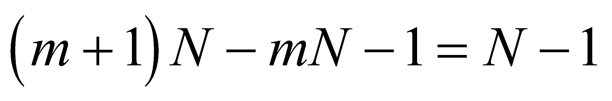

because the limits are not included. Therefore, For *N* = 5, the number of minima is 4.

**Assess** The interference pattern resembles that shown in Figure 32.8. Note that the number of minima is independent of the order number *m*. Also note that our result agrees with Figure 32.8.

**16.** **Interpret** This problem involves a multiple-slit system. We are to find the first maximum given the angular position of the first minimum.

**Develop** Apply Equation 32.4 to find the ratio *λ*/*d*. For the first minima (*m* = 1), this gives

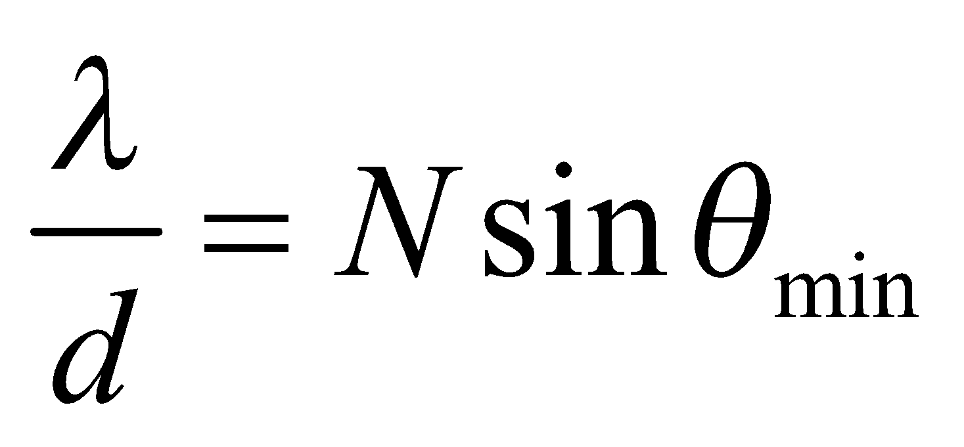

where *N* = 3 for this problem (i.e., three slits). The angular position of the first maxima can then be found using Equation 32.1a.

**Evaluate** The first maximum is at

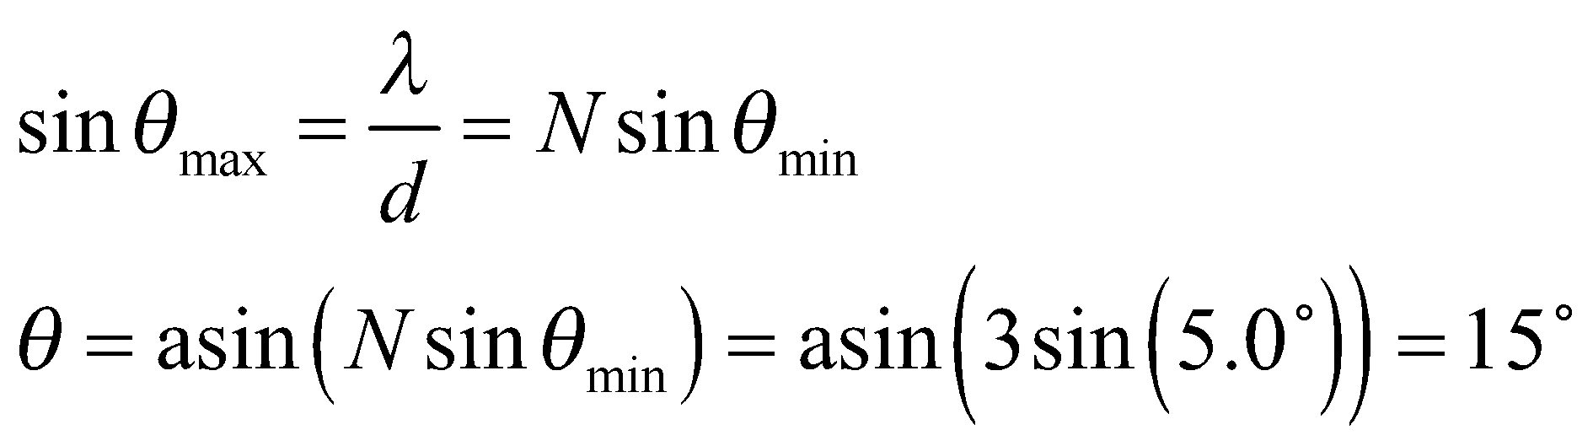

**Assess** The two minima occur at approximately 5° and 10°.

**17. Interpret** In this problem, we want to locate certain maxima and minima in a multiple-slit interference experiment. We are given the necessary parameters.

**Develop** According to Equation 32.1a, primary maxima occur at angles 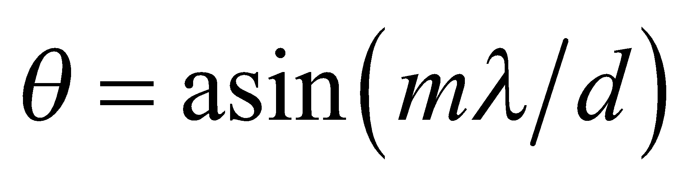. On the other hand, minima occur at angles (see Equation 32.4)



where *m*′ is an integer but not an integer multiple of *N*.

**Evaluate (a)** Using the above equation, the first two maxima (after the central peak,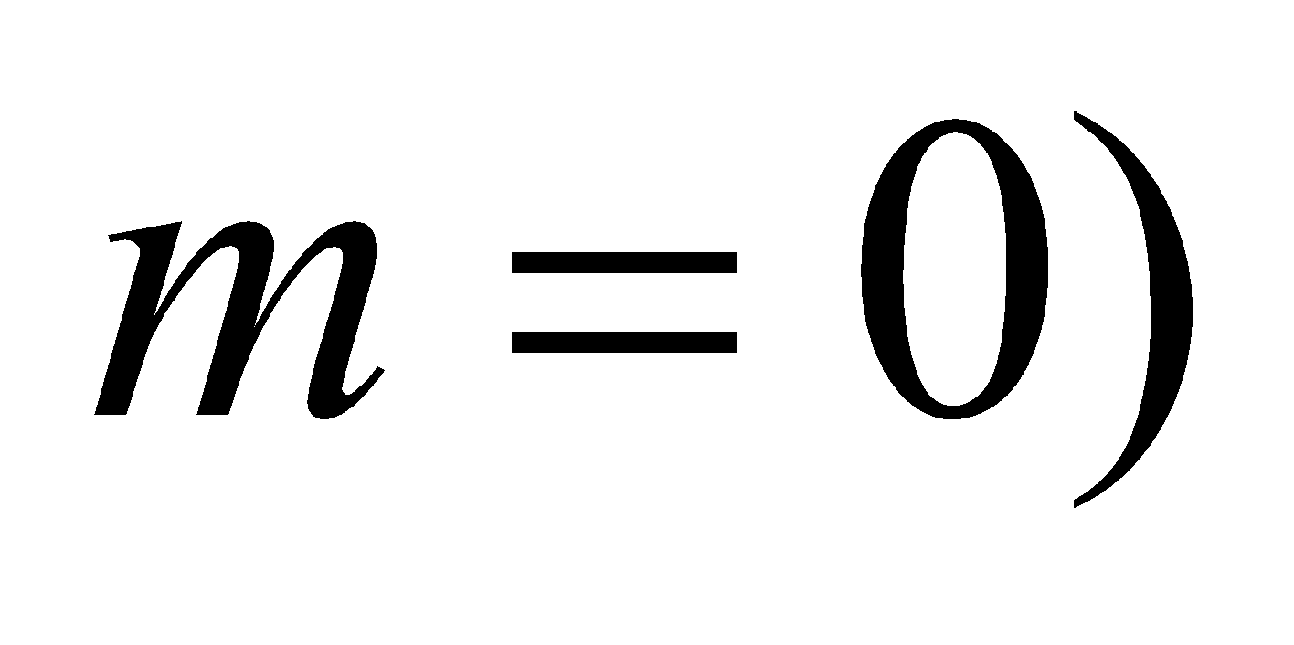are for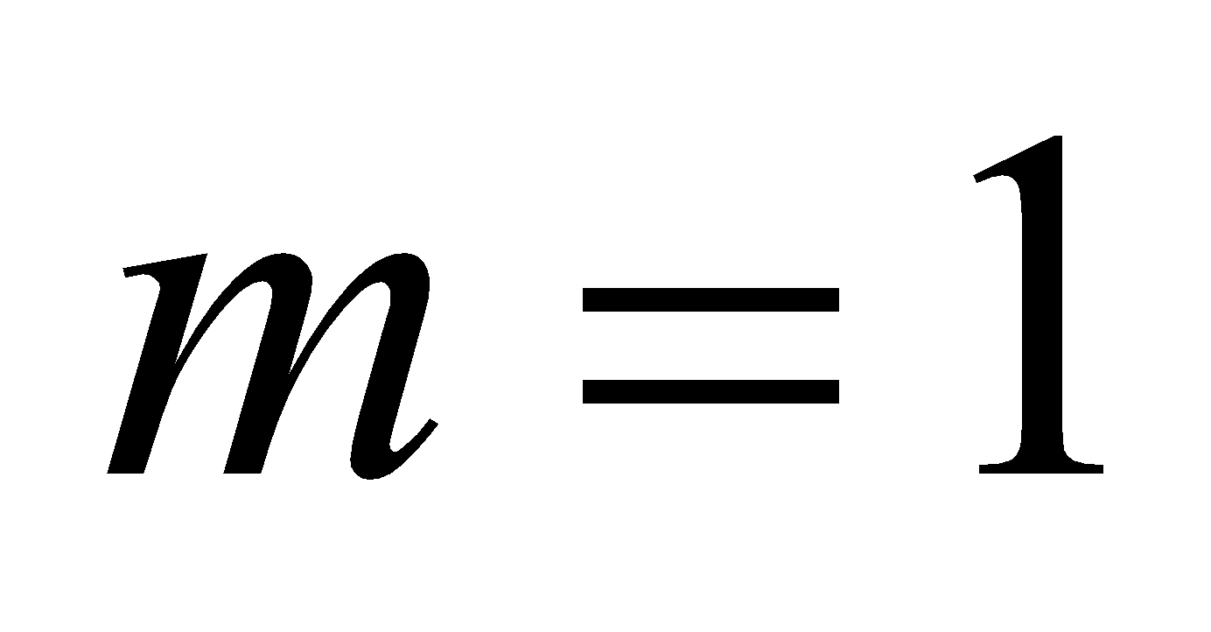and 2. The angular position for these maxima are at

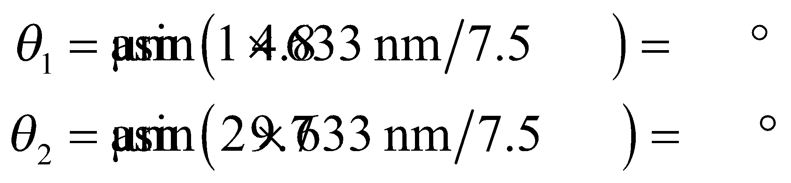

**(b)** With *N* = 5, excluded, the third minimum is for *m*′ = 3 and the sixth for *m*′ = 7 (because *m*′ = 5 doesn’t count). Then

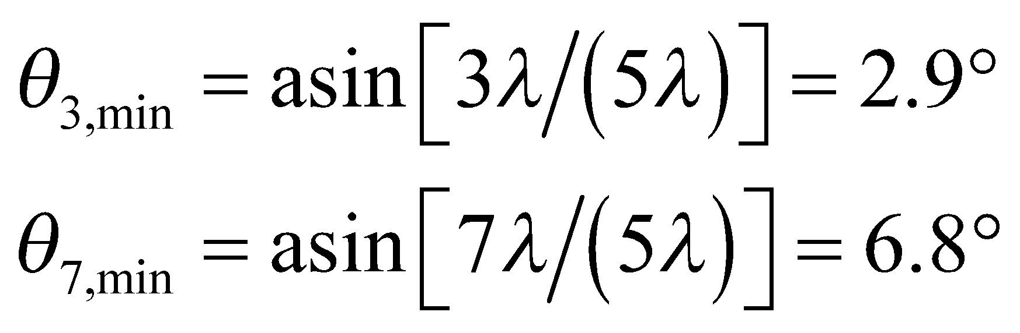

**Assess** The minima would be difficult to observe because the secondary maxima between them are faint.

**18.** **Interpret** We are to find the first- and fifth-order diffraction angle given the grating spacing and the wavelength.

**Develop** For light normally incident on a diffraction grating, maxima occur at angles

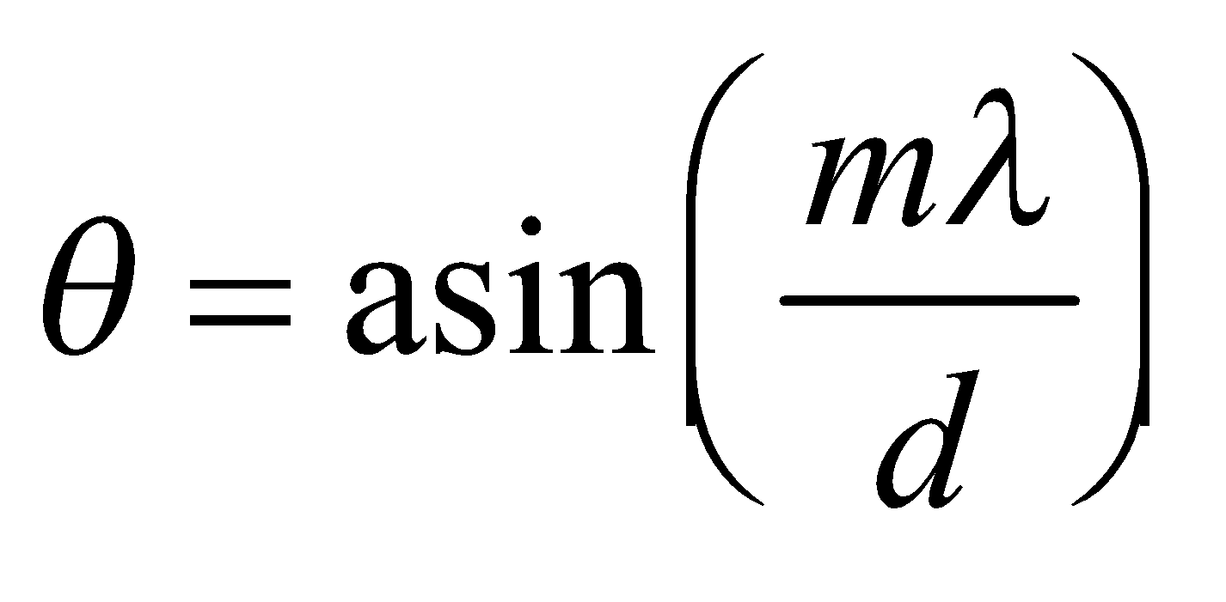

(see Equation 32.1a) where *m* is the order number and *d* is the grating spacing and is equal to the reciprocal of the number of lines per meter:

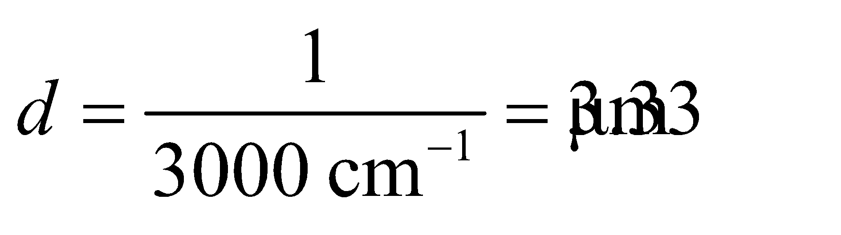

**Evaluate** **(a)** In first order,

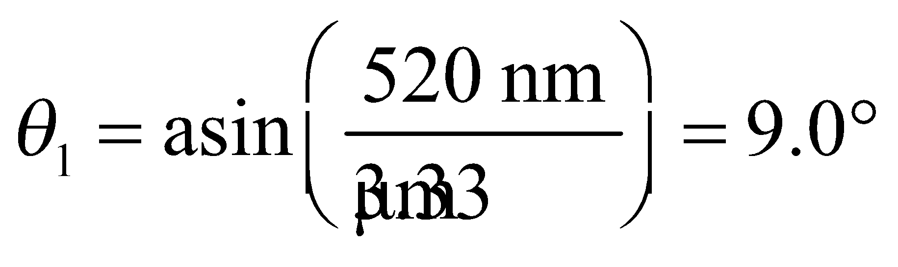

**(b)** In fifth order,

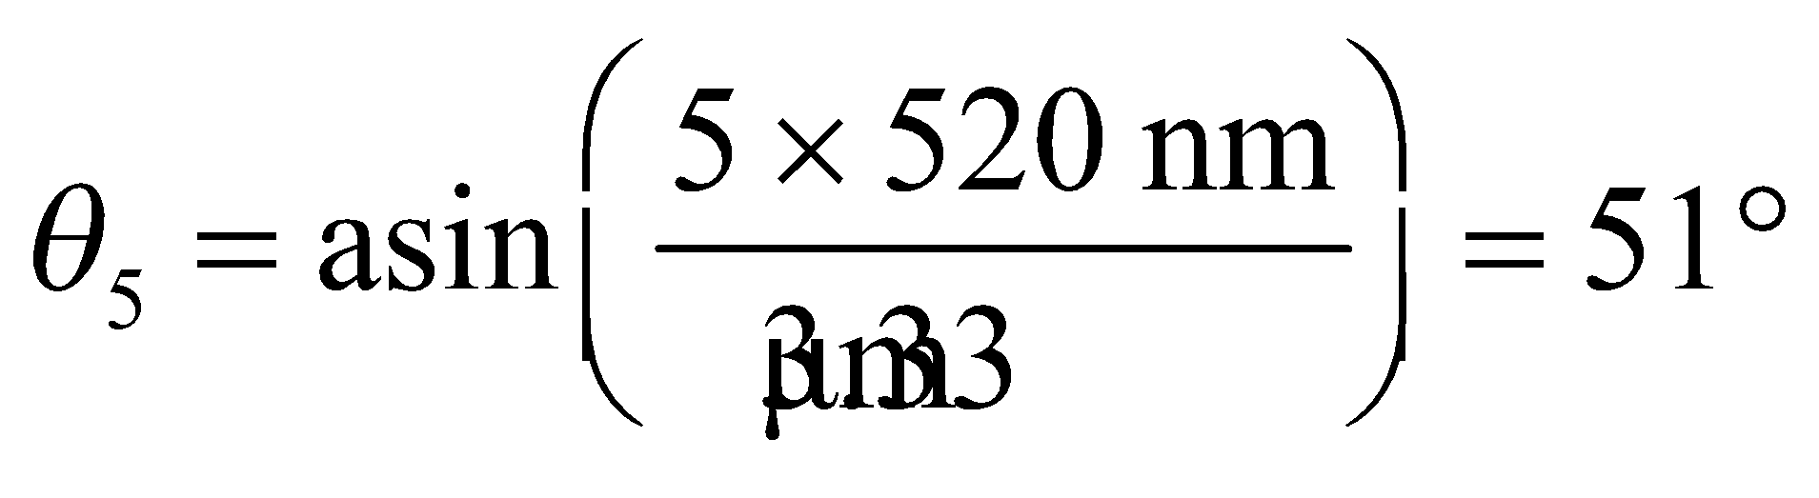

**Assess** One can see that the relationship between *θ*1 and *θ*5 is almost linear (i.e. *θ*5 ~ 5 × *θ*1).

**19. Interpret** This problem is about diffraction gratings. For a given wavelength, we are interested in the highest visible order.

**Develop** The grating condition is 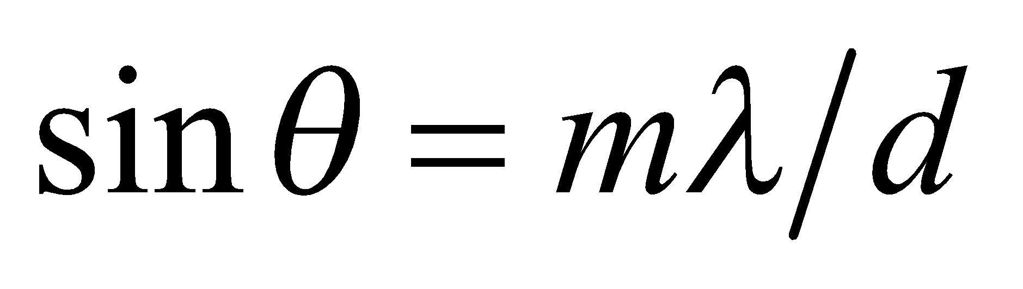 and q must be less than 90° (or *mλ*/*d* < 1) for the diffracted light to be visible. Therefore, the highest order visible is the greatest integer *m* less than *d*/*λ*. The grating spacing is *d* = (1 cm)/104 = 103 nm.

**Evaluate** **(a)** For *λ* = 450 nm, the highest visible order is

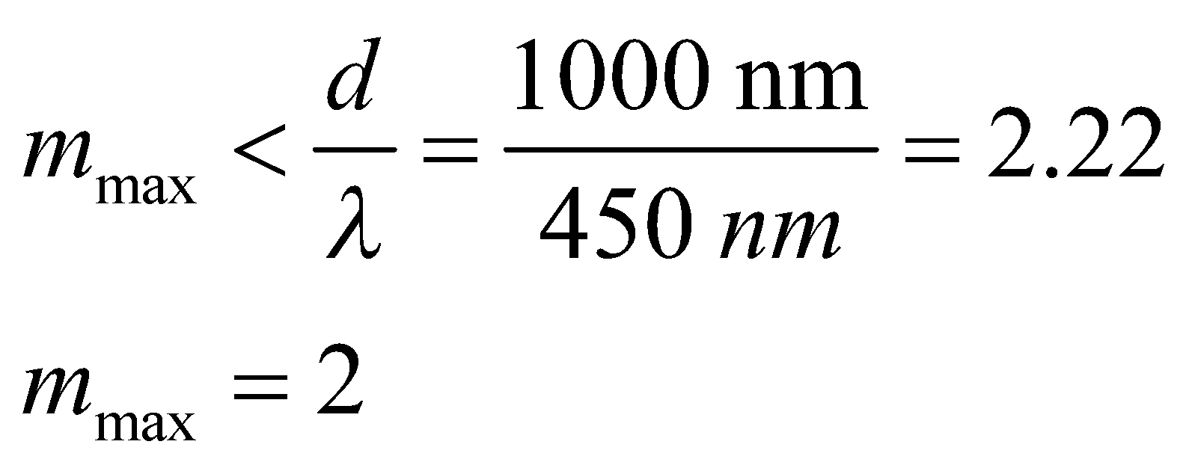

**(b)** Similarly, for *λ* = 650 nm, the highest visible order is

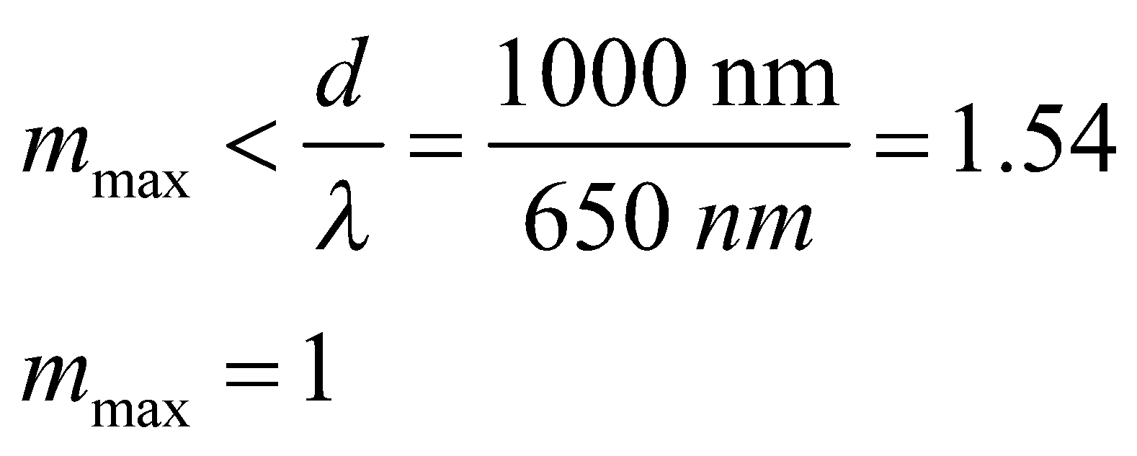

**Assess** Increasing wavelength lowers  This can be seen from Equation 32.1a, 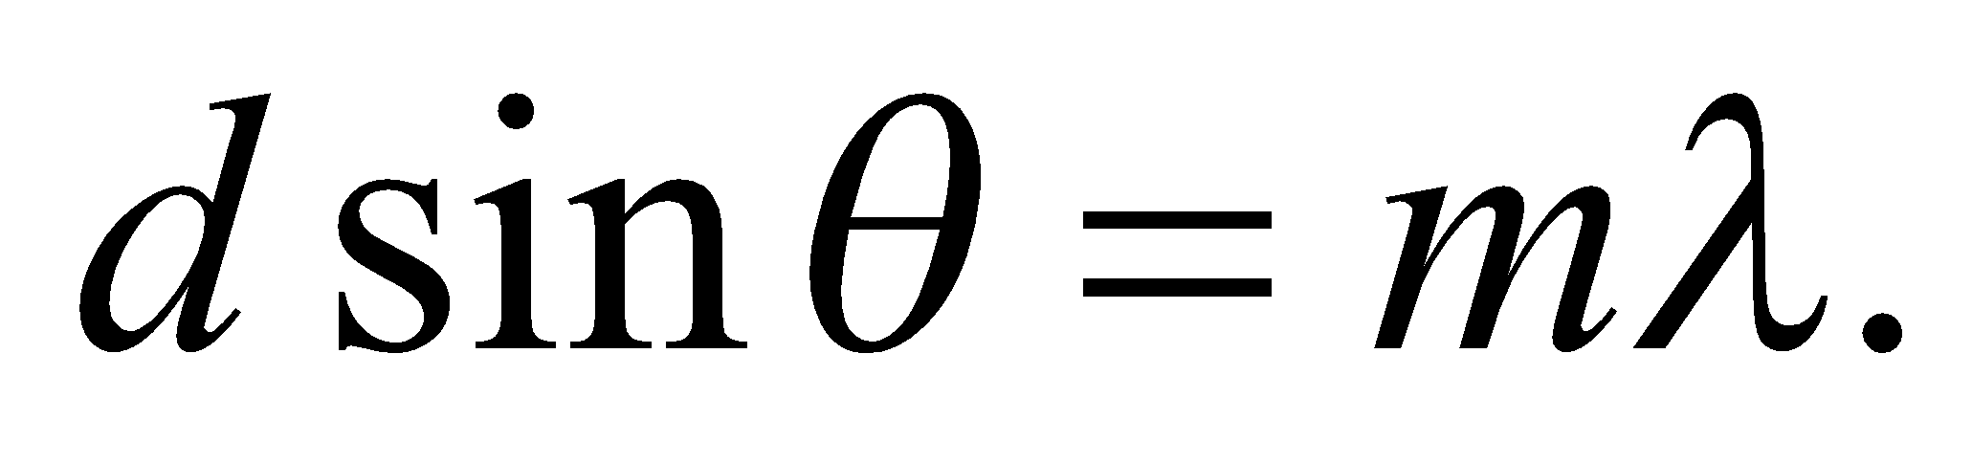

**20. Interpret** We will use interference to find the angular separation for the second-order (*m* = 2) interference maxima for the *Hα* and *Hβ* lines.

**Develop** The wavelengths of the two lines are 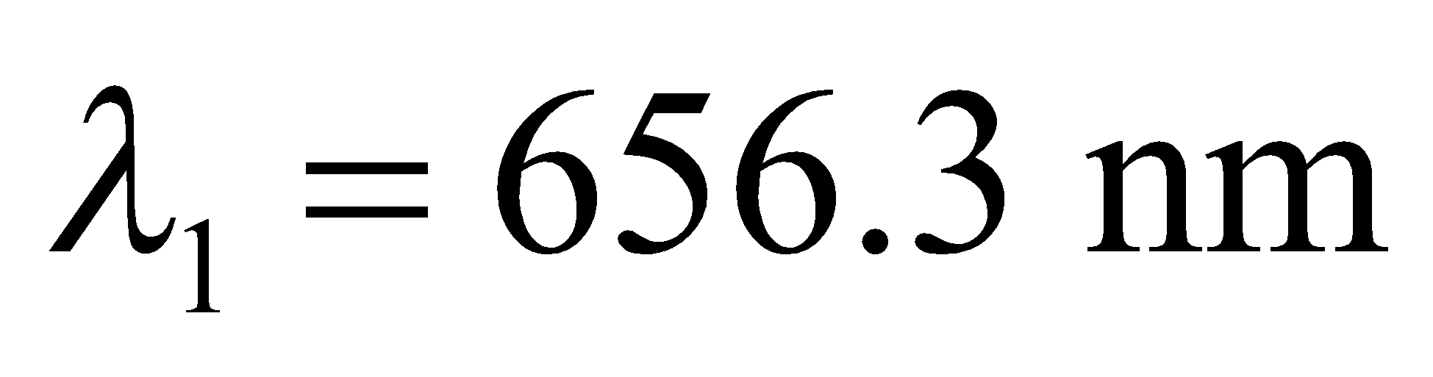 and 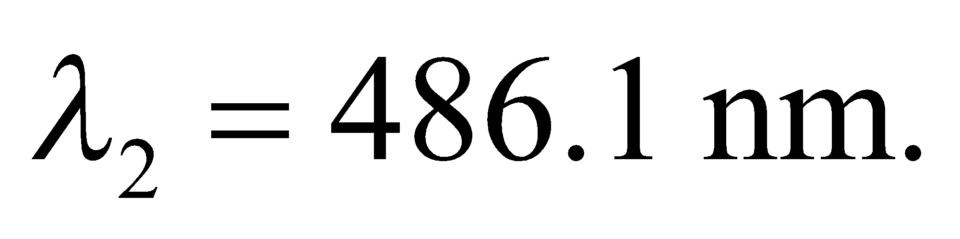 The interference equation (Equation 32.1a) is 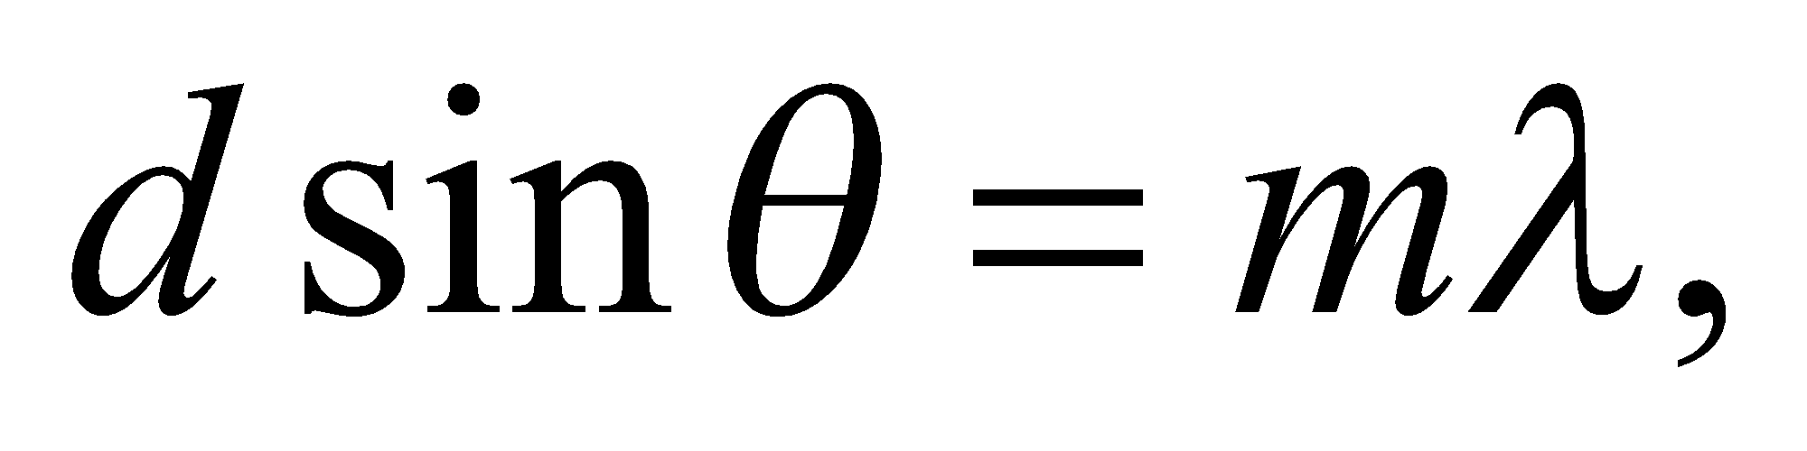 where from Example 32.2 we see that *d* = 1.667 μm. We shall find the value of *θ* for each line, then take the difference between the two.

**Evaluate** Solving for the angle *θ* gives



so

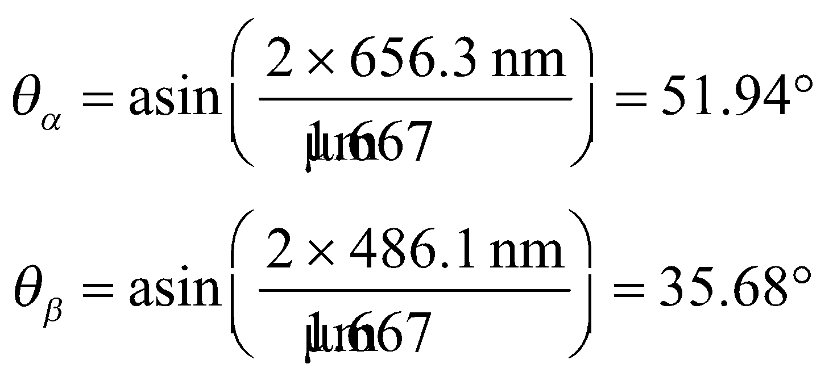

The angular difference between the two is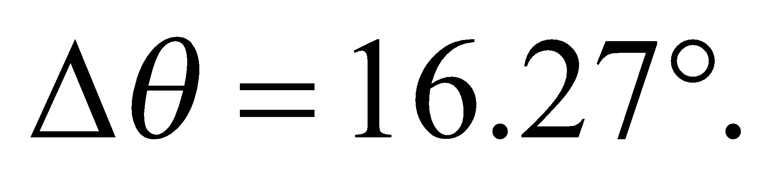

**Assess** Most optical spectrometers are designed to use second-order interference, rather than first-order, because the angular dispersion is larger.

**Section 32.4 Interferometry**

**21. Interpret** This problem involves interference in a thin film. We want to find the minimum film thickness that results in constructive interference for the given wavelength.

**Develop** The condition for constructive interference from a soap film is Equation 32.7:

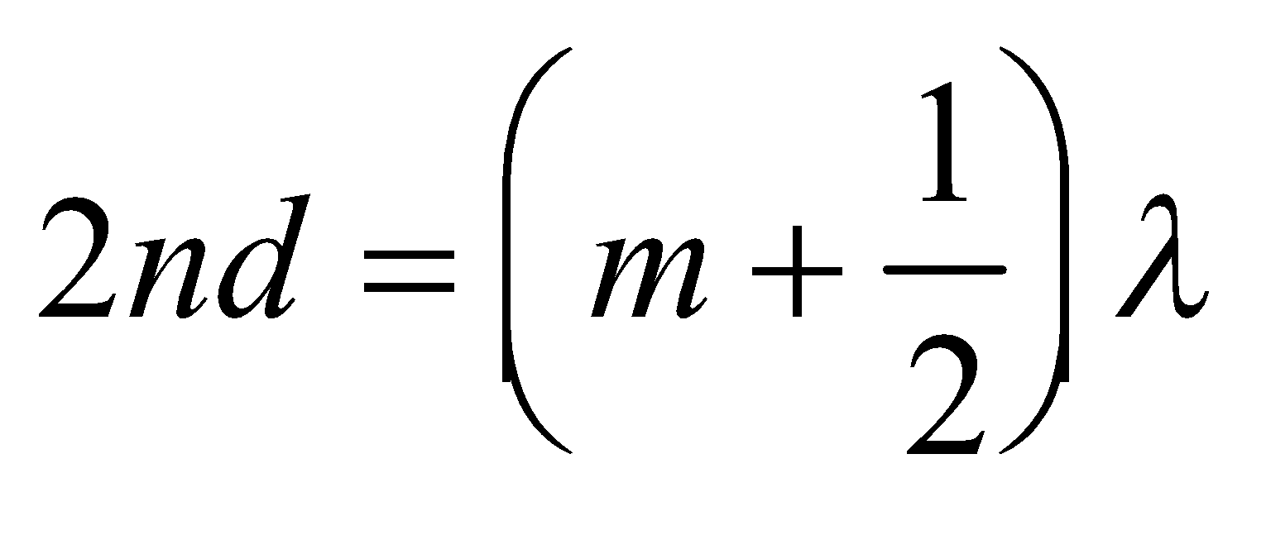

The minimum thickness corresponds to the integer *m* = 0.

**Evaluate** Substituting the values given, we get

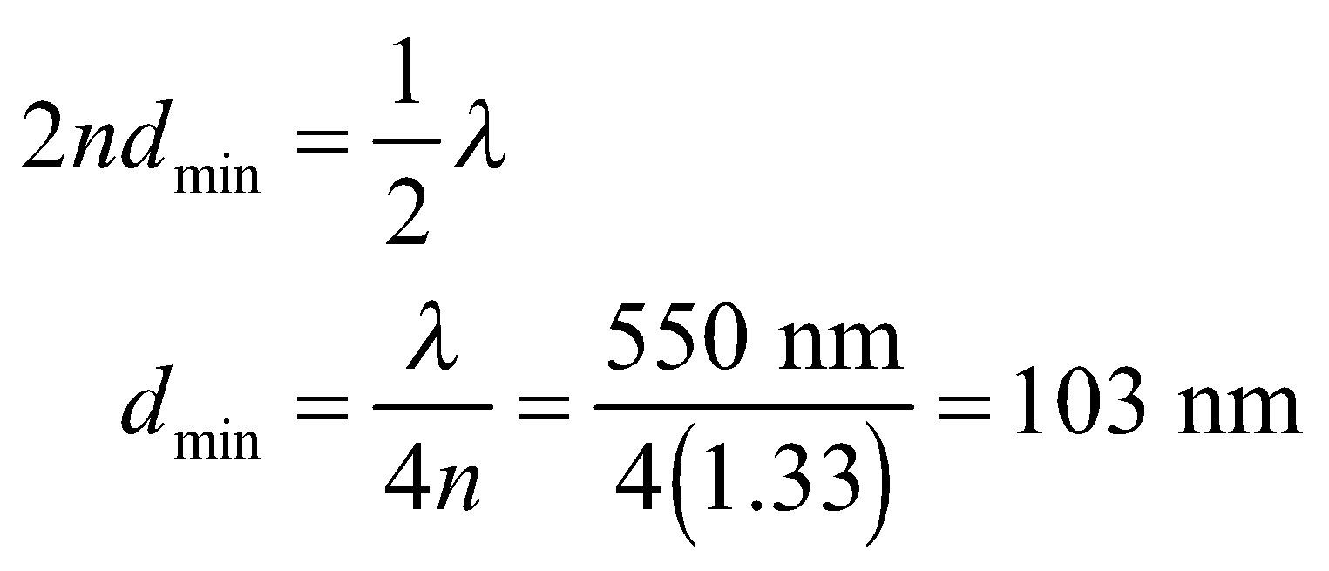

Note that Equation 32.7 applies to normal incidence on a thin film in air.

**Assess** The typical thickness of a thin film is on the order of 100 nm. Thin-film interference accounts for the bands of color seen in soap films or oil slicks.

**22.** **Interpret** This problem involves constructive interference. Given the thickness of the material, we are to find the wavelength which results in constructive interference.

**Develop** We shall use the result from Problem 32.21, which gives the minimum thickness for constructive interference in a thin material. Thus, the minimum thickness of the wedge at which constructive interference occurs is 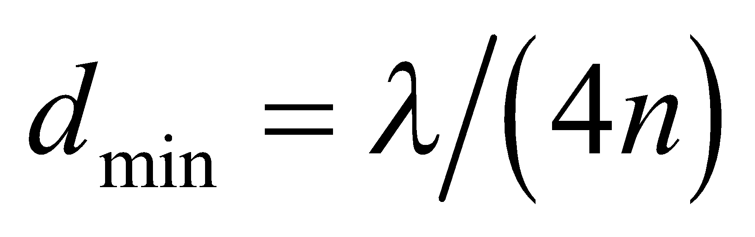. Solve this for *λ* to find the wavelength.

**Evaluate** Inserting the given quantities gives

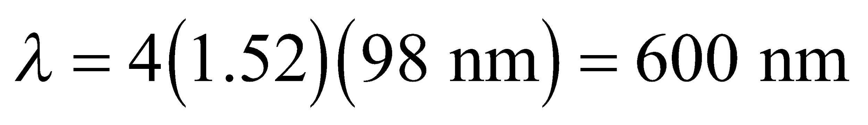

where the result is precise to two significant figures.

**Assess** This is orange light and is within the visible range.

**23. Interpret** The enhanced reflection is a consequence of constructive interference, so we shall look for the range of wavelengths that satisfies this condition.

**Develop** Equation 32.7 gives the condition for constructive interference from a given thickness of glass surrounded by air. Solving this equation for *λ* gives

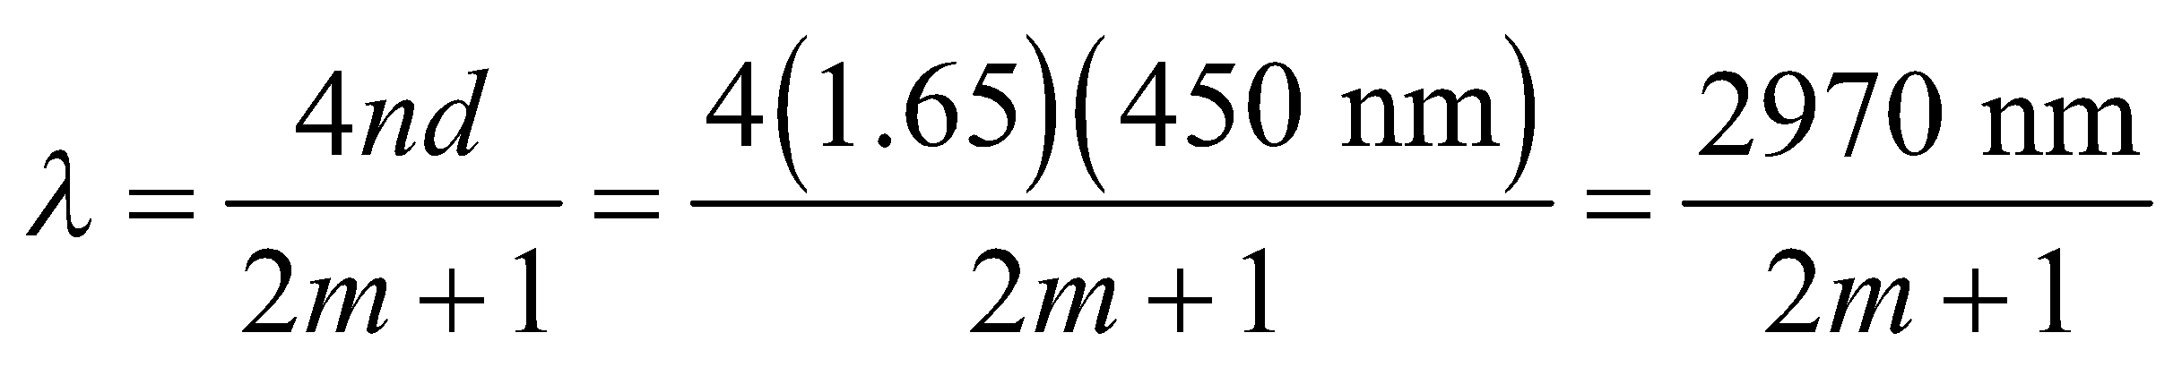

**Evaluate** Integers giving wavelengths in the visible range (400 to 750 nm) are m = 2 and 3, which correspond to *λ* = 594 and 424 nm, respectively.

**Assess** The wavelengths correspond to orange and blue colors, respectively.

**24.** **Interpret** We are to find the wavelength for which constructive interference makes it reflect most strongly from the given thin material.

**Develop** Apply the solution derived for Problem 32.22. Maximum constructive interference occurs for *λ* = 4*nd*.

**Evaluate** Inserting the given quantities yields

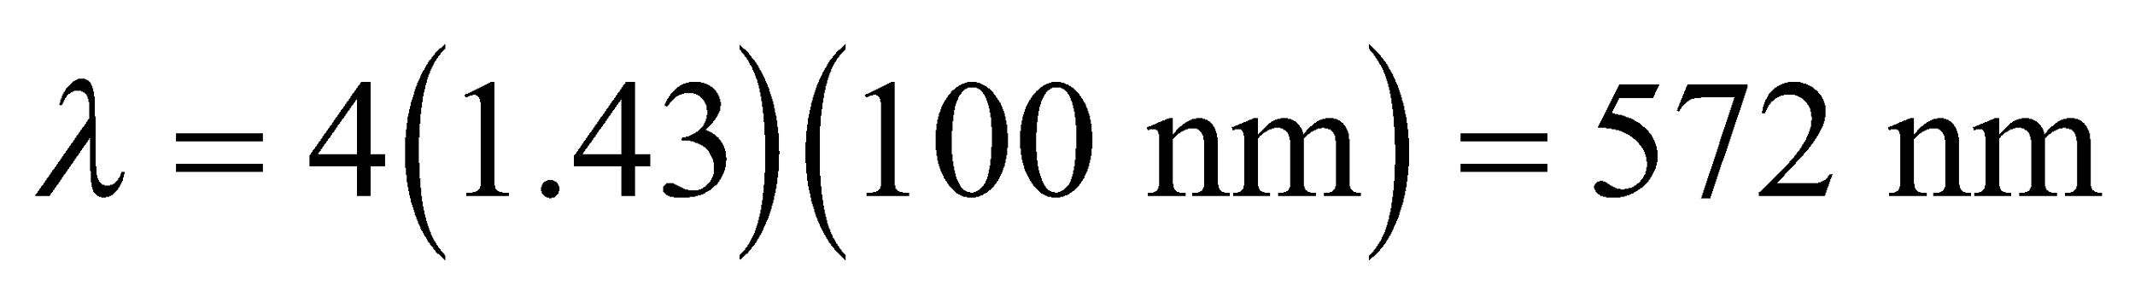

**Assess** This is yellow.

**25. Interpret** The problem asks what portion of a soap film will appear dark because it is too thin for constructive interference in reflected light.

**Develop** The soap film is 20 cm high and goes from zero thickness at the top to 1-μm thick at the bottom. See figure below. White light shines on the film and the reflected light from the two soap-air surfaces will constructively interfere when the thickness of the film satisfies Equation 32.7: 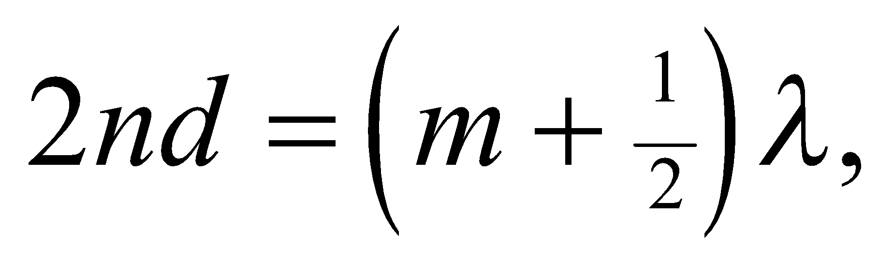 where the index of refraction is that of water 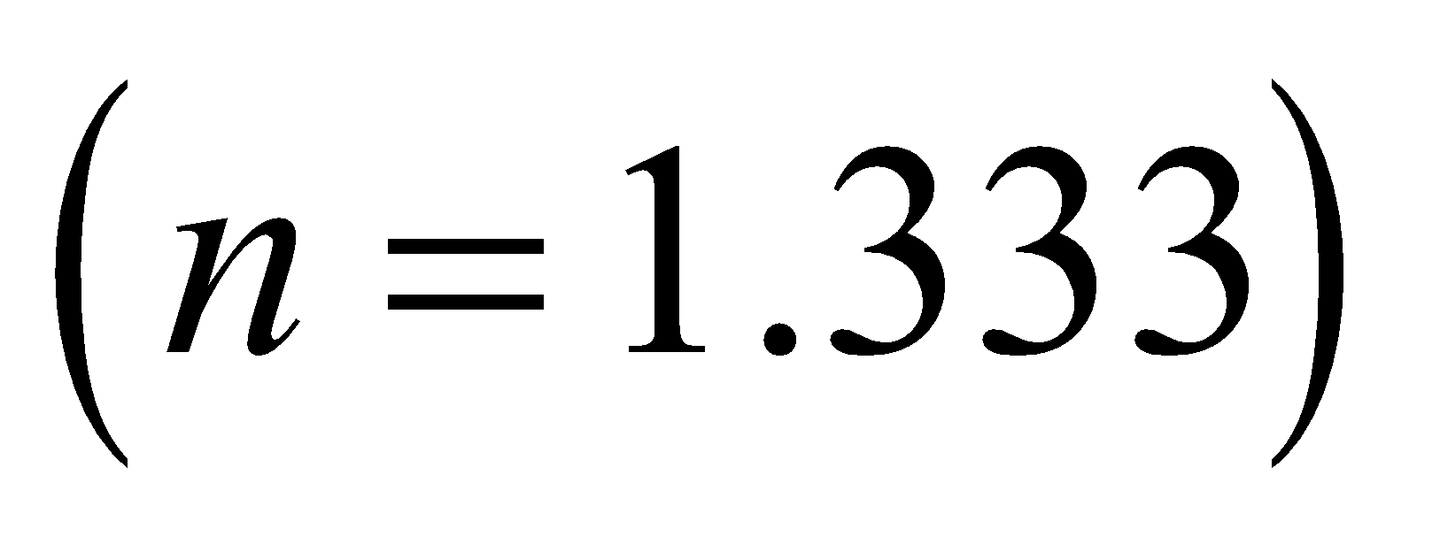 and the integer 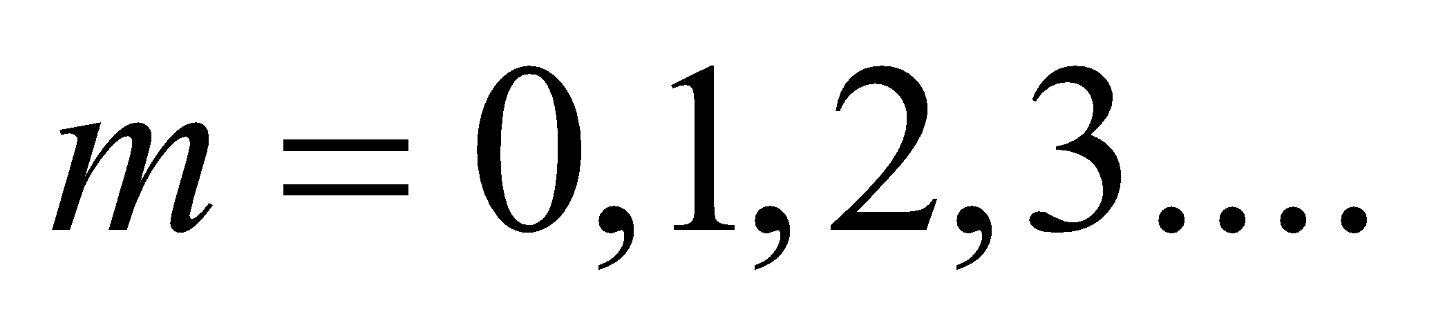 We are looking for the region of the film that is too thin to support constructive interference, so we will define  as the smallest thickness for a bright band and 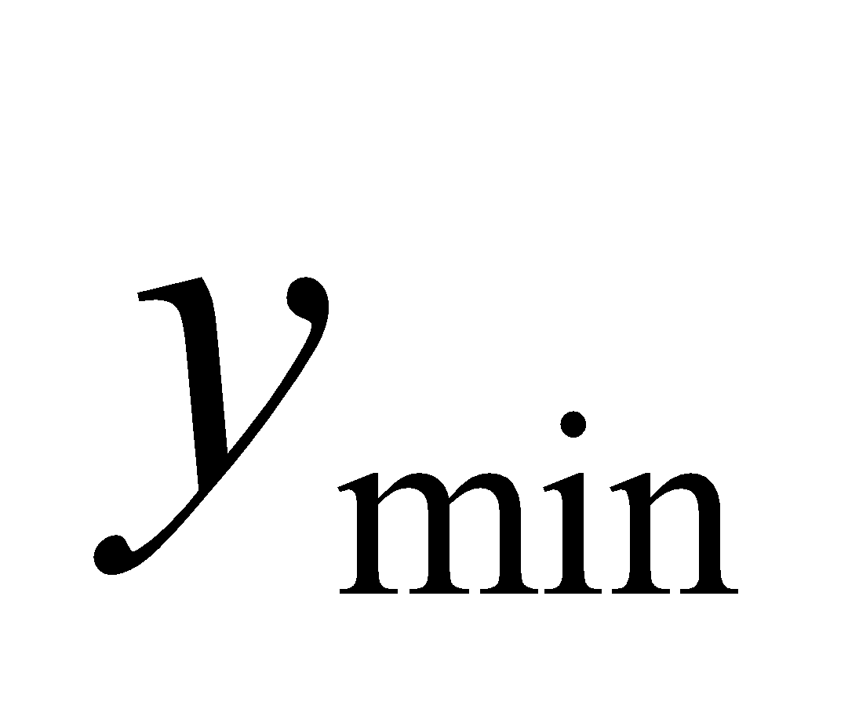 as the distance to this first band from the top, see figure. The region defined by  will be dark.



**Evaluate** White light is a combination of wavelengths from 400 to 700 nm, so there will be bright bands of different colors coming from the soap film. Near the top of film, where it is thinnest, the bands will correspond to the zeroth order 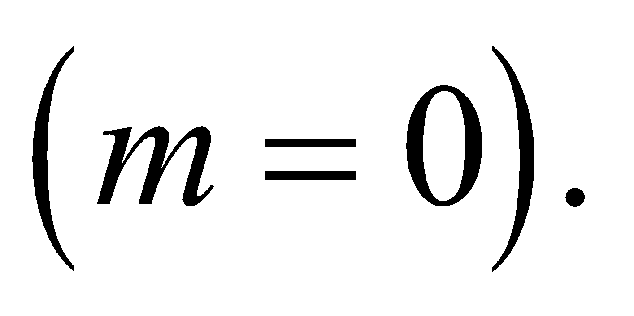At the top of this set of bands will be the blue band for 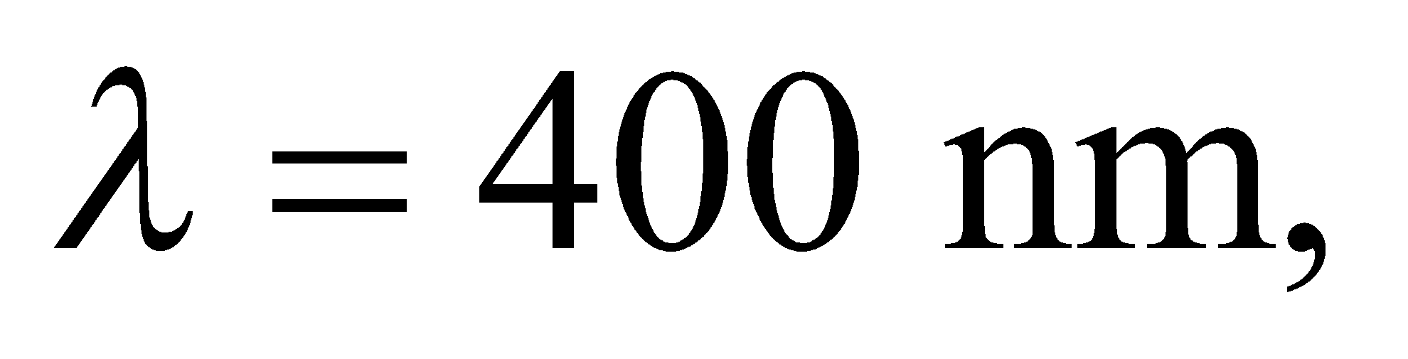since this corresponds to the thinnest part of the film that still supports constructive interference:

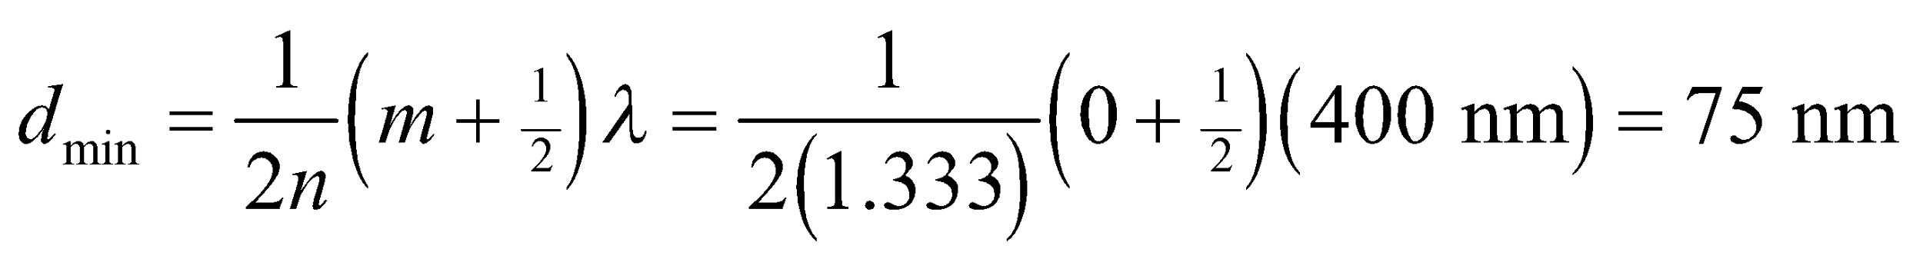

From the figure above, we can see that this minimum thickness occurs at

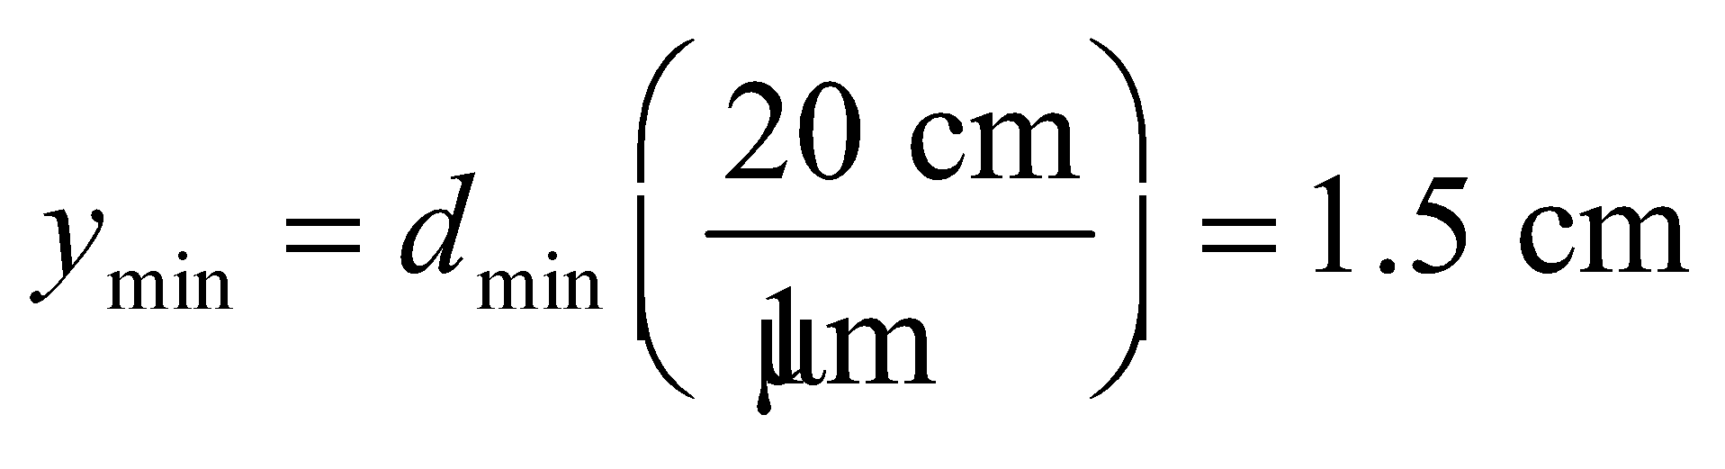

Therefore, the top 1.5-cm of the film will be dark.

**Assess** What happens to the light in this dark region? It is fully transmitted, so if we were to look at the backside of the soap film, the top portion would be bright, and we would see dark bands in transmission at the points corresponding to the bright bands in reflection.

**Section 32.5 Huygens’ Principle and Diffraction**

**26. Interpret** This problem involves Huygens’ principle, which we can use to find the ratio *a*/*λ* that causes the first diffraction minimum to occur at 90°.

**Develop** Huygen’s principle leads to Equation 32.8 for a single slit of size *a*. We shall apply this equation to find the ratio *a*/*λ* that corresponds to *m* = 1 and *θ* = 90°.

**Evaluate** For the given conditions, Equation 32.8 takes the form

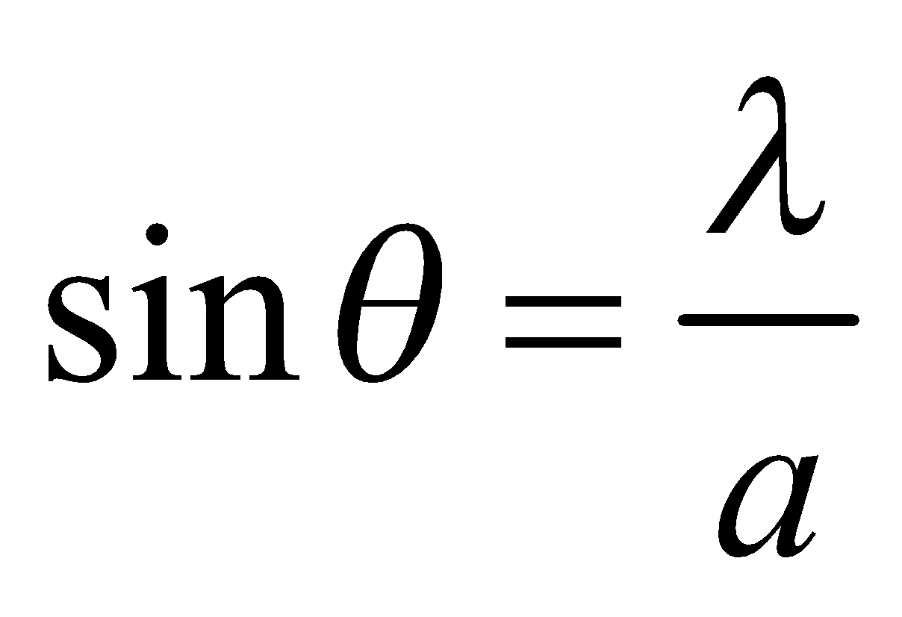

which leads to

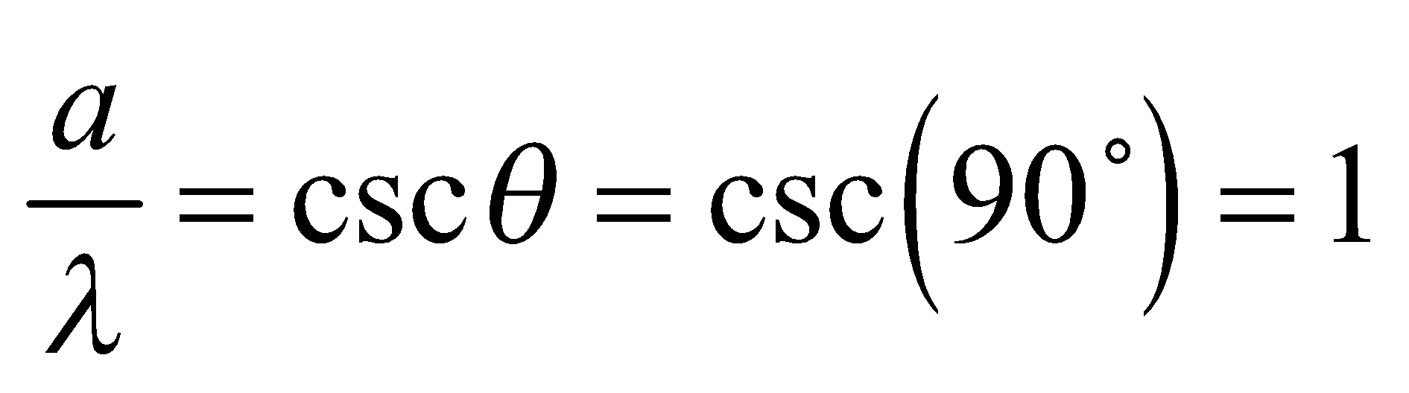

**Assess** This demonstrates that smaller slits will lead to wider diffraction maxima.

**27. Interpret** This problem involves a single-slit diffraction of light. We are interested in the angular width of the central peak.

**Develop** The condition for destructive interference in a single-slit diffraction is given by Equation 32.8:

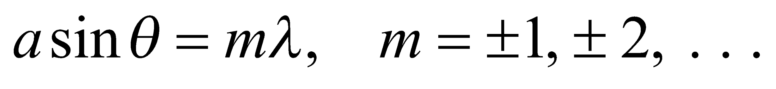

The first minima 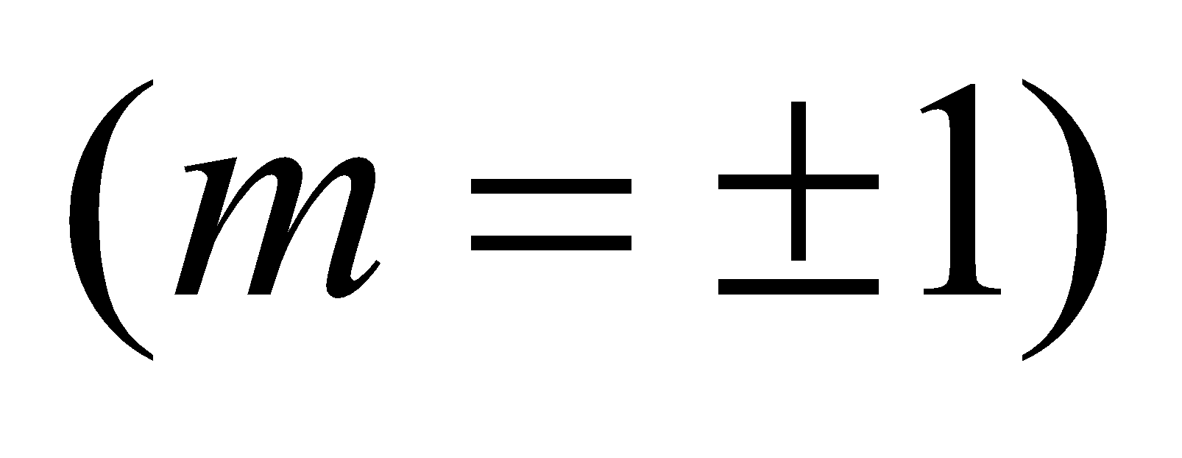 occur at

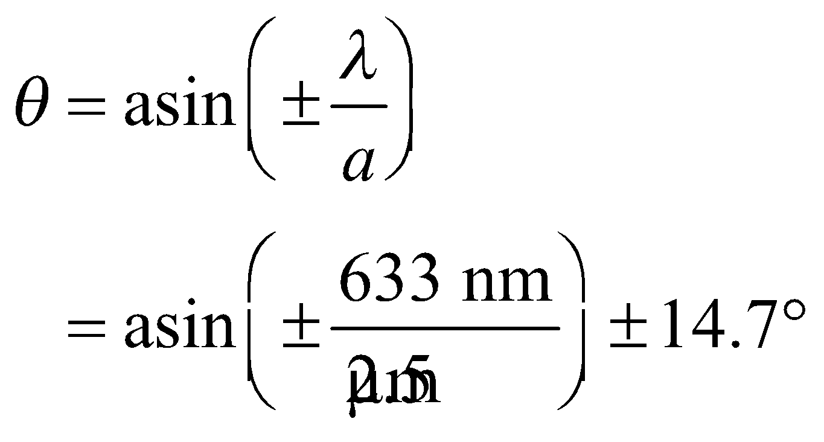

**Evaluate** The total angular width of the diffracted beam is 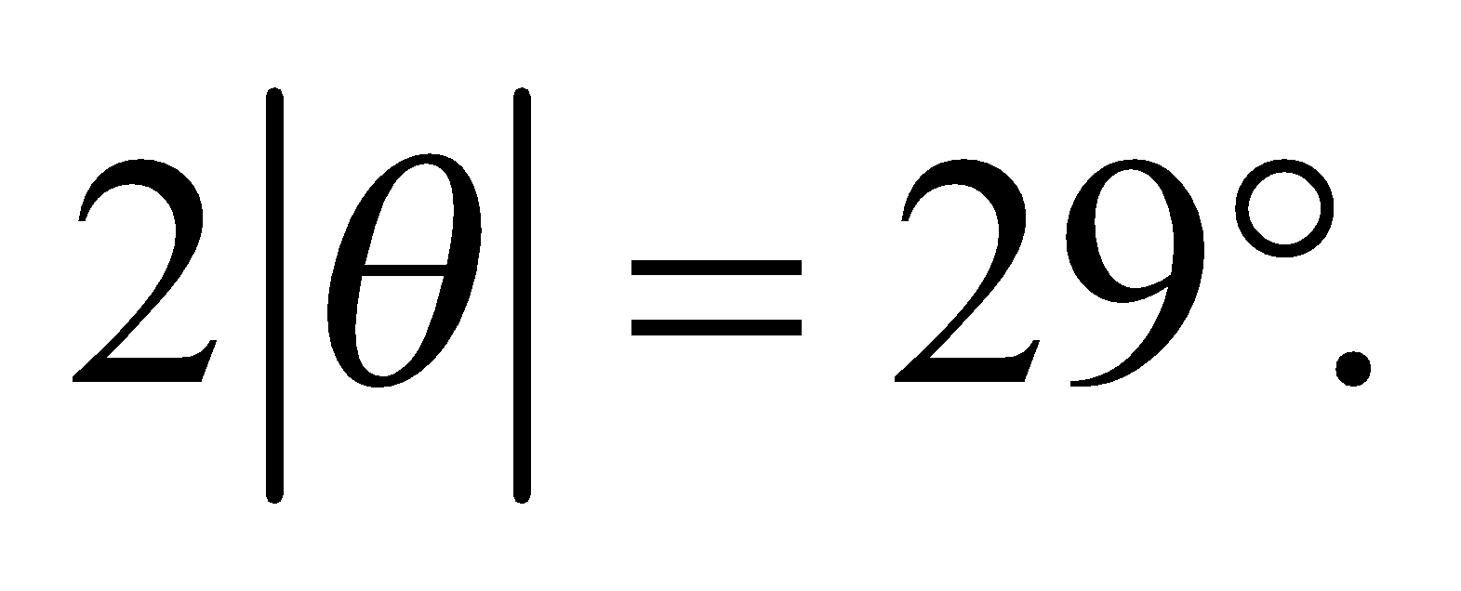

**Assess** The case *m* = 0 is excluded in Equation 32.8 because it corresponds to the central maximum in

which all waves are in phase.

**28.** **Interpret** This problem involves the diffraction of electromagnetic radiation due to a slit. We are to find the angular width of the beam when it emerges from the slit.

**Develop** Take the width of the diffracted beam to be the angular separation between the first minima. Using Equation 32.8, 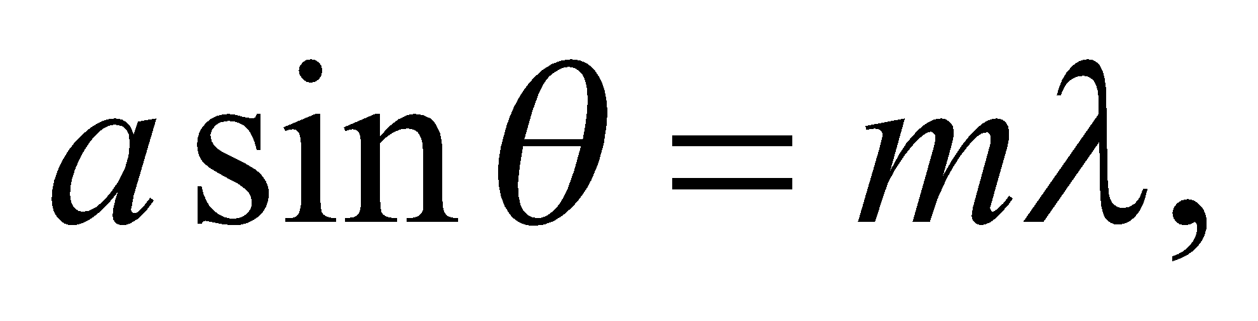 these occur at 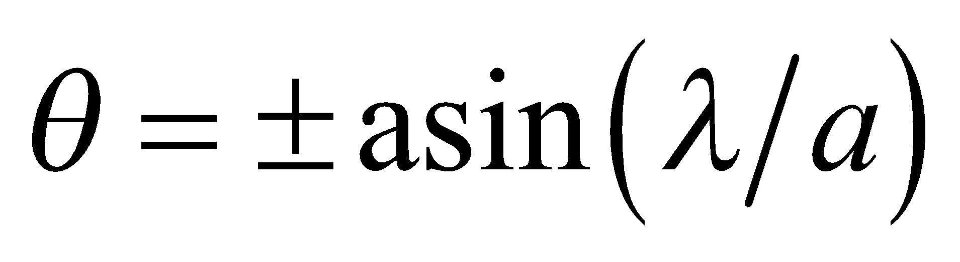, so the angular width is 2*θ*. The wavelength is *λ* = *c*/*f*, where *f* is the given frequency.

**Evaluate** Inserting the given quantities gives

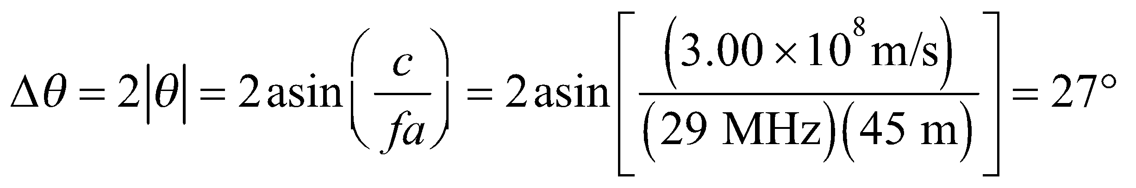

**Assess** The wavelength is ~10 m, so for more closely spaced buildings (i.e., smaller slits), the angular width would be larger.

**29. Interpret** We are to find the intensity of a diffraction maximum relative to the central peak. The second secondary maxima is the second small maxima next to the central peak.

**Develop** The intensity as a function of angle in single-slit diffraction is given by Equation 32.10:

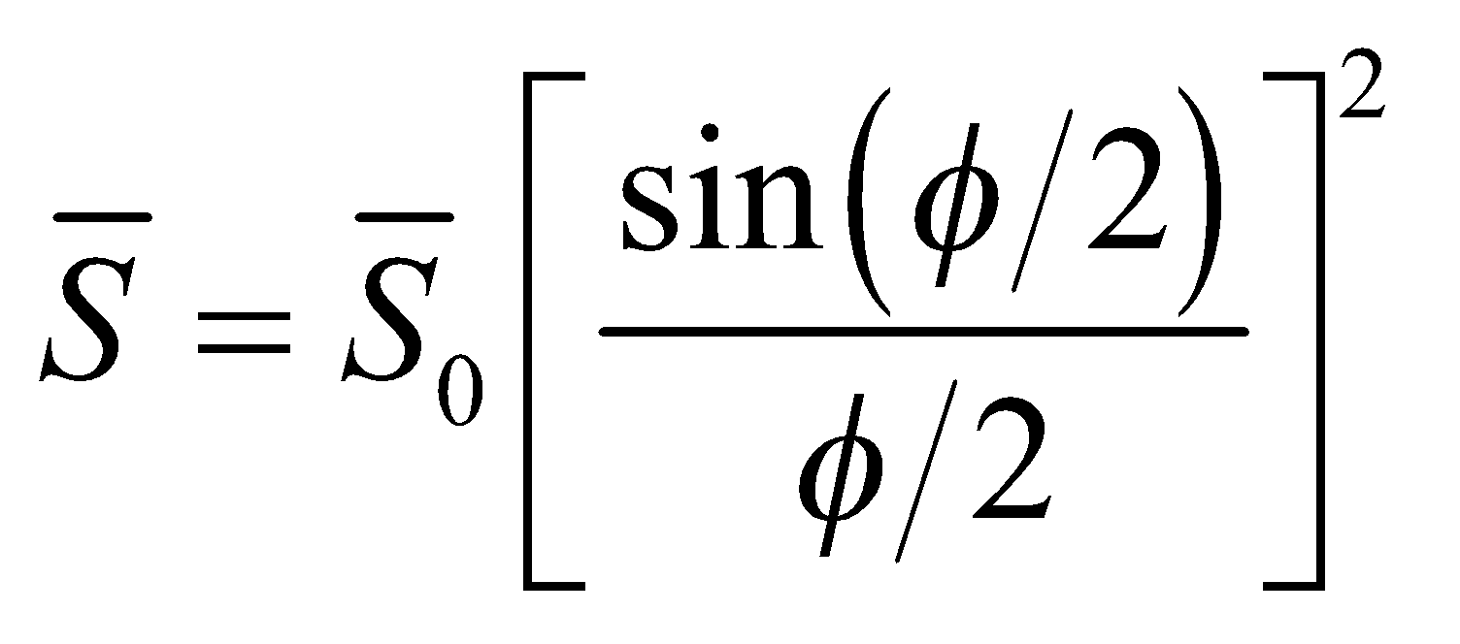

The second and third minima lie at angles 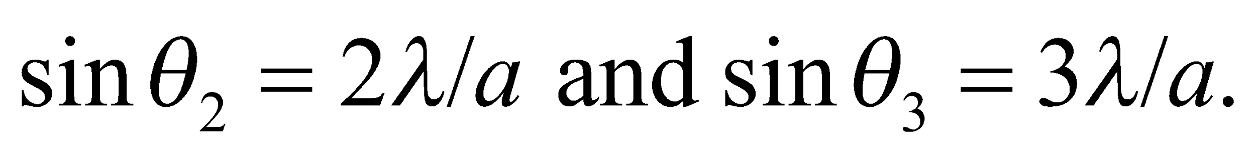

**Evaluate** If we take the mid-value to be at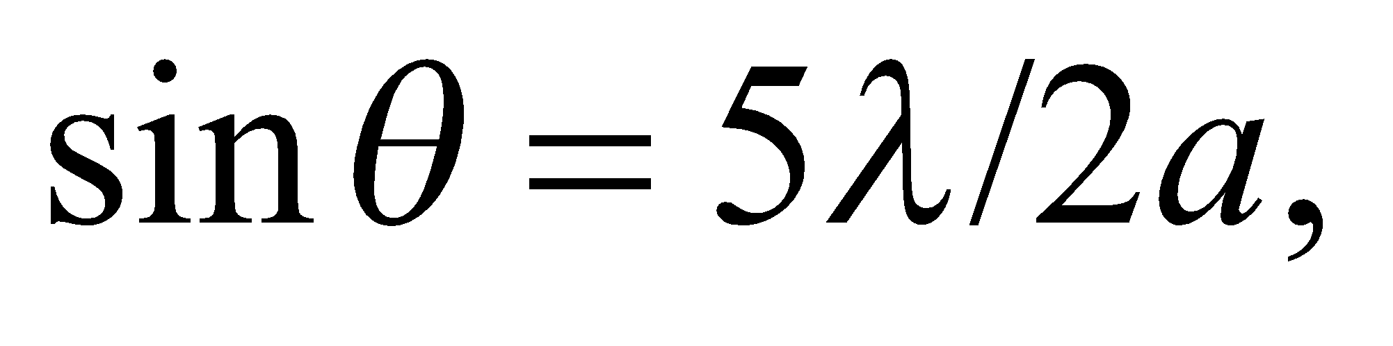then the intensity at this angle, relative to the central intensity, is

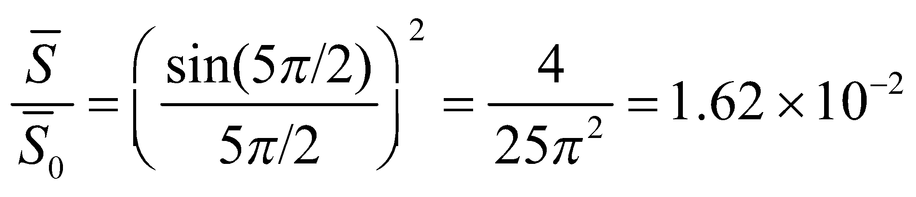

**Assess** The intensity at the second secondary maximum is only about 1.62% of the central-peak intensity.

**Section 32.6 The Diffraction Limit**

**30. Interpret** We are to find the minimum angular separation that can be resolved with 633-nm light through a 2.1-cm diameter aperture. We will assume that the limiting factor is diffraction, and use the Rayleigh criterion.

**Develop** Apply the Rayleigh criterion for circular apertures (Equation 32.11b): 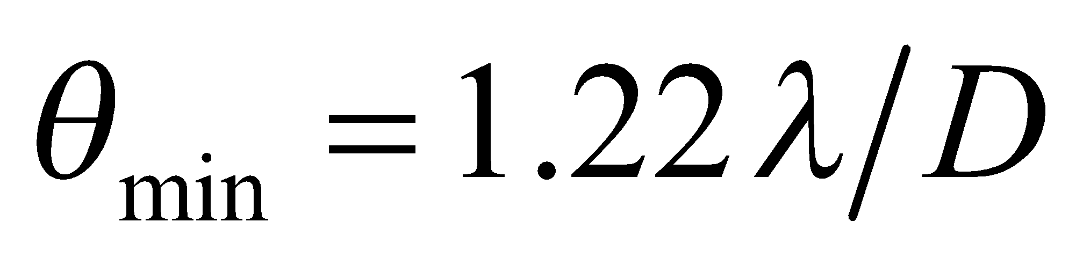. The wavelength is 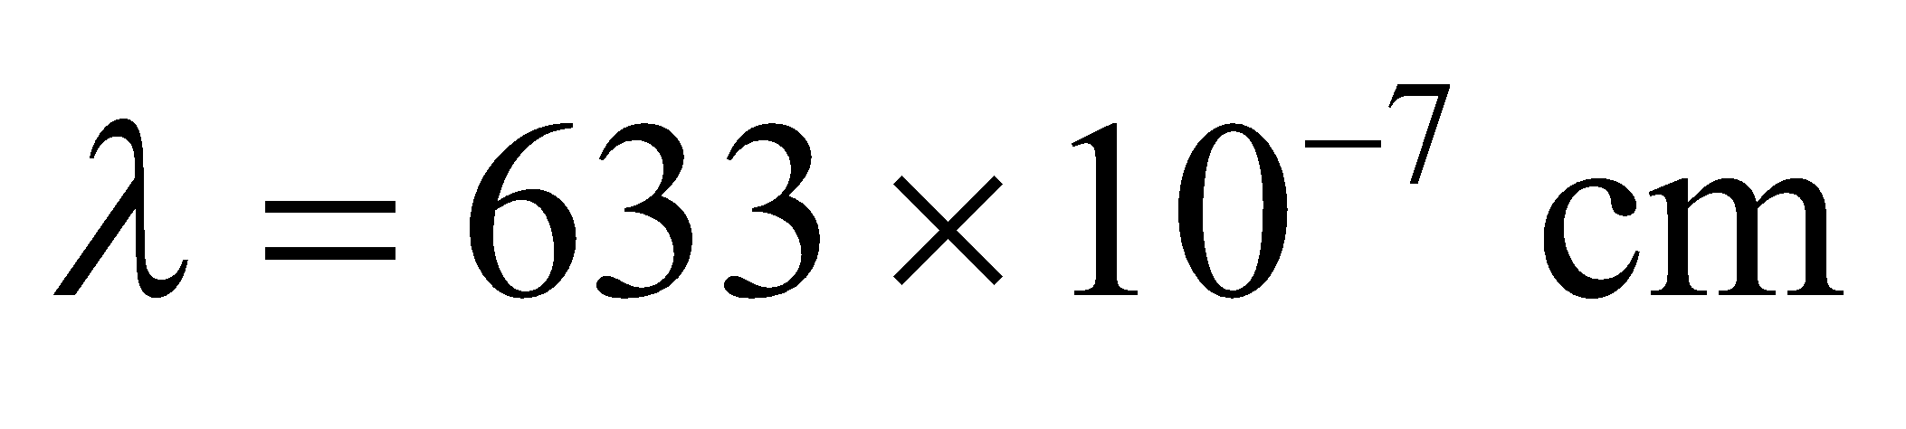 and the diameter is *D* = 2.1 cm.

**Evaluate** The minimum angular separation is



**Assess** This angular resolution is equivalent to distinguishing two objects 3.7 millimeters apart from 100 meters away.

**31. Interpret** We shall use the Rayleigh criterion to determine how large an aperture is needed on a telescope to resolve the given angle.

**Develop** Apply the Rayleigh criterion for circular apertures (Equation 32.11b): . The wavelength is *λ* = 500 nm and the angular resolution needed is



Solve for *D*.

**Evaluate** The diameter needed is

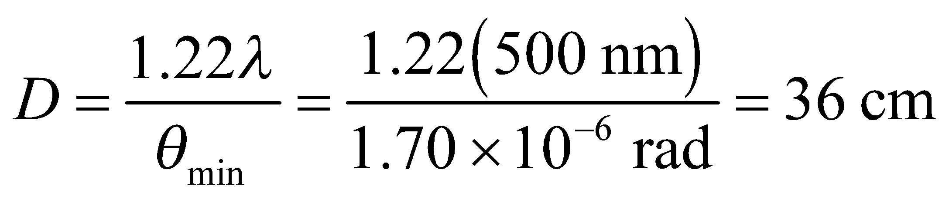

**Assess** Make sure that you always use radians for your angle measurements in this type of problem!

**32. Interpret** We shall use the Rayleigh criterion to determine the longest wavelength of light with which one is able to resolve the given angle through the given aperture.

**Develop** Apply the Rayleigh criterion for circular apertures (Equation 32.11b): . The angular resolution necessary is 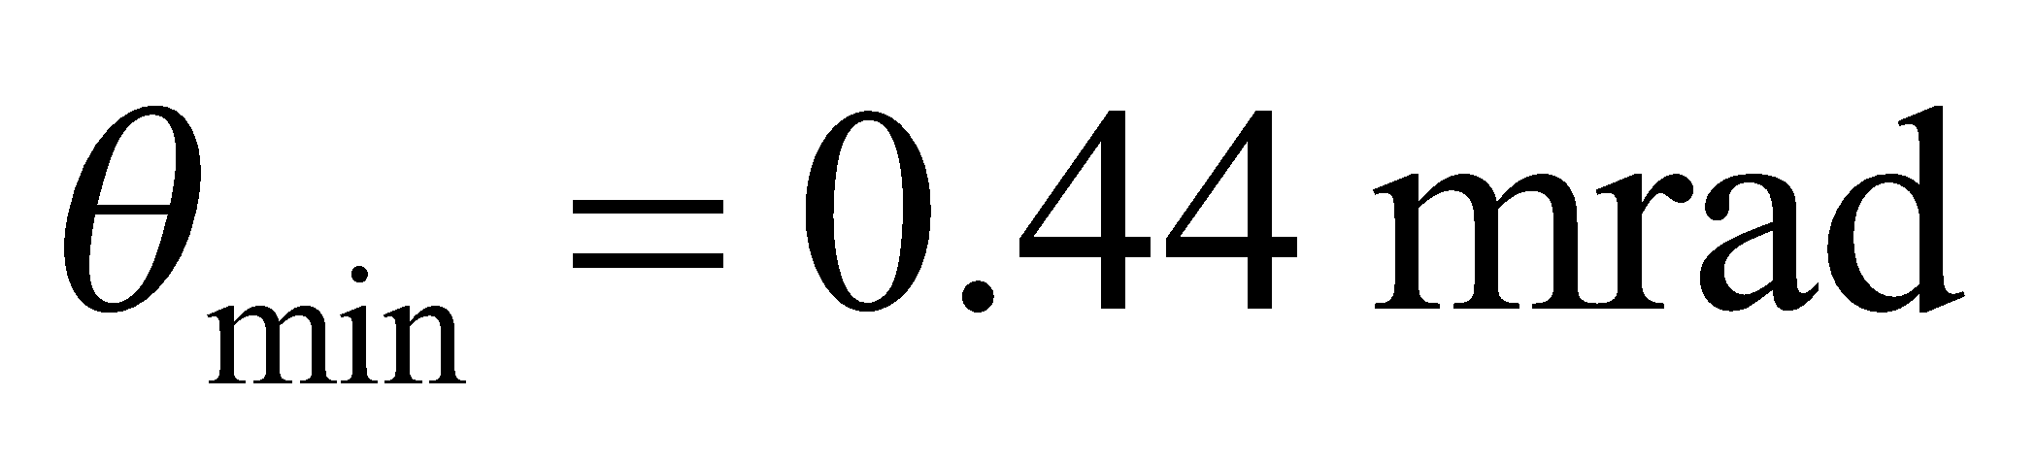 and the aperture is *D* = 1.2 mm. Solve for the wavelength.

**Evaluate** The longest wavelength able to resolve this is

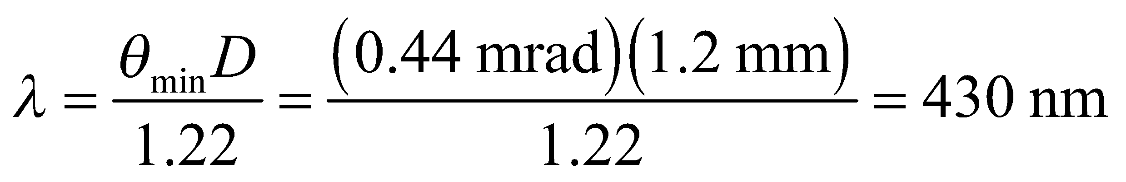

to two significant figures.

**Assess** Using a short wavelength gives you a much better angular resolution. This is why an *electron* microscope gives such high resolution, as we will discover later.

**33. Interpret**  We're asked to find the diffraction limit of the eye in bright light when the pupil has contracted.

**Develop** The minimum angular resolution of a circular aperture is given in Equation 32.11b: 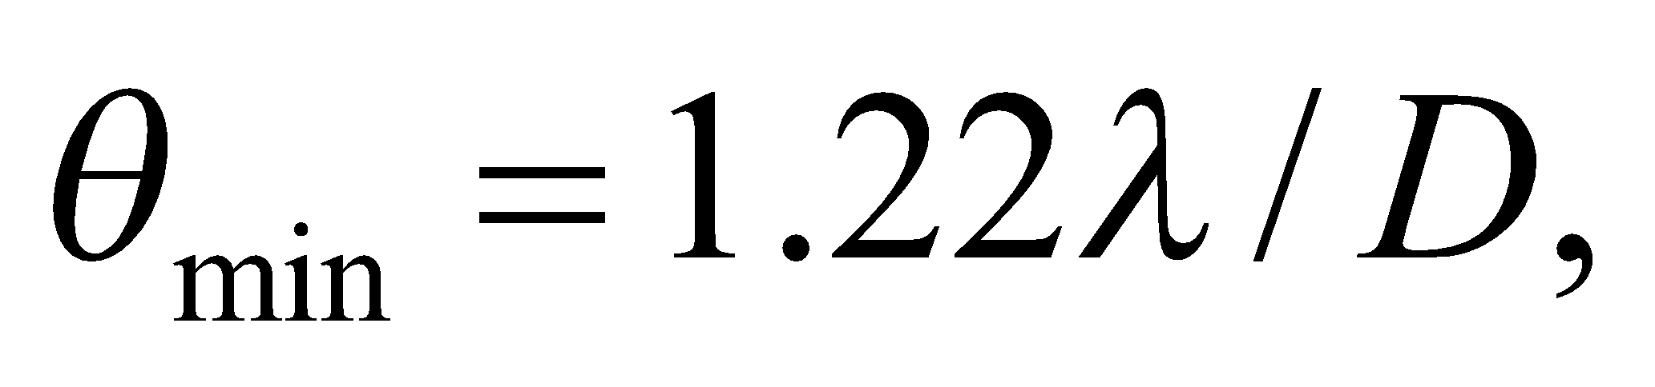where the result is in radians.

**Evaluate** For the given pupil diameter and light wavelength, the resolution is

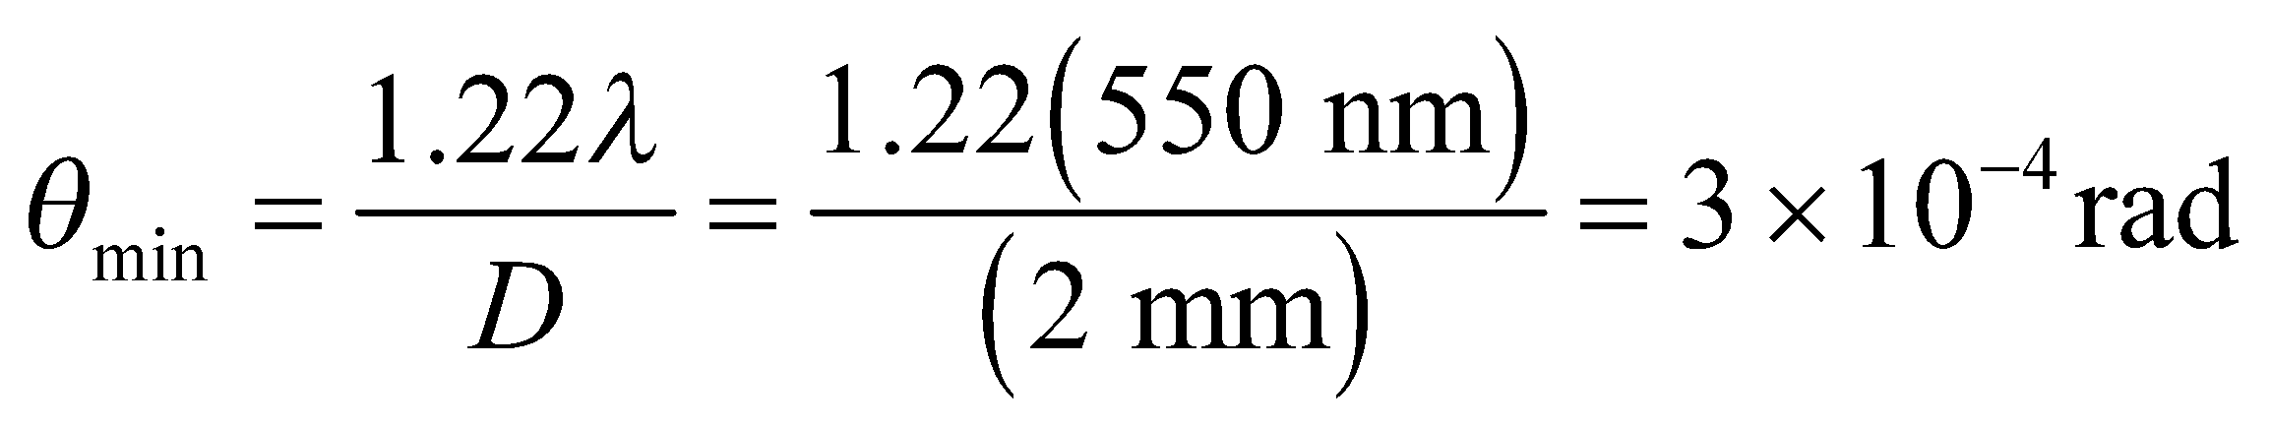

In terms of degrees, this is about 0.02°, or about 1 arcminute.

**Assess** This says that on a bright day our eyes would be able to distinguish objects 3 mm apart at a distance of 10 m. This is a little unrealistic. Our eyes are not only limited by the diffraction through the pupil; their resolution is also affected by the spacing of receptors (rods and cones) on the back of the retina.

**Problems**

**34. Interpret** We are to find the angle at which the second order (i.e., *m* = 2) bright fringe occurs in a double-slit experiment with the given parameters.

**Develop** Use Equation 32.1a to find the angle *θ* for the different wavelengths *λ*, with d = 1.5 μm.

**Evaluate** (**a**) For *λ* = 400 nm, the angle is

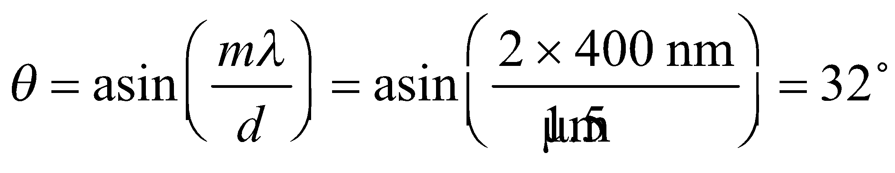

(**b**) For λ = 700 nm,

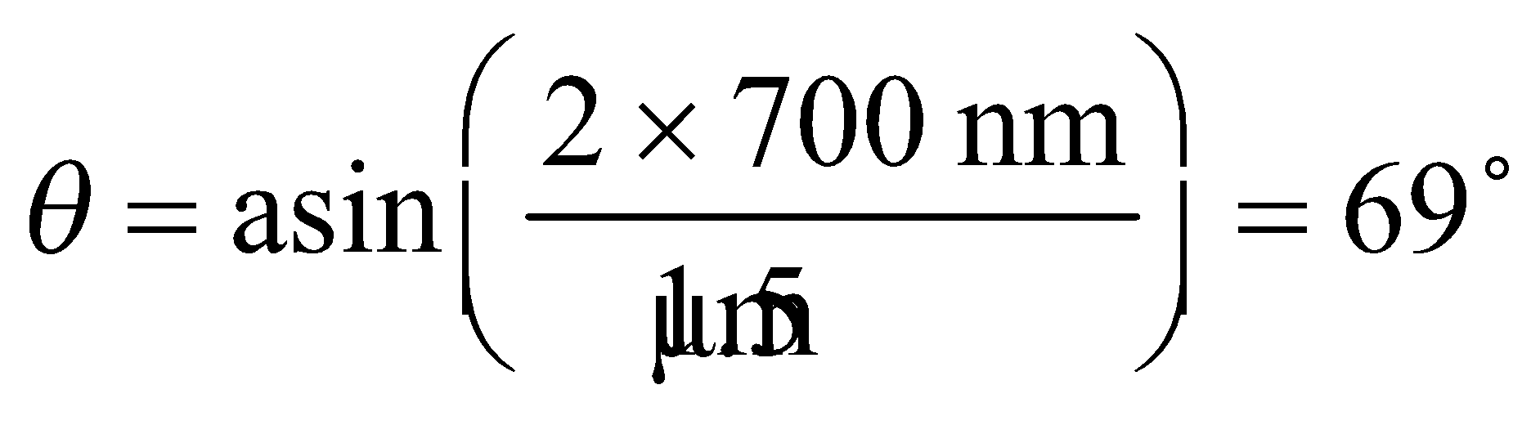

**Assess** Notice the nonlinear behavior. Were it linear, the result for part (b) would be 56º.

**35. Interpret** The concept behind this problem is double-slit interference. The object of interest is the phase difference between the waves emanating from the different slits.

**Develop** The path-length difference for waves arriving from the two different slits is

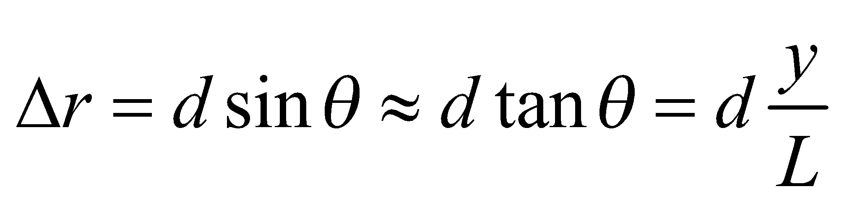

since 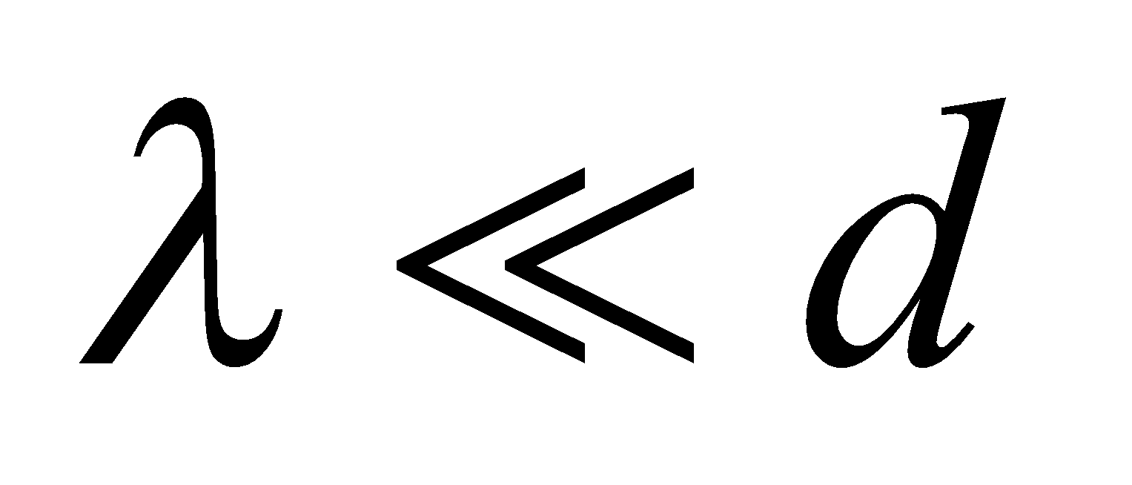 and the small-angle approximation can be used (see derivation of Equations 32.2a and 32.2b). The phase difference is

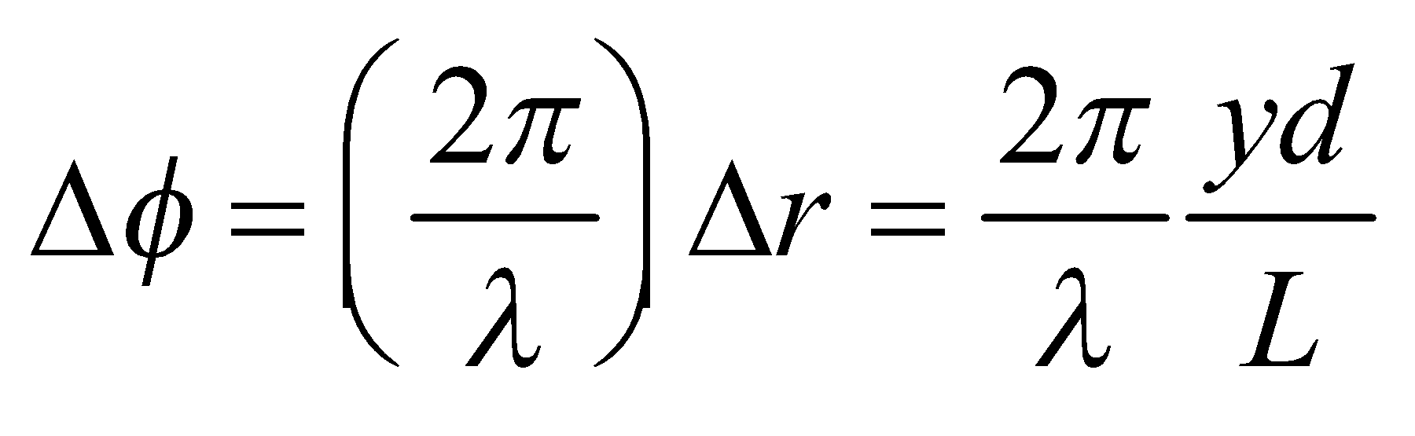

**Evaluate** The phase difference is

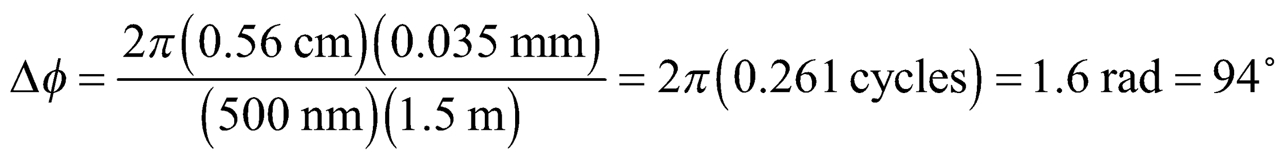

**Assess** Constructive interference corresponds to 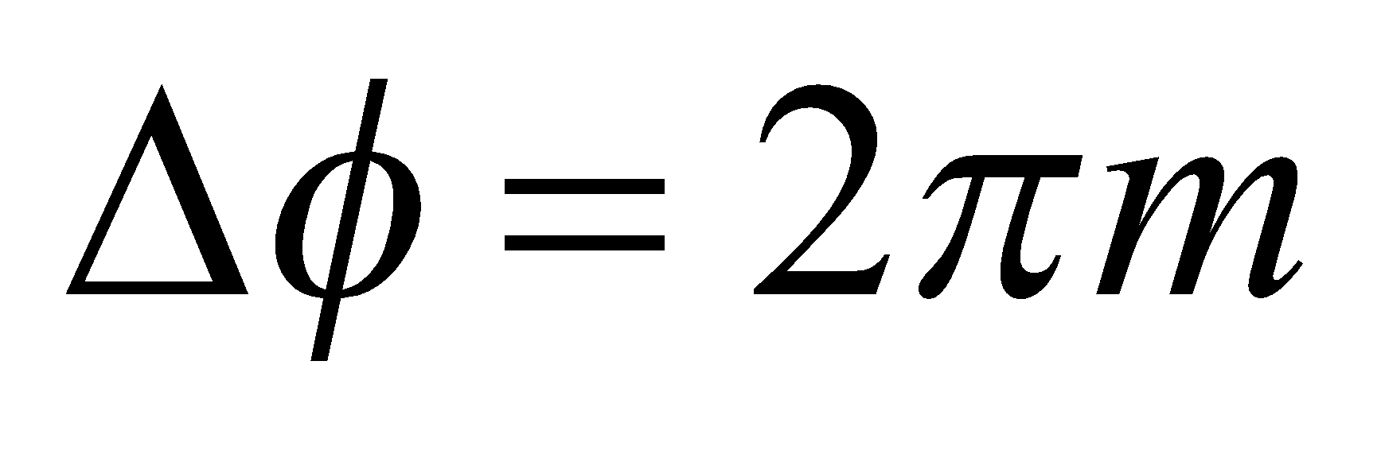, or 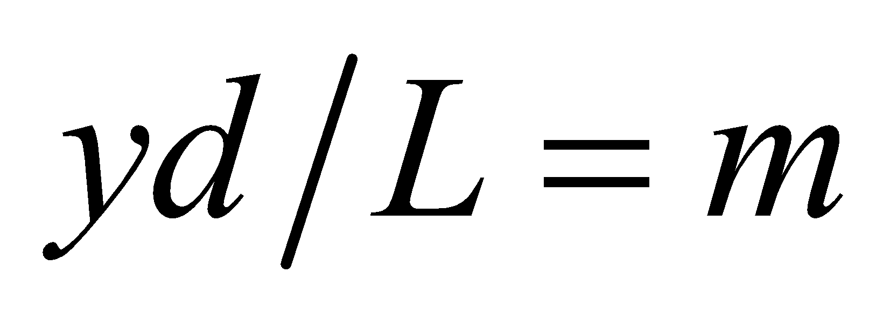, where *m* is an integer.

**36.** **Interpret** This problem involves a double-slit experiment with the given parameters, for which we are to find the angular position at which the path-length difference is a quarter wavelength.

**Develop** The path-length difference is the left side of Equation 32.1a (i.e., *d*sin*θ*), so we shall set this equal to a quarter wavelength and solve for the angle *θ*.

**Evaluate** Solving for q and inserting the given quantities yields

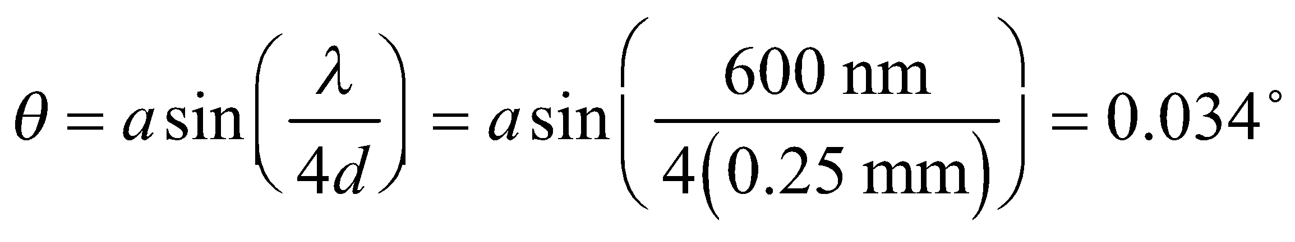

**Assess** We could have simplified the calculation by using the small-angle approximation sin*θ* ~ *θ*, which gives the same result.

**37. Interpret** This problem involves a double-slit experiment. Given the slit spacing, we are asked to find the highest-order bright fringes.

**Develop** The maximum diffraction angle for which light hits the screen is

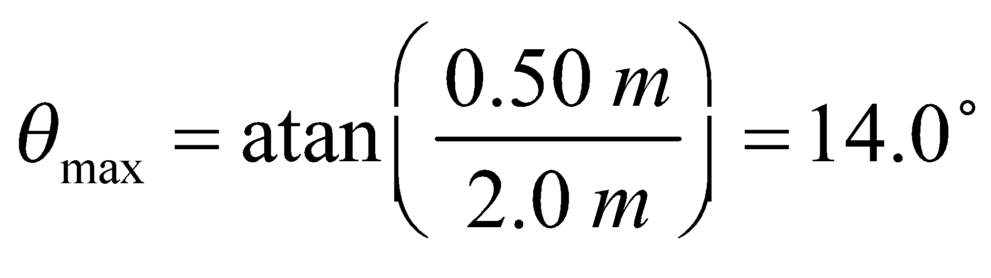

From Equation 32.1a, we know that bright fringes will appear on the screen in orders of interference for which

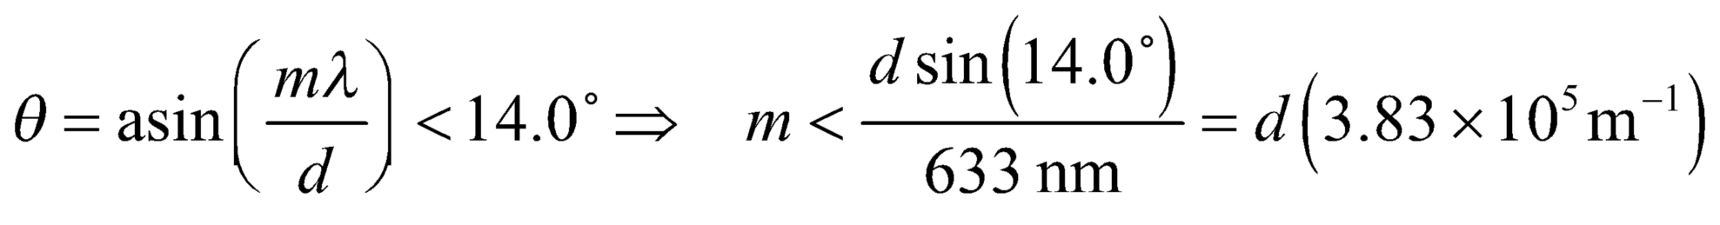

**Evaluate** **(a)** For d = 0.10 mm, 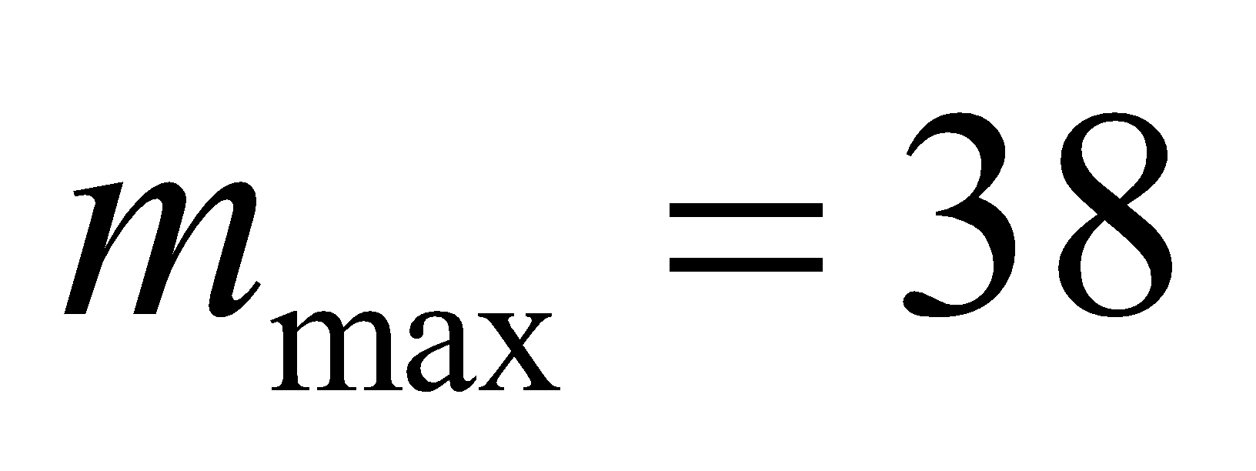.

**(b)** For 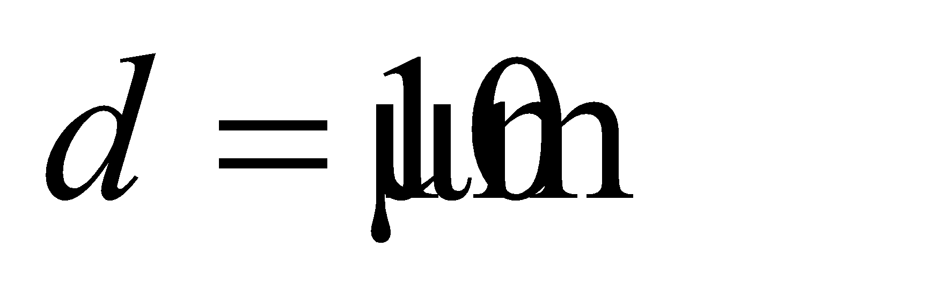, 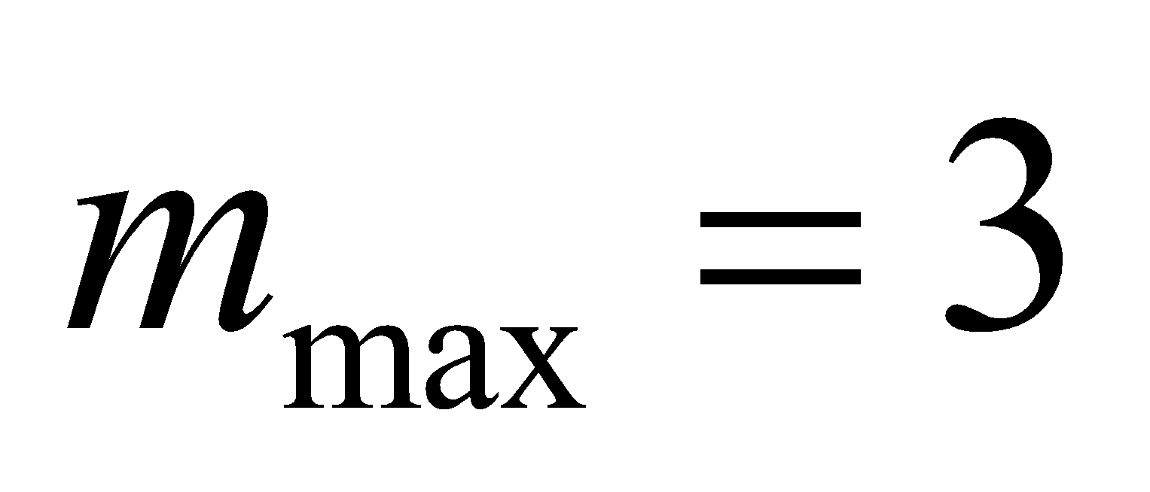.

**Assess** The maximum order  increases as the slit spacing *d* decreases.

**38. Interpret** Our light source for the double-slit experiment has two wavelengths. For the lowest order bright fringe, we are to find the angular position where interference is constructive for one wavelength and destructive for the other.

**Develop**  In a double-slit apparatus of the type described in the text, for a bright fringe of order *m*1 from wavelength *λ*1 to have the same angular position as a dark fringe of order *m*2 from wavelength *λ*2, we must have (see Equations 32.1a and 32.1b)

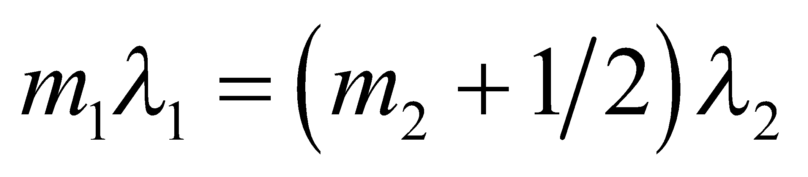

For *λ*1 = 550 nm and *λ*2 = 400 nm, one finds

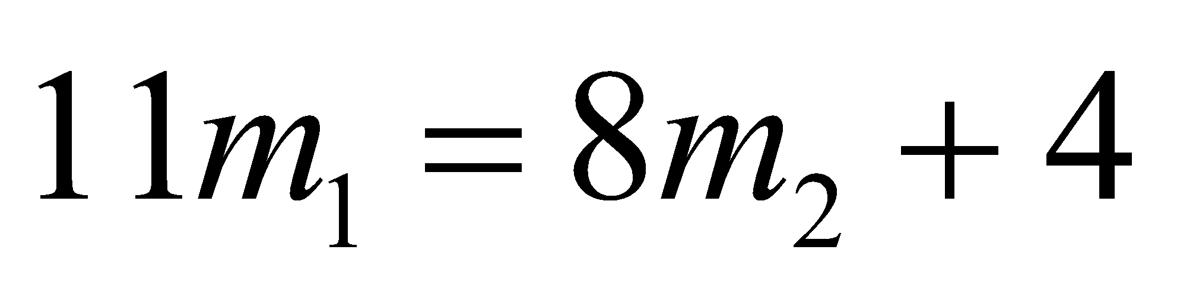

**Evaluate** By inspection, the smallest integer values satisfying this condition are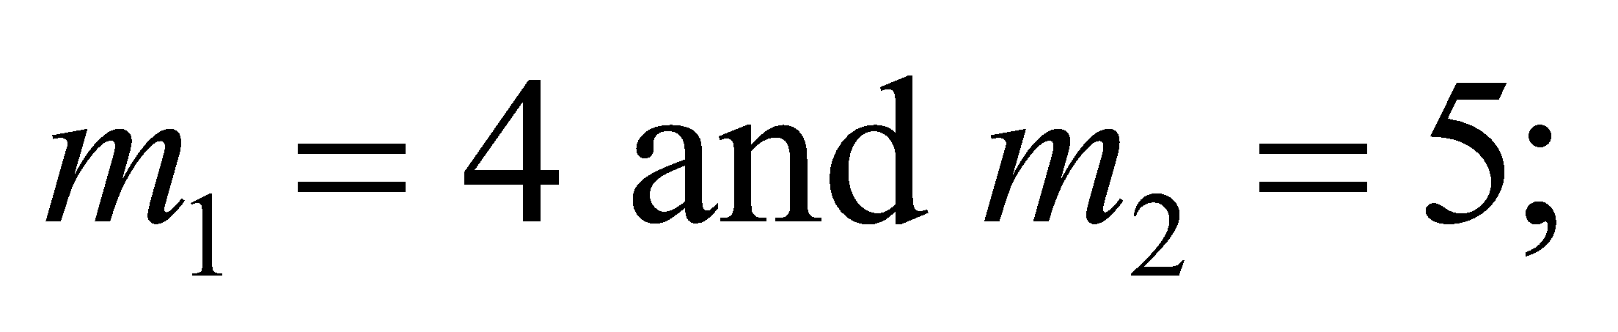that is, the fourth bright fringe of wavelength 550 nm coincides with the sixth dark fringe of wavelength 400 nm (recall that the first bright fringe has *m* = 1, whereas the first dark fringe has *m* = 0).

**Assess** This problem demonstrates the role played by the wavelength in determining the nature of the interference at an angular position.

**39.** **Interpret** This problem involves a multiple-slit apparatus. We are given the number of dark fringes between two adjacent major maxima, and are asked to find the number of slits in the apparatus. We are also to find the slit separation given.

**Develop** From Figure 32.8, we see that an N-slit system has 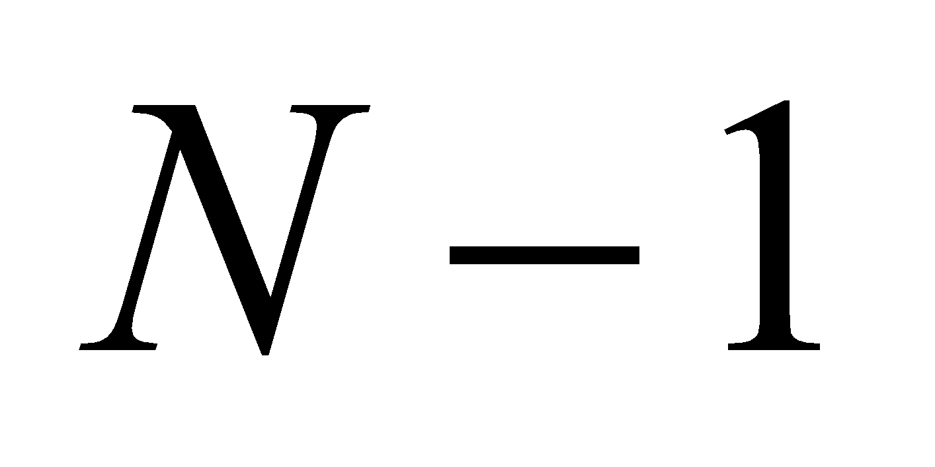 minima between the major maxima. The position of the maxima is governed by Equation 32.1a, which for small angles takes the form

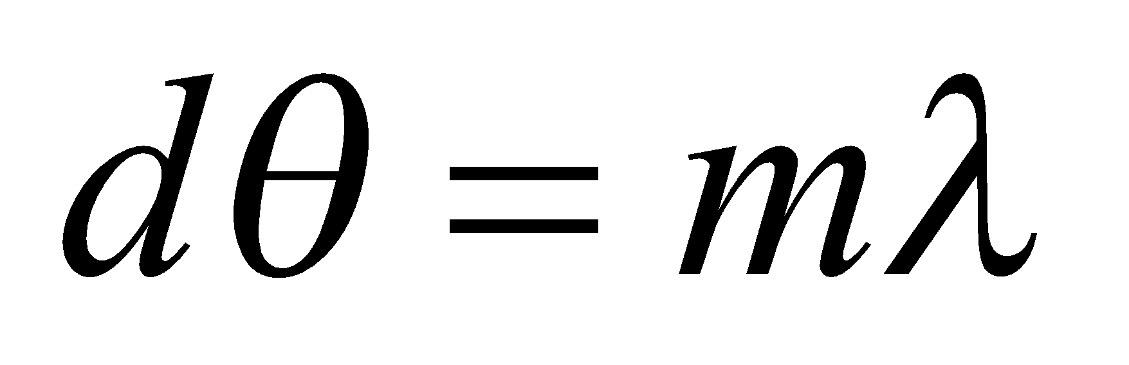

The angular separation between adjacent maxima (i.e., between m = n and m = n + 1) is

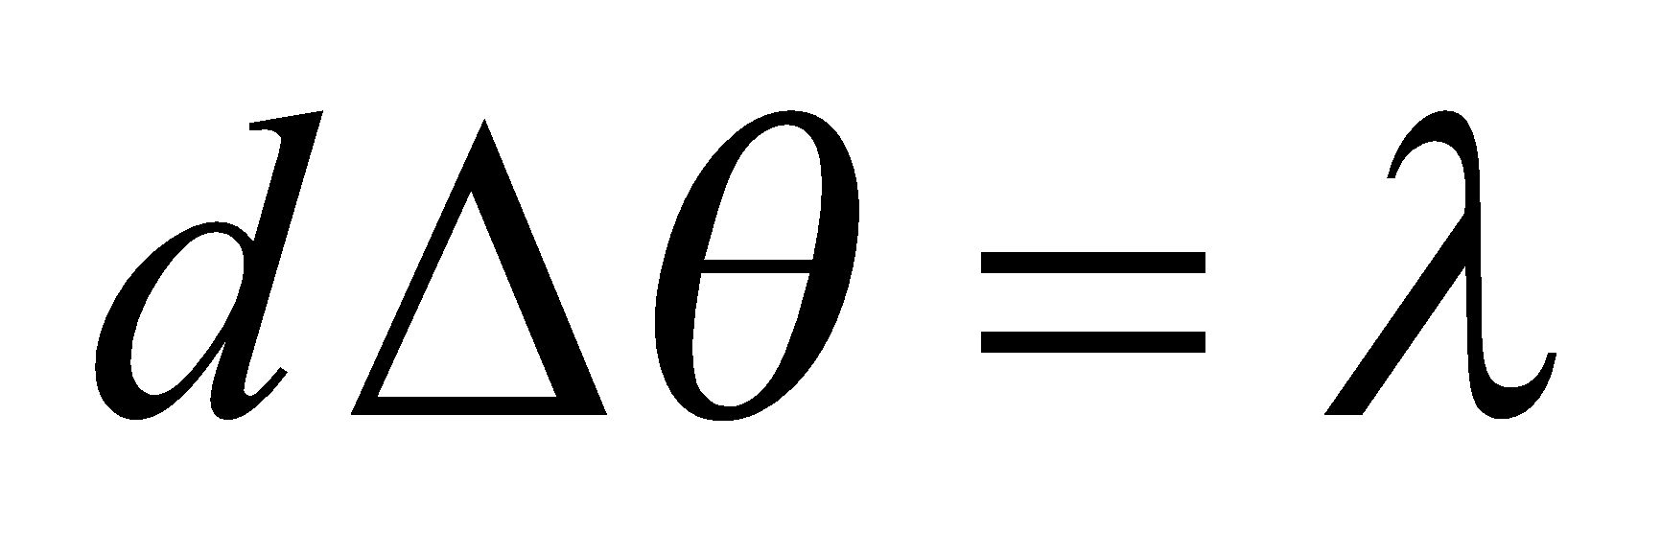

The angular separation is 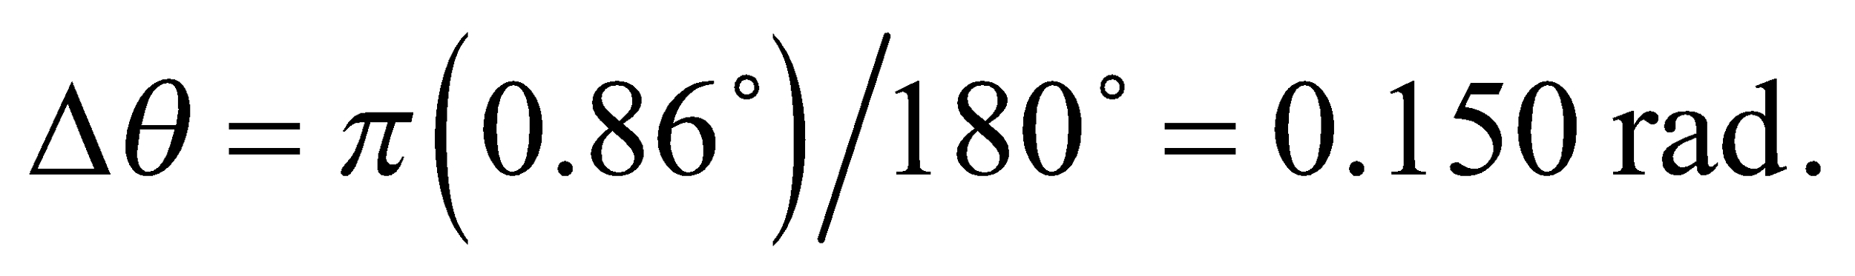

**Evaluate** (**a**) For 7 minima, we have *N* – 1 = 7, we have *N* = 8 slits.

(**b**) The slit separation is

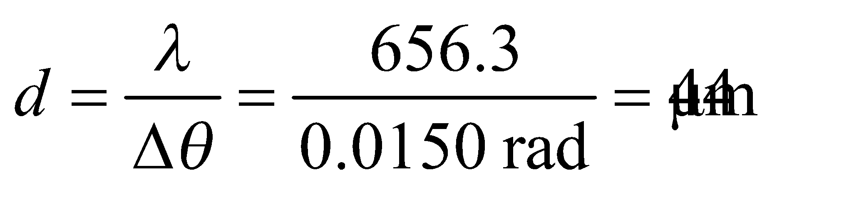

**Assess** The result is given to two significant figures because the angular separation *Δθ* is given to that precision. The angle in radians has 3 significant figures because it is an intermediate result.

**40. Interpret**  You're determining the slit (line) spacing needed for a new spectrometer.

**Develop** You need at least an angular separation of 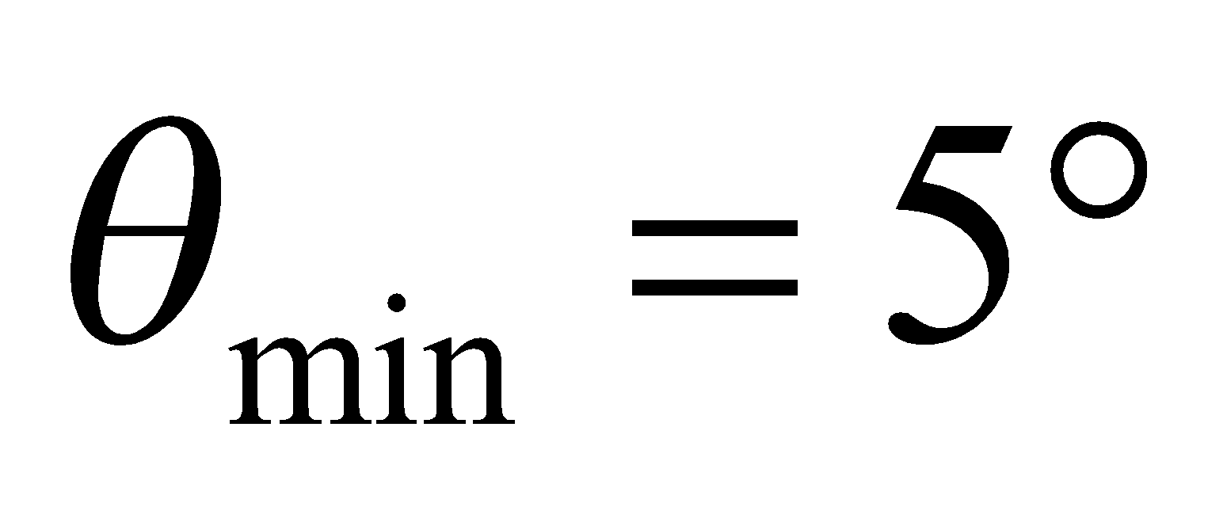 between the third-order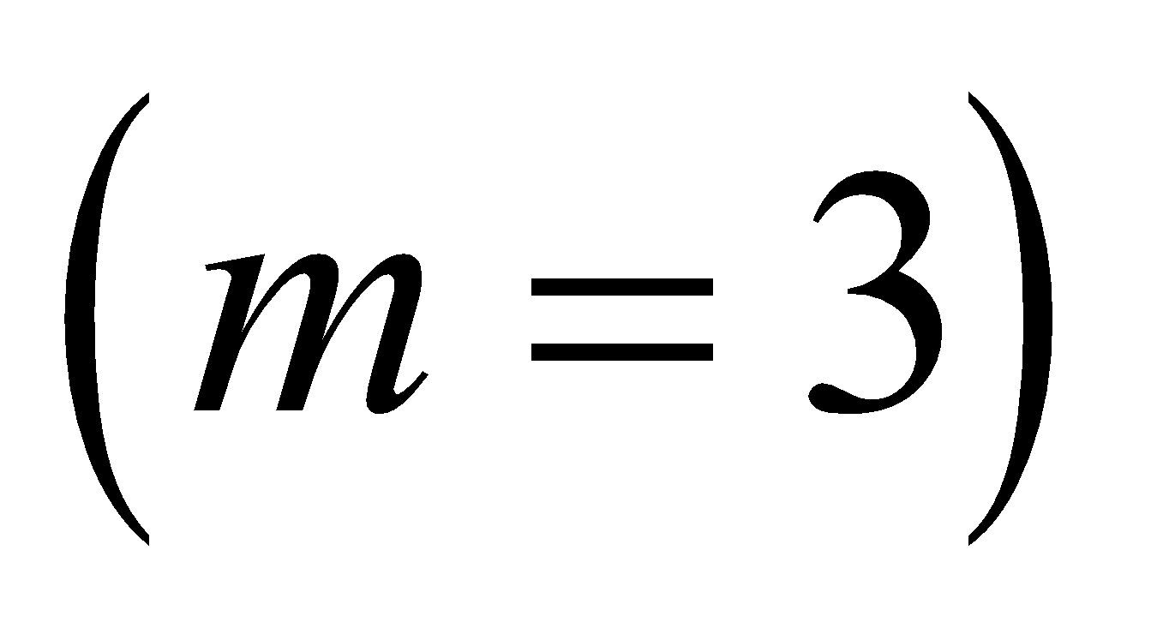 lines of hydrogen and sodium, specifically: 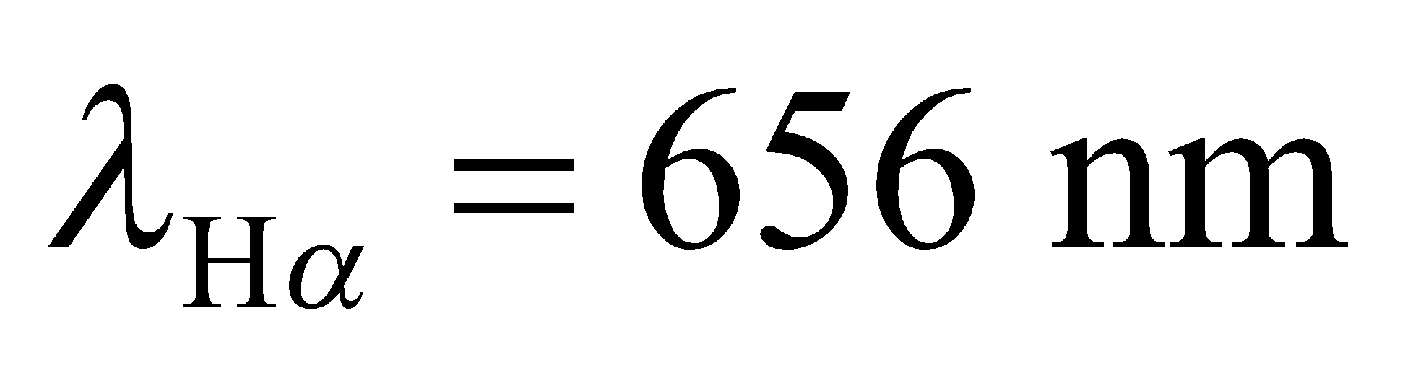 and 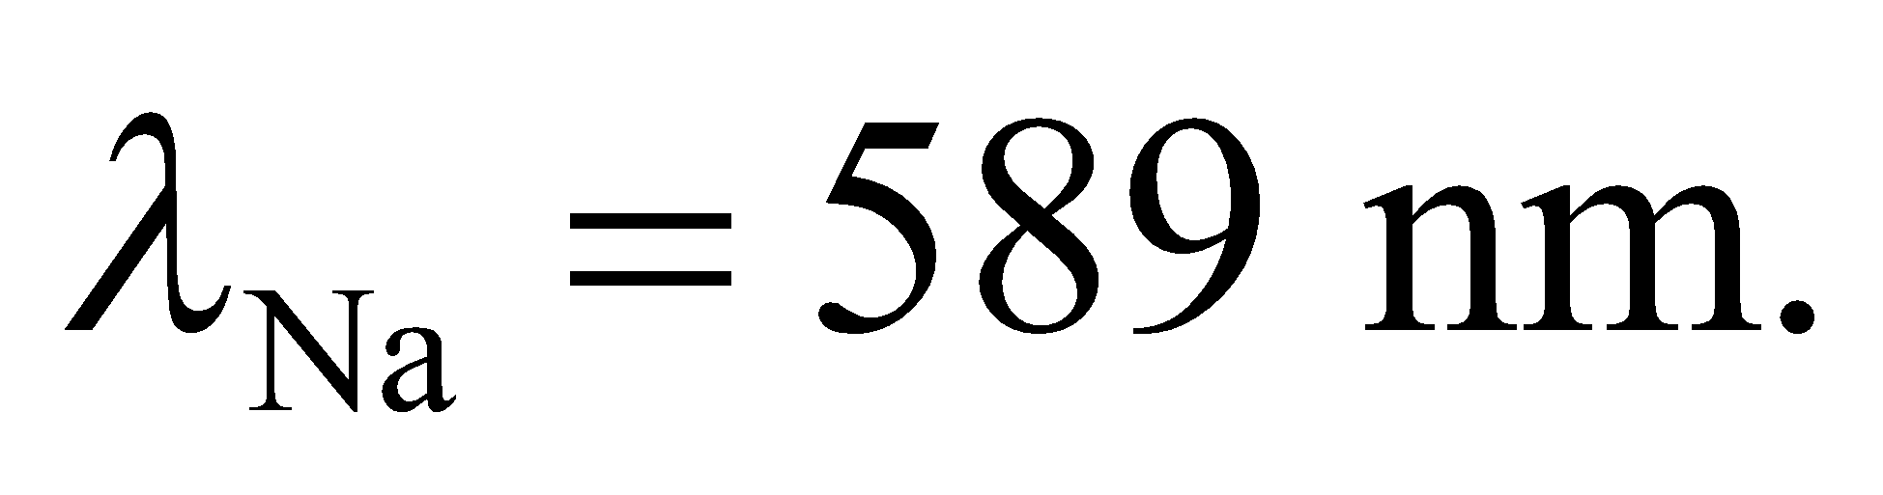 The angle of each these lines will satisfy Equation 32.1a:

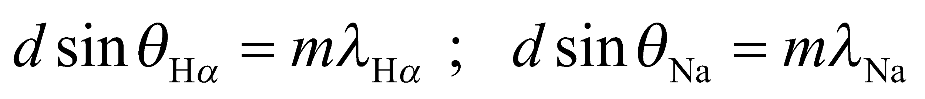

We will use these equations and the fact that 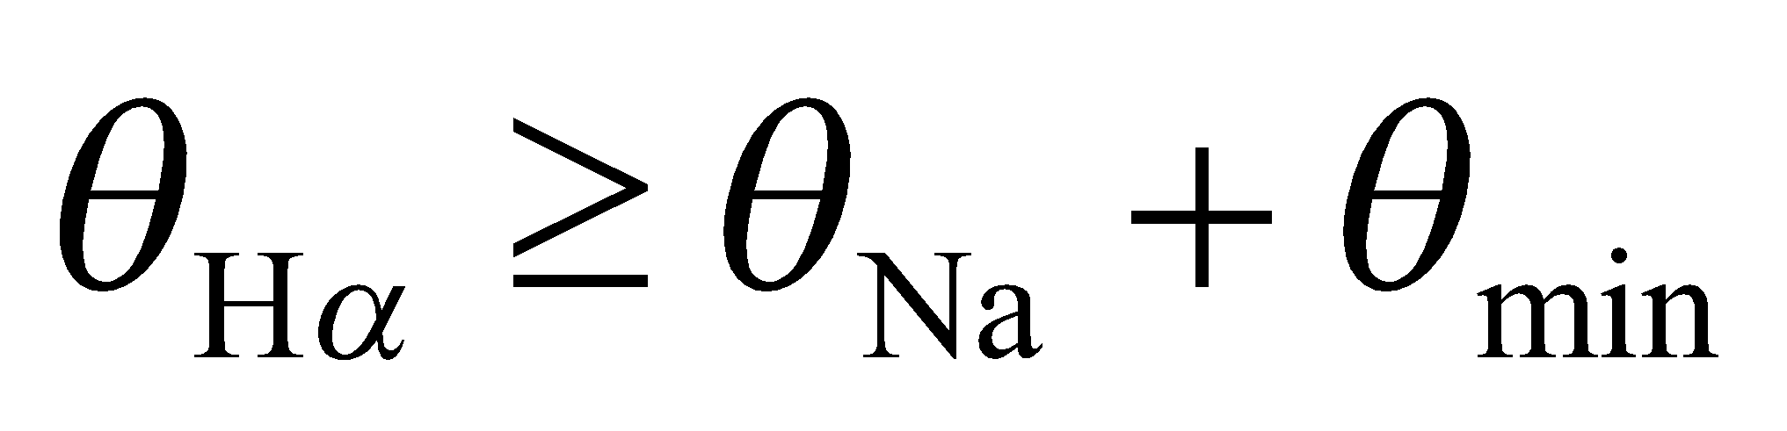to solve for the slit spacing, *d*. The number of slits (or lines) per cm is just the inverse of this, 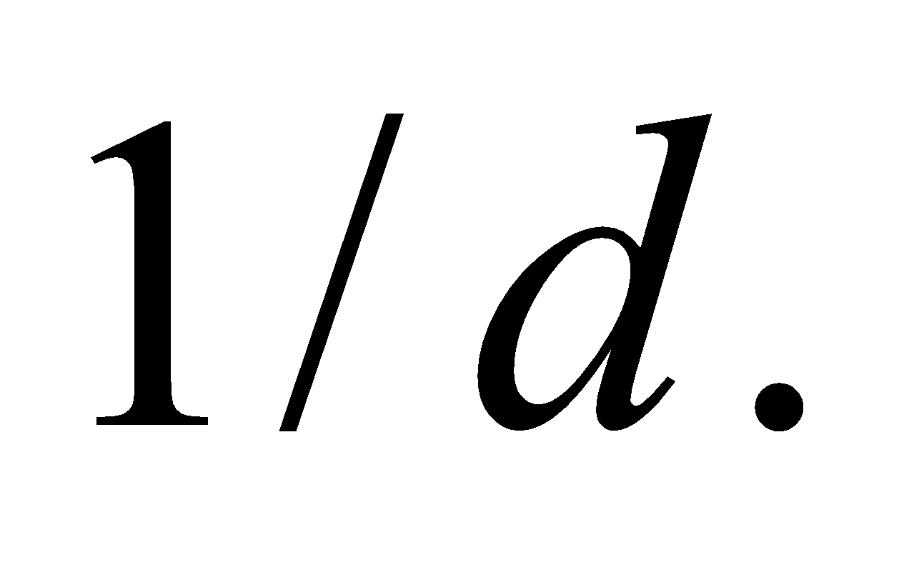

**Evaluate** For the given pupil diameter and light wavelength, the resolution is



In terms of degrees, this is about 0.02°, or about 1 arcminute.

**Assess** We first eliminate one of the unknown angles with a trig identity from Appendix A:



We can plug in 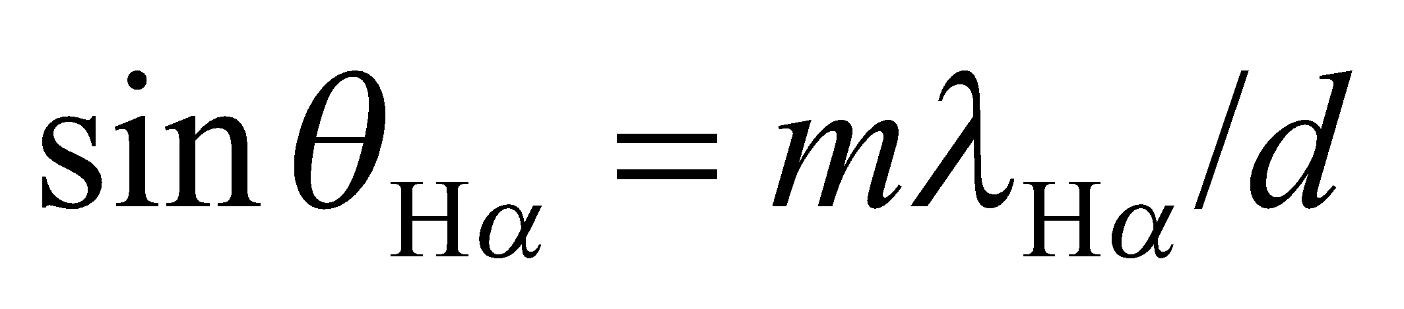 and 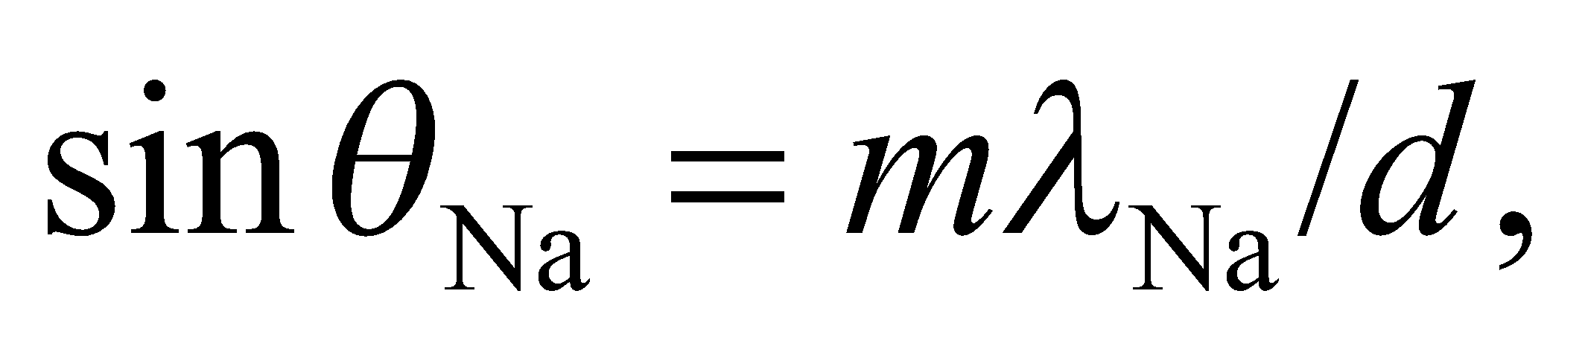 and use the fact that 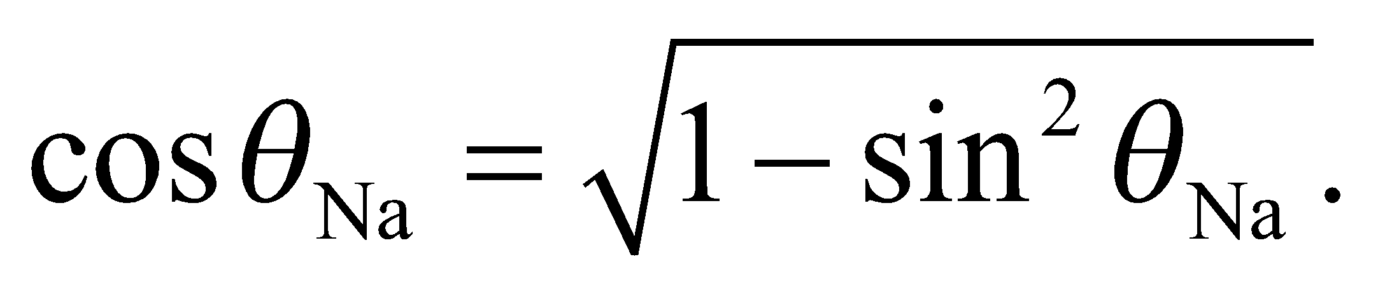 With some algebra, we arrive at:

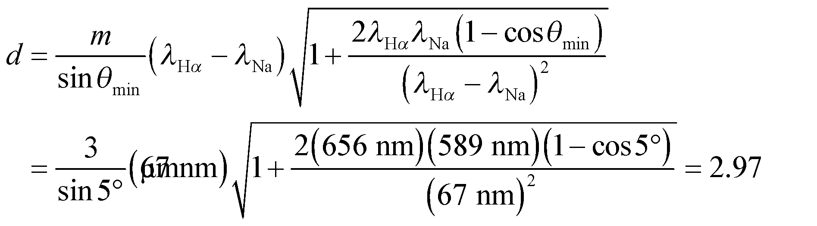

The inverse of this is 3370 lines/cm, so the coarsest grating you could use is the one with 3500 lines/cm.

**Assess** Notice that for a small minimum angle, the spacing equation simplifies to 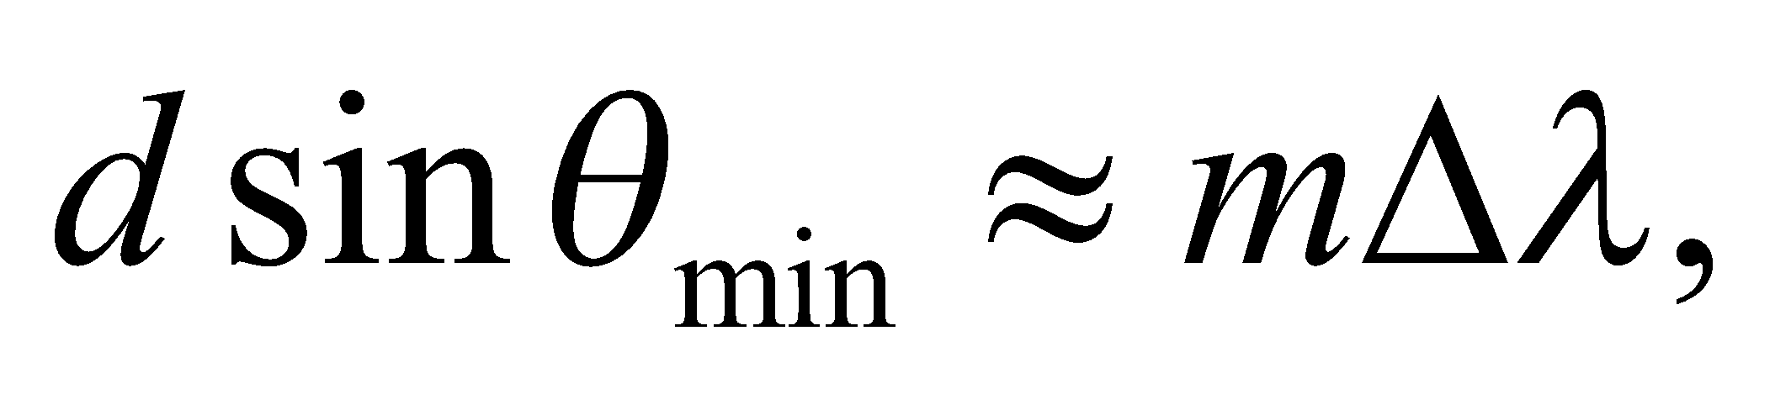 where 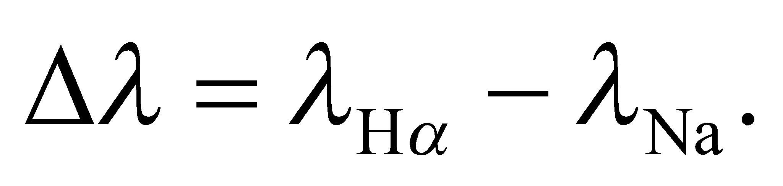This makes it clear that in order to increase the angular separation of two nearby spectral lines, one must use a spectrometer with more slits or gratings per cm.

**41.** **Interpret**  We're asked to show that the only order where the visible spectrum doesn't overlap itself is the first order.

**Develop** Within a given order, *m*, the spectral lines in the visible region stretch from the angle 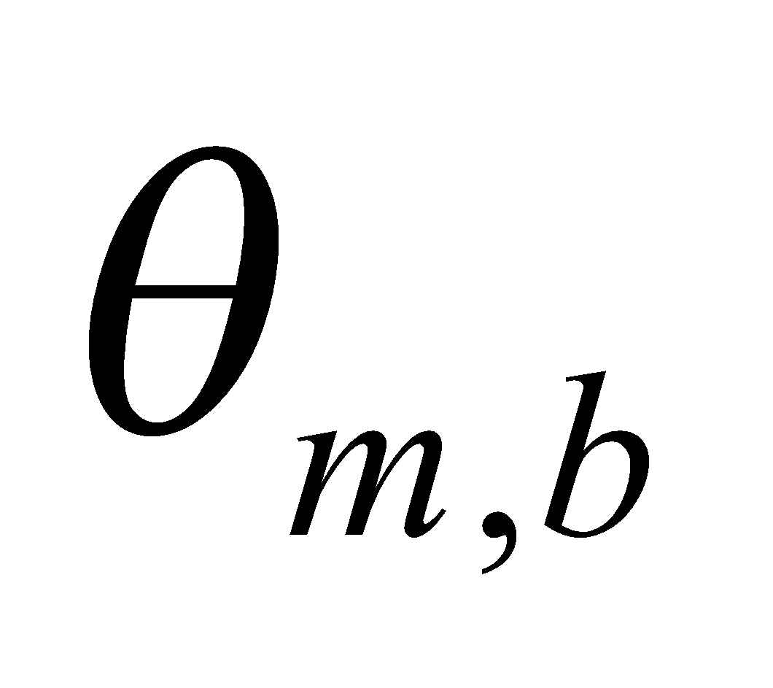for the blue wavelength, and 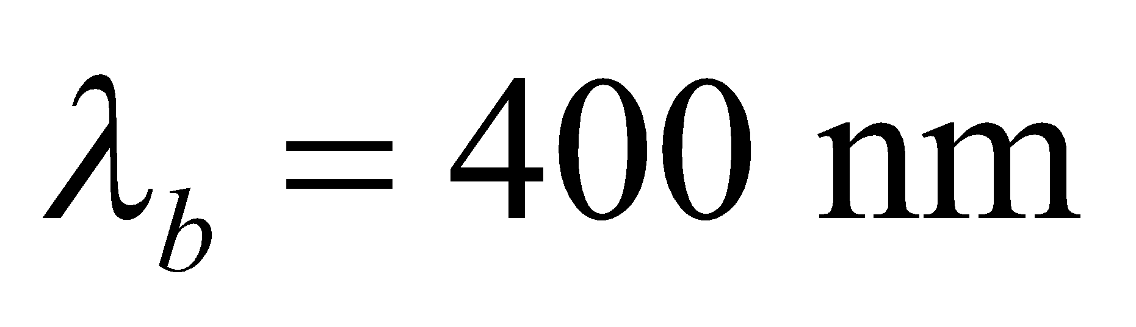 to the angle 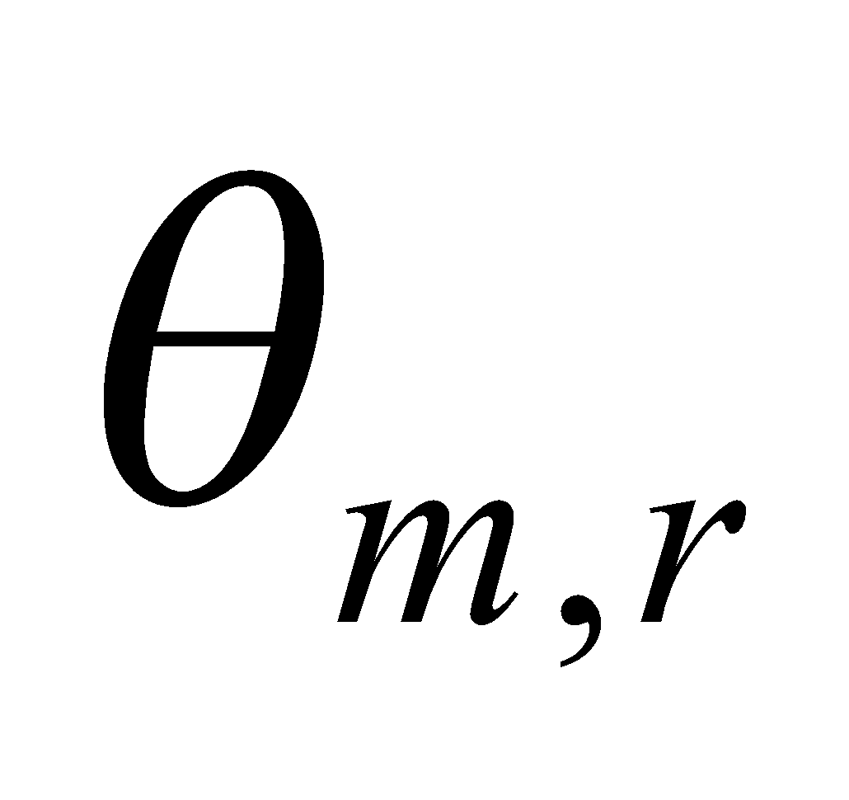for the red wavelength 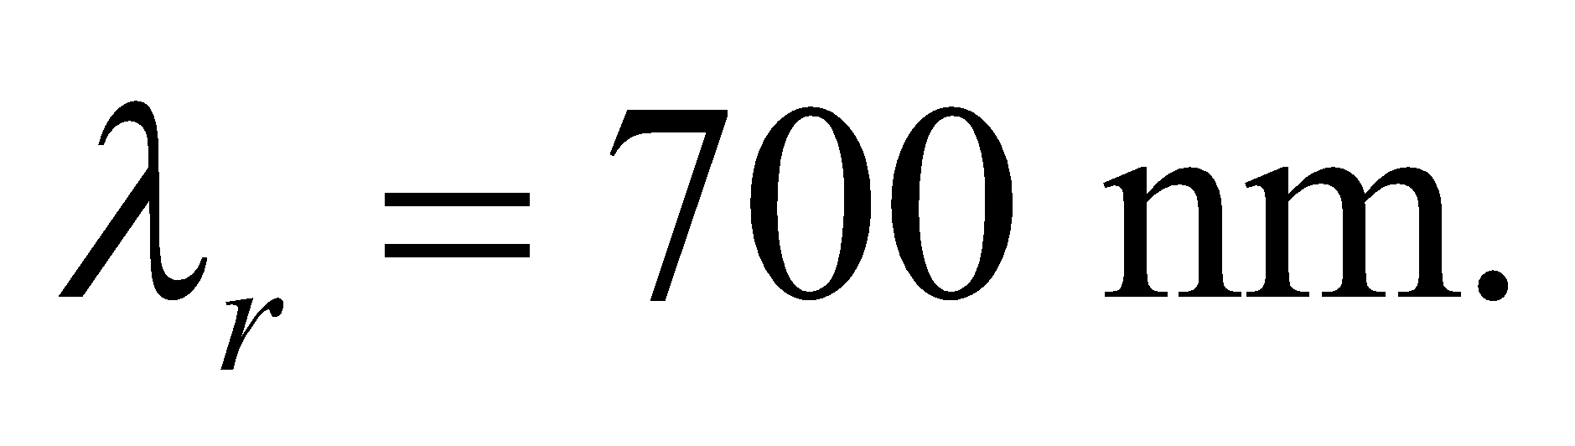 Each of these angles satisfies Equation 32.1a: 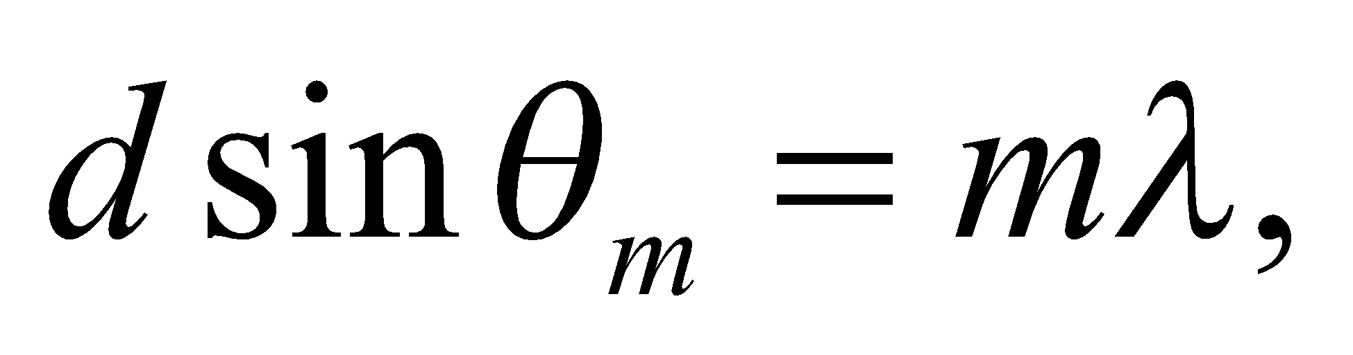 so 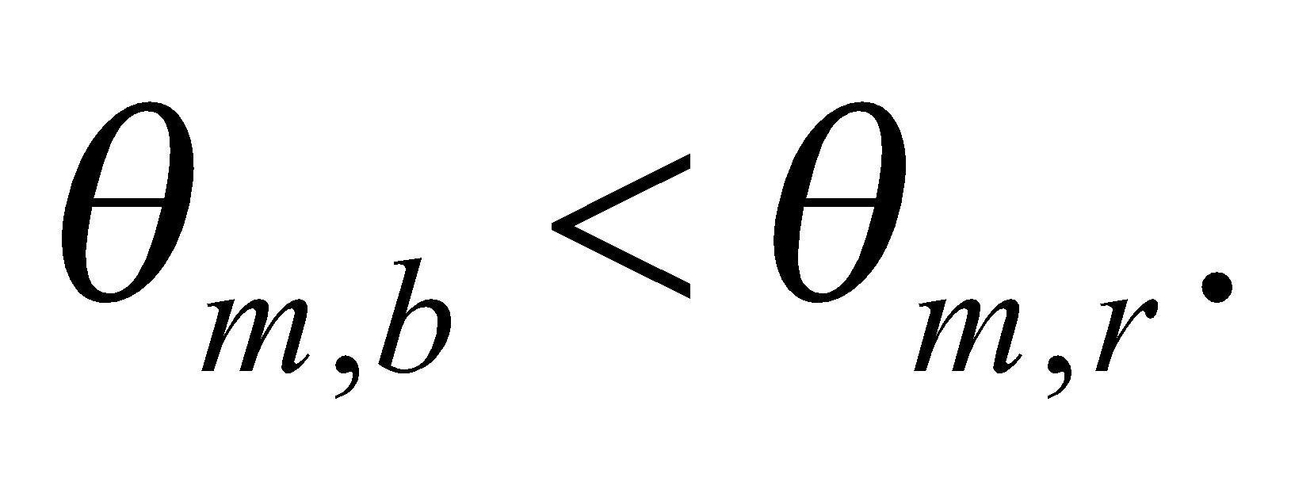 Overlap will occur when the blue spectral line of the 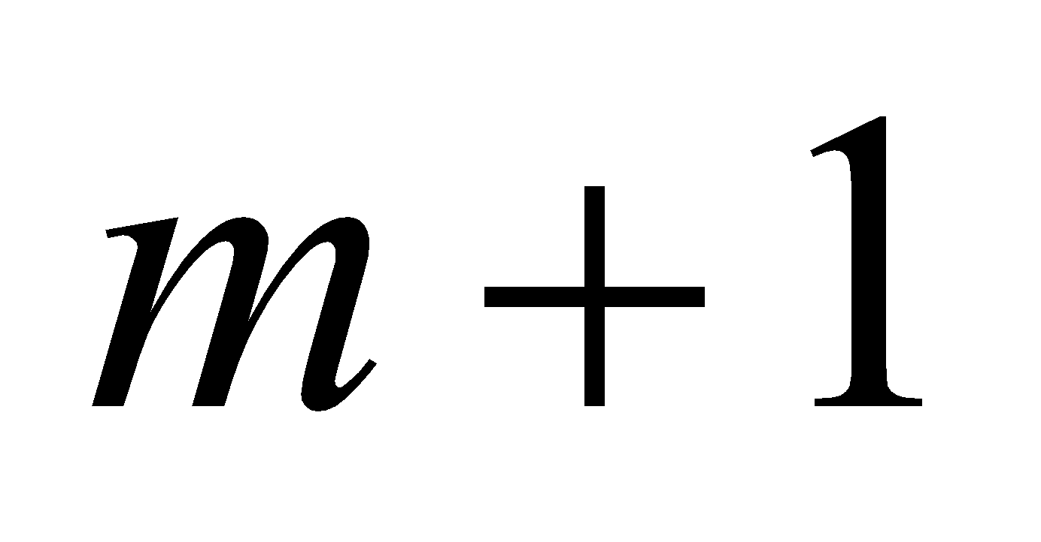 order occurs at an angle smaller than the red spectral line of the *m* order: 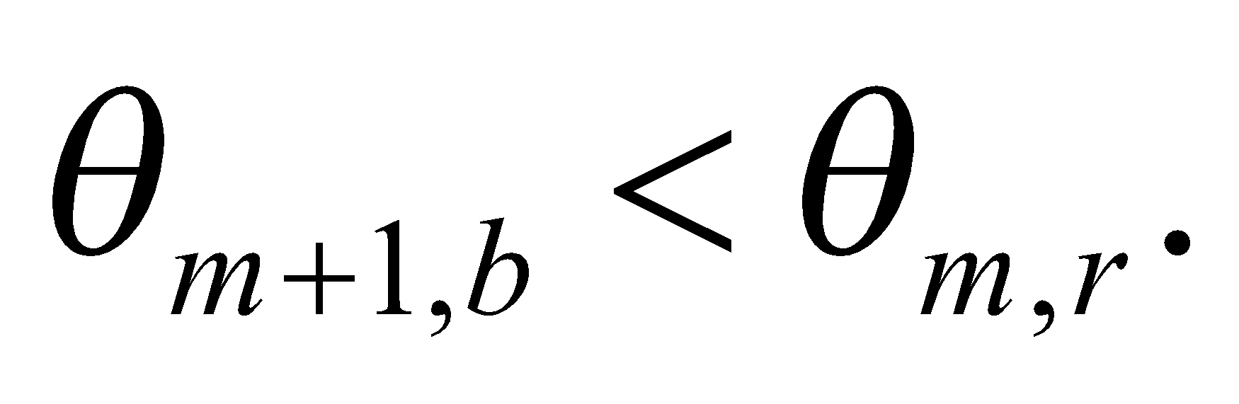

**Evaluate** If 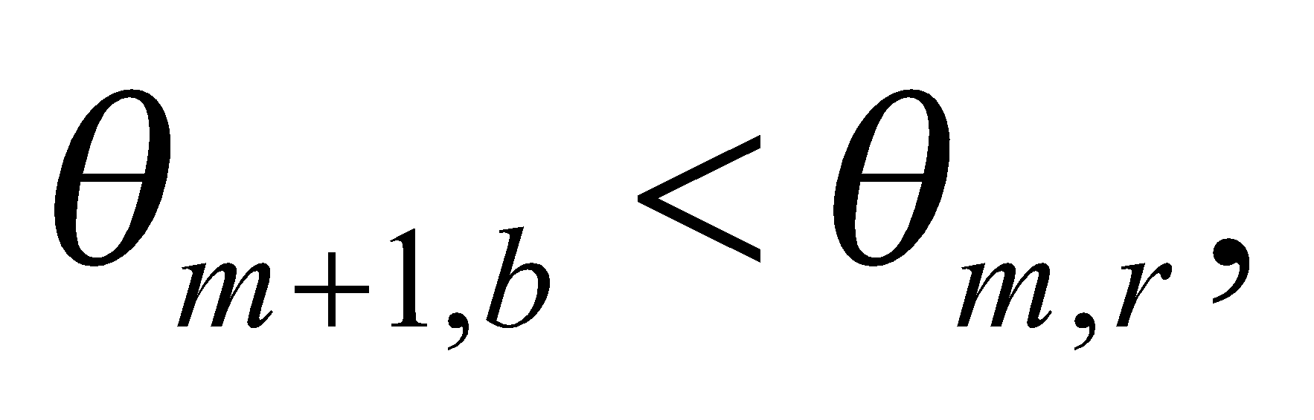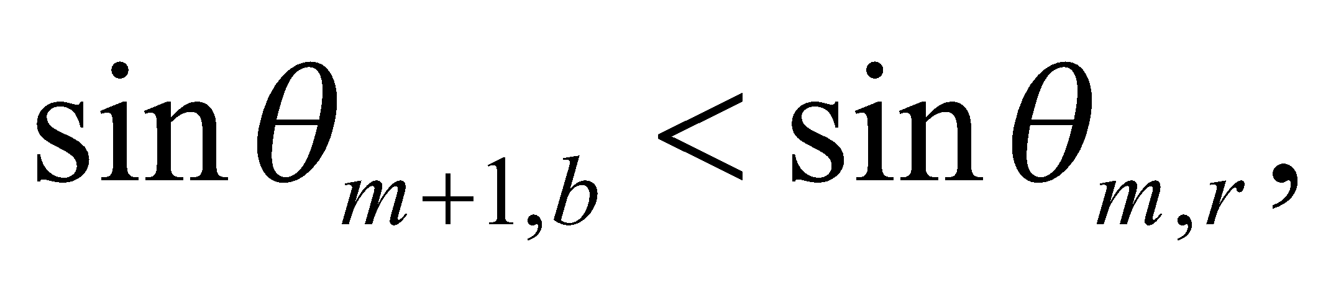and

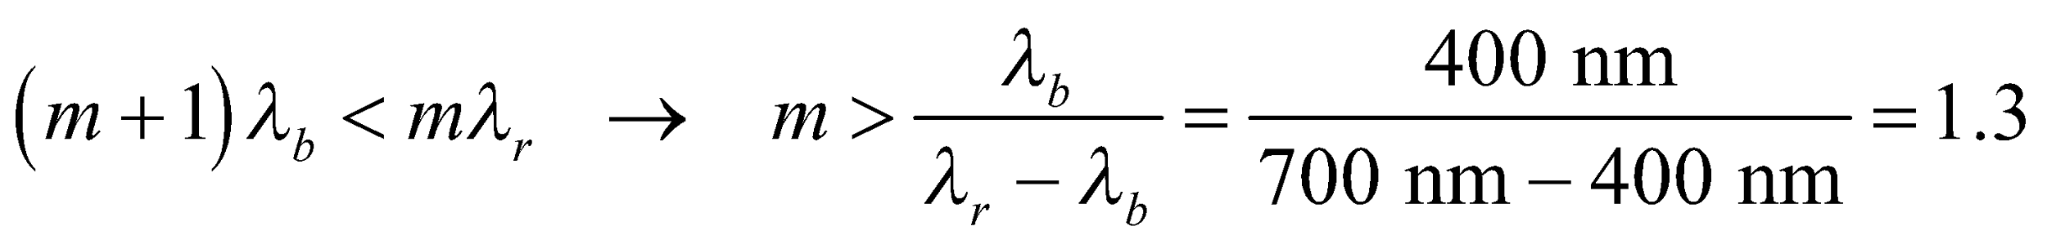

This says that there's no overlap for the first order, but there will be overlap for the second order and above.

**Assess** We can verify that there is overlap in the second order. The 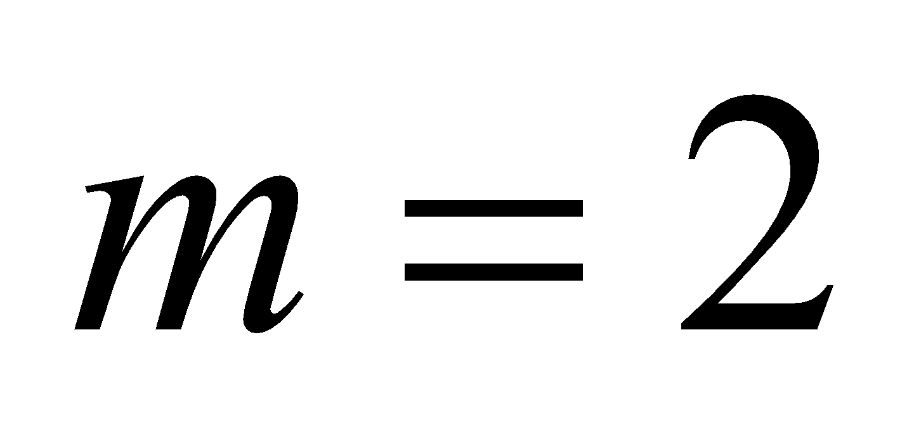 red line occurs at 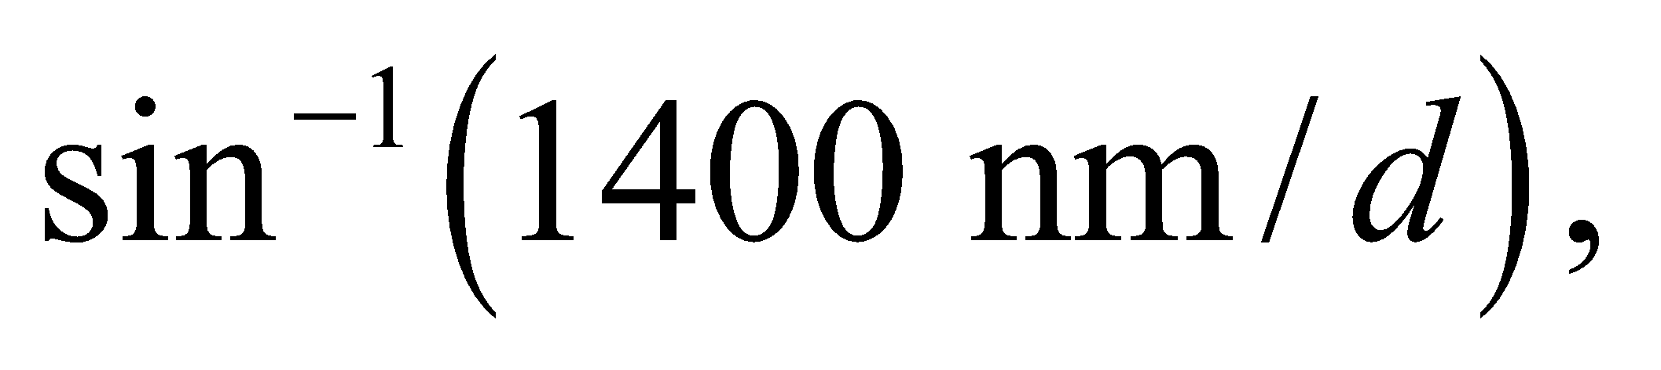 whereas the 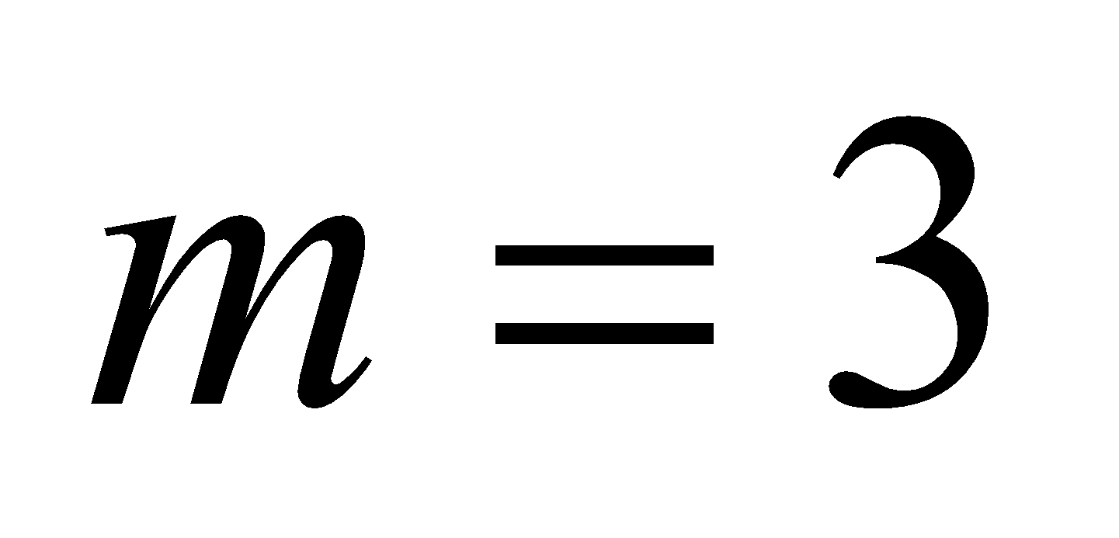 blue line occurs at 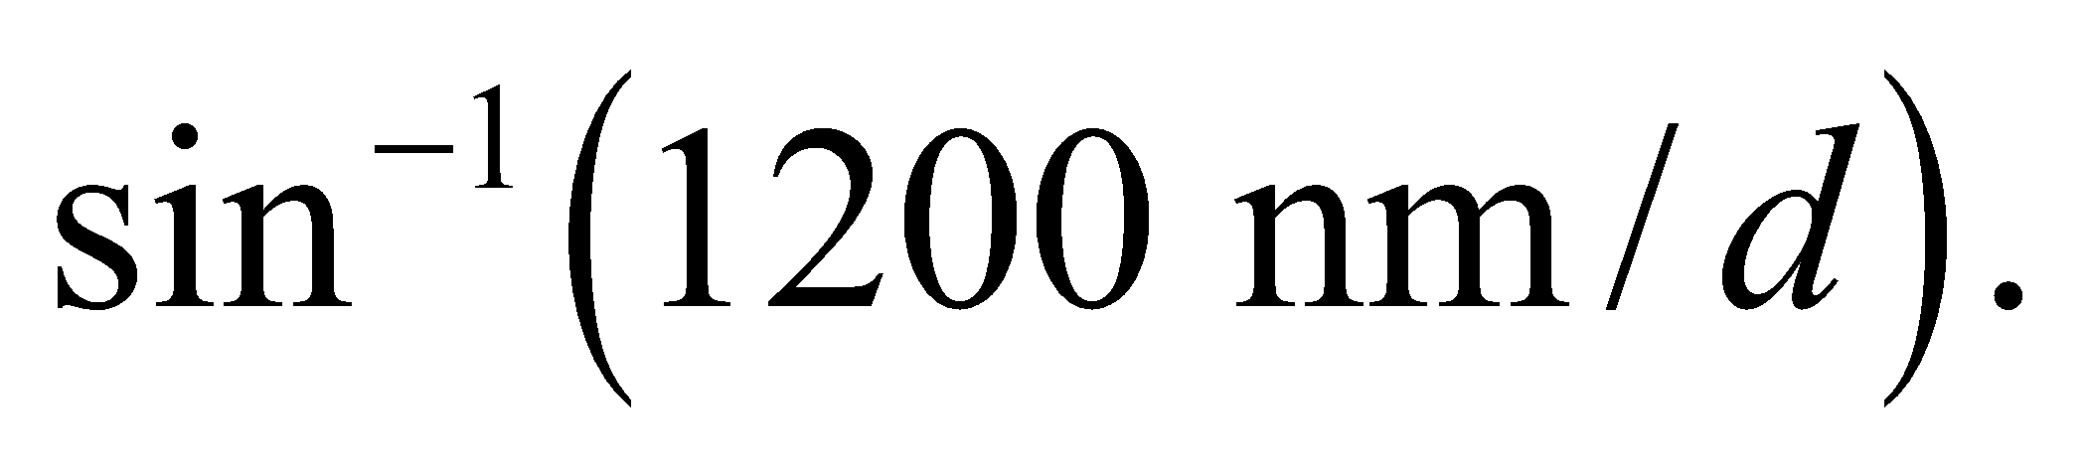 Therefore, 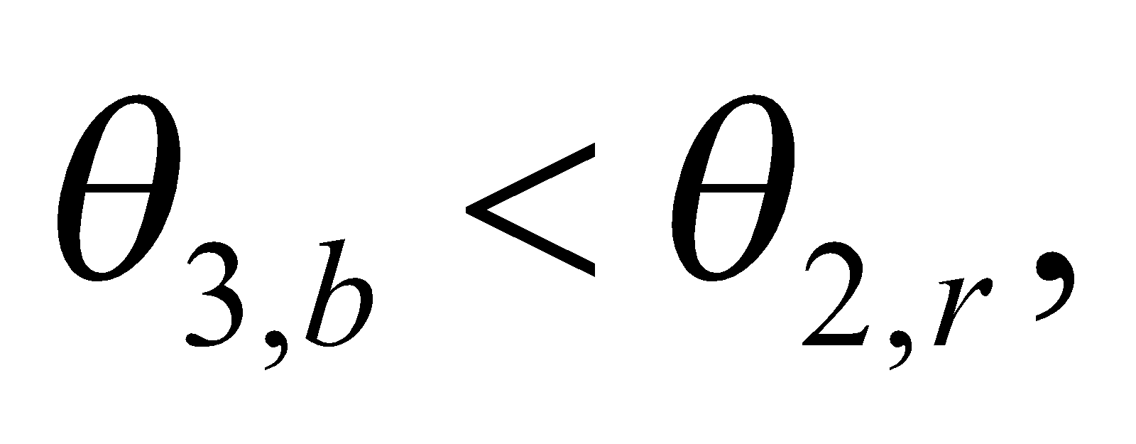which means the second and third orders overlap.

**42.** **Interpret** This problem involves a grating diffractometer for which we are to find the total number of lines in the grating that will give the desired angular separation between the central peak and the third-order peak.

**Develop** The grating condition for normally incident light (same as Equation 32.1a) and the given data imply a grating spacing of 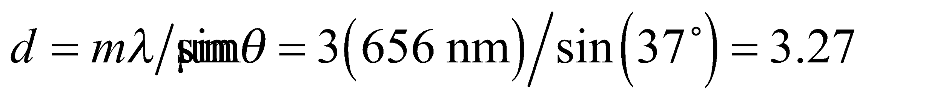 or a grating constant of 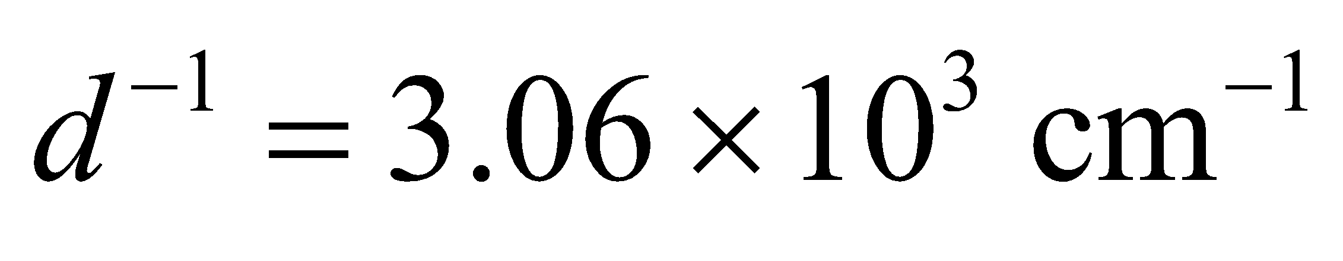.

**Evaluate** On a grating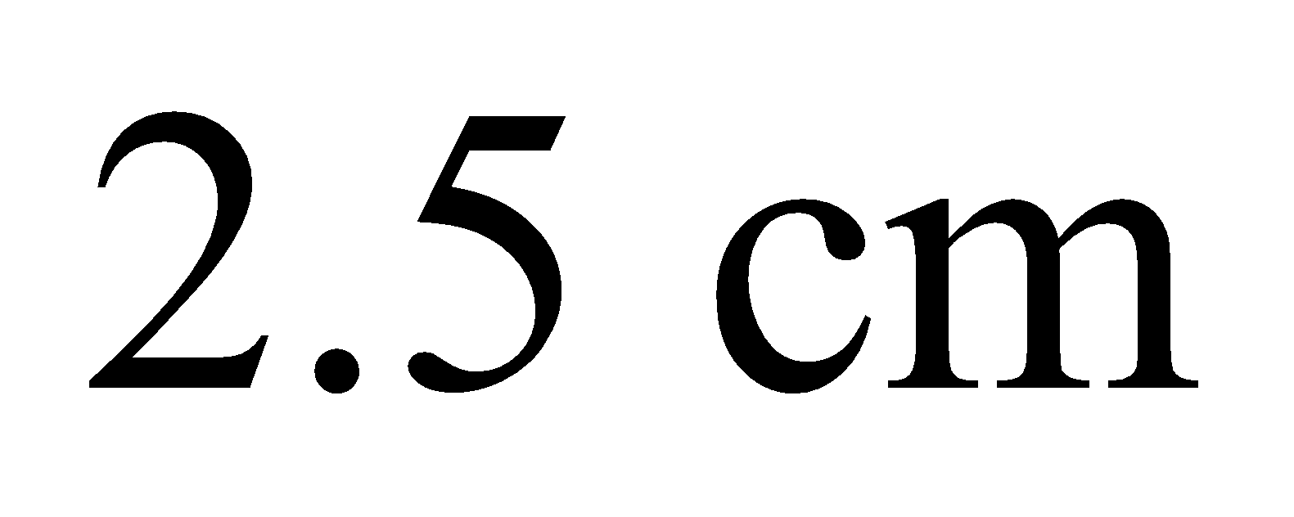wide, the total number of lines is 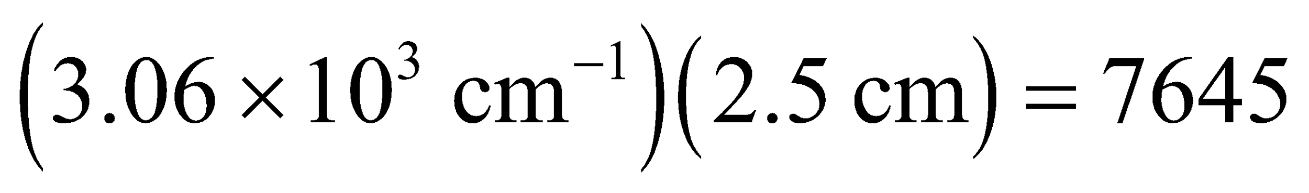, to within a hundredth of a line.

**Assess** This grating spacing is typical of visible-light spectrometers.

**43.** **Interpret** We are to find the diffraction order necessary to resolve (i.e., separate) two closely spaced spectral lines.

**Develop** From Equation 32.5, wavelengths can be resolved if

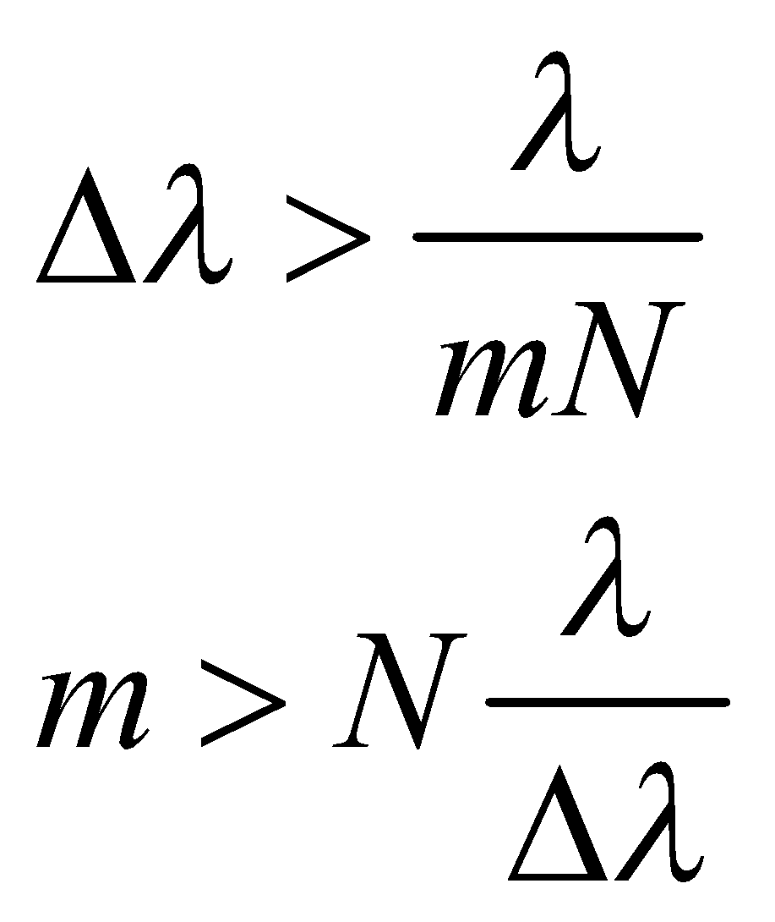

where Δλ = 648.07 – 647.98 nm = 0.090 nm and *N* = 4500.

**Evaluate** The requisite order is

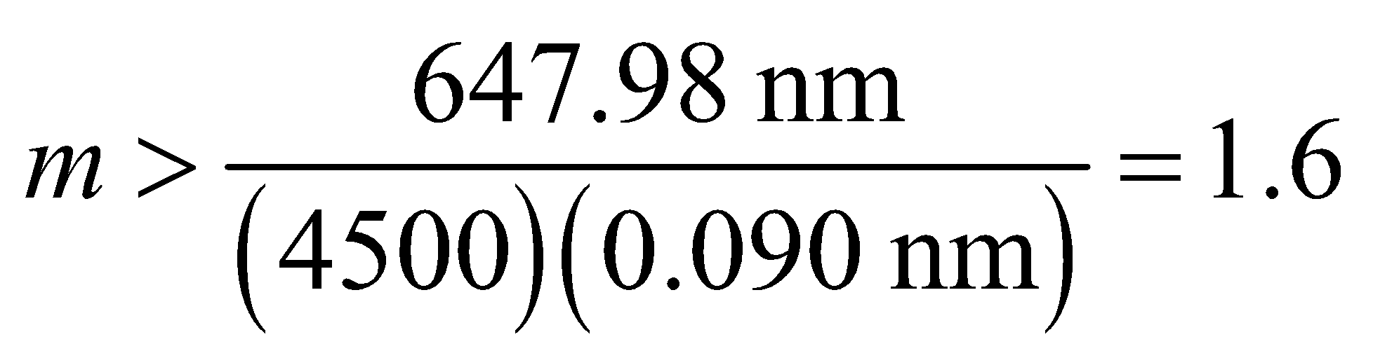

So the second or higher order is required to resolve these spectral lines.

**Assess** Note that *N* is a dimensionless number, so the dimensions work out in the expression for the minimum order number.

**44. Interpret** This problem is about thin-film interference. Three media involved are toluene, water, and air. We are to find the film thickness of toluene on water that results in the maximum reflectance of the given wavelength.

**Develop** Since 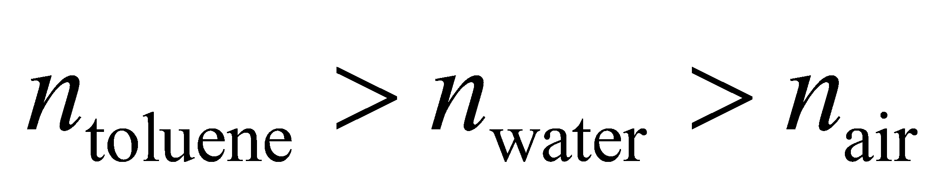 there is a 180° phase change for reflection at the air-toluene interface and no phase change at the toluene-water interface (see Figure 32.12). Equation 32.7 thus applies for constructive interference (of normally incident rays):



**Evaluate** Solving for the thickness *d*, we get

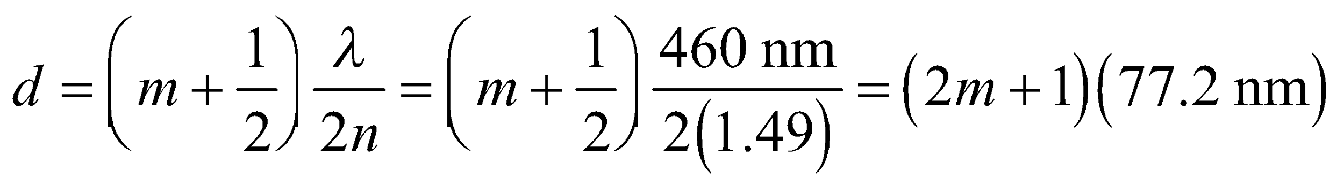

The minimum thickness is for *m* = 0, so *d*min = 77.2 nm.

**Assess** The typical thickness of a thin film is on the order of 100 nm. Thin-film interference accounts for the bands of color seen in a soap film or oil slick. Note that odd multiples of our result will also give the desired maximum reflectance at 460 nm.

**45. Interpret**  You're assessing the feasibility of resolving Earth-sized planets with a single space telescope.

**Develop** You can assume that resolving the planet means roughly that it's angular extent in the sky is at least equal to the diffraction limit of the proposed telescope. The angular extent of an Earth-sized planet at a distance of *L* is 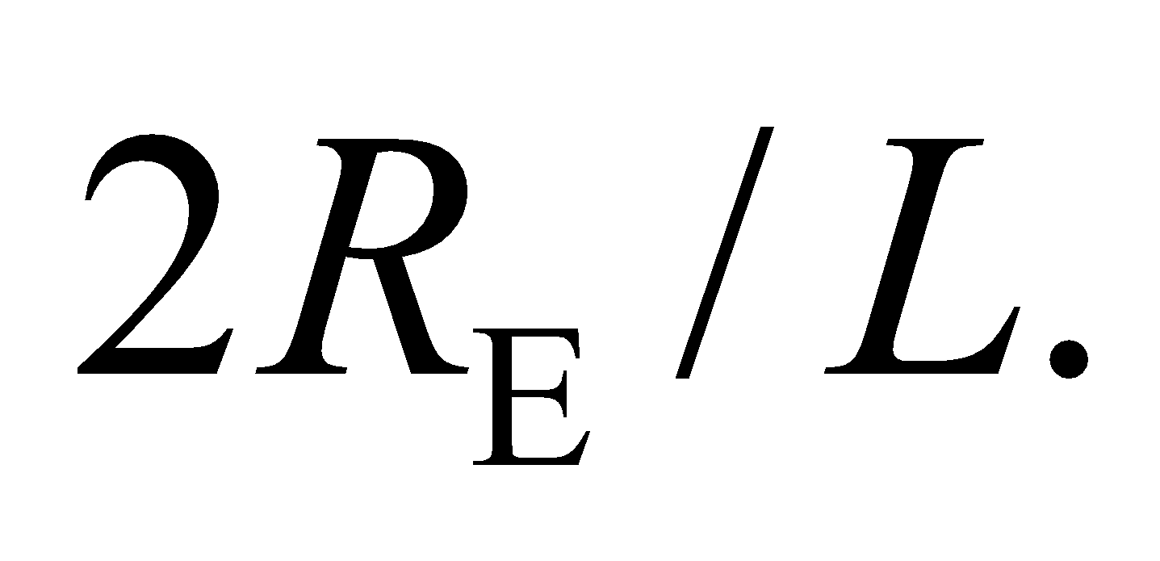 Equating this to Rayleigh criterion in Equation 32.11b gives for the minimum telescope diameter:

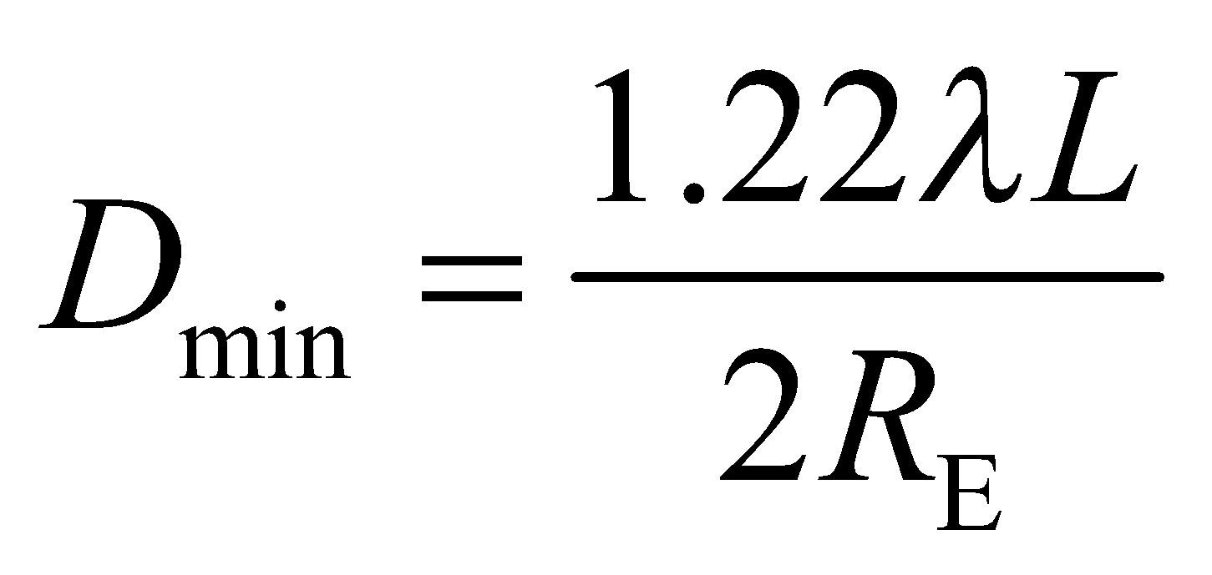

**Evaluate** Our equation says that the smaller the wavelength we use, the smaller the telescope has to be. So you might as well choose the lower limit of the optical wavelengths: 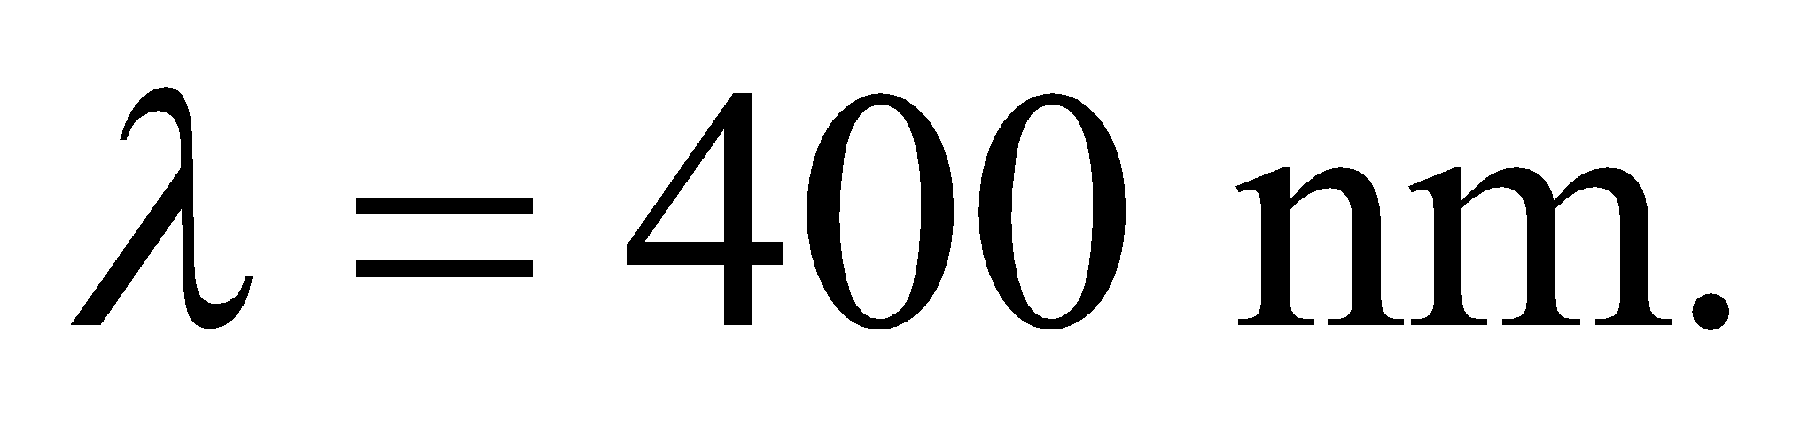 As such, the telescope diameter needed would be

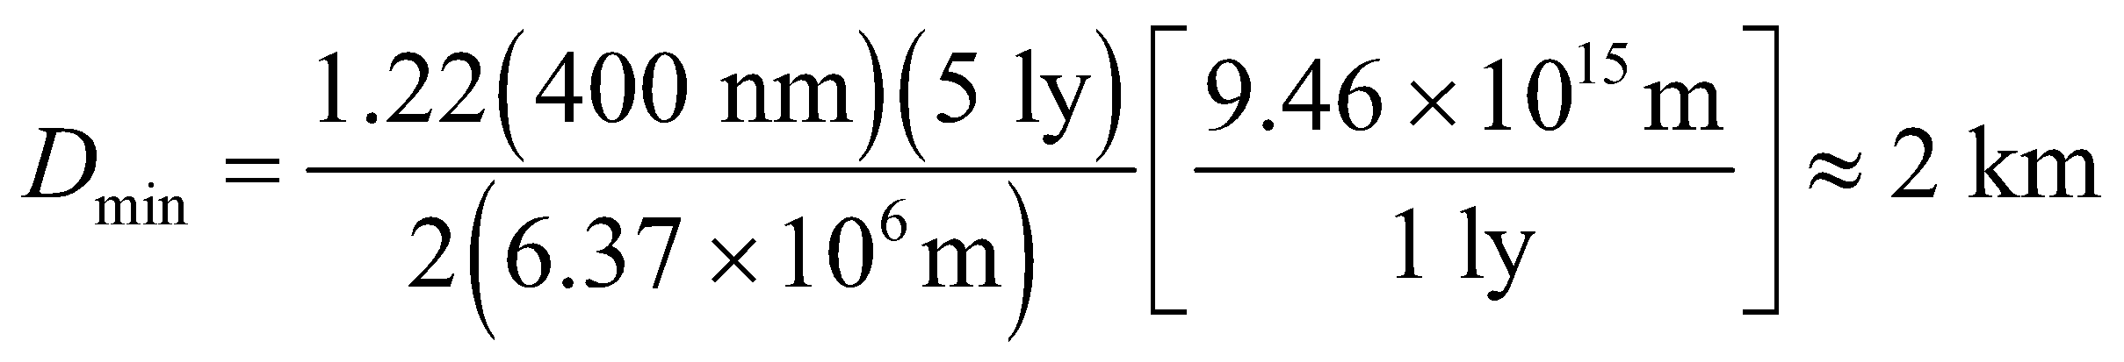

A 2-km-wide telescope in space, or even on the ground, is not feasible.

**Assess** NASA is considering ways to detect Earth-sized planets with a space telescope. However, the goal is not to resolve the planet, but merely separate its light signal from that of its host star. In this case, the angle is not set by the planet's diameter but by its orbital radius. For a planet orbiting its star at the same distance as Earth is from the sun 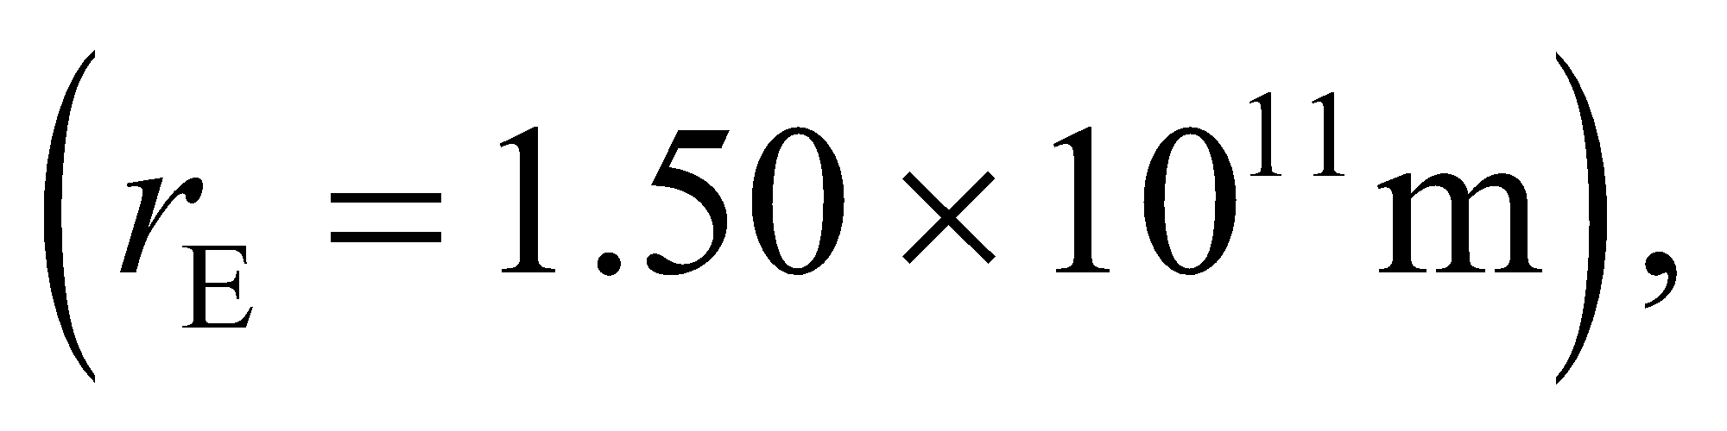 the minimum telescope diameter is less than 20 cm. However, this is largely irrelevant. The real challenge in getting a direct image of a distant planet is not the angular resolution, but the fact that the star is so much brighter than the planet. The starlight completely overwhelms the planet's signal, so astronomers are looking for ways to filter out the light coming from the star.

**46. Interpret** In this problem, we are asked to compare the resolving power between an echelle grating and a more conventional (i.e., more lines per cm) grating.

**Develop** If the echelle grating and the conventional grating have the same width, then the number of lines in each is proportional to the given line spacings, so 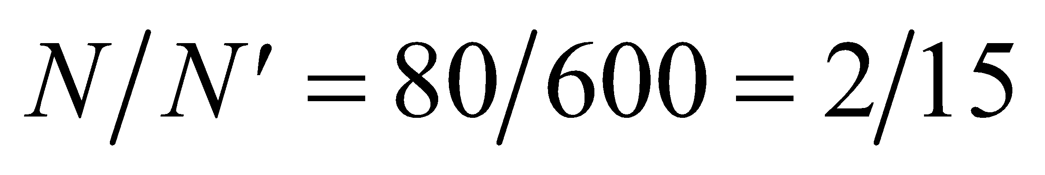. The resolving power of a grating is given by Equation 32.5:

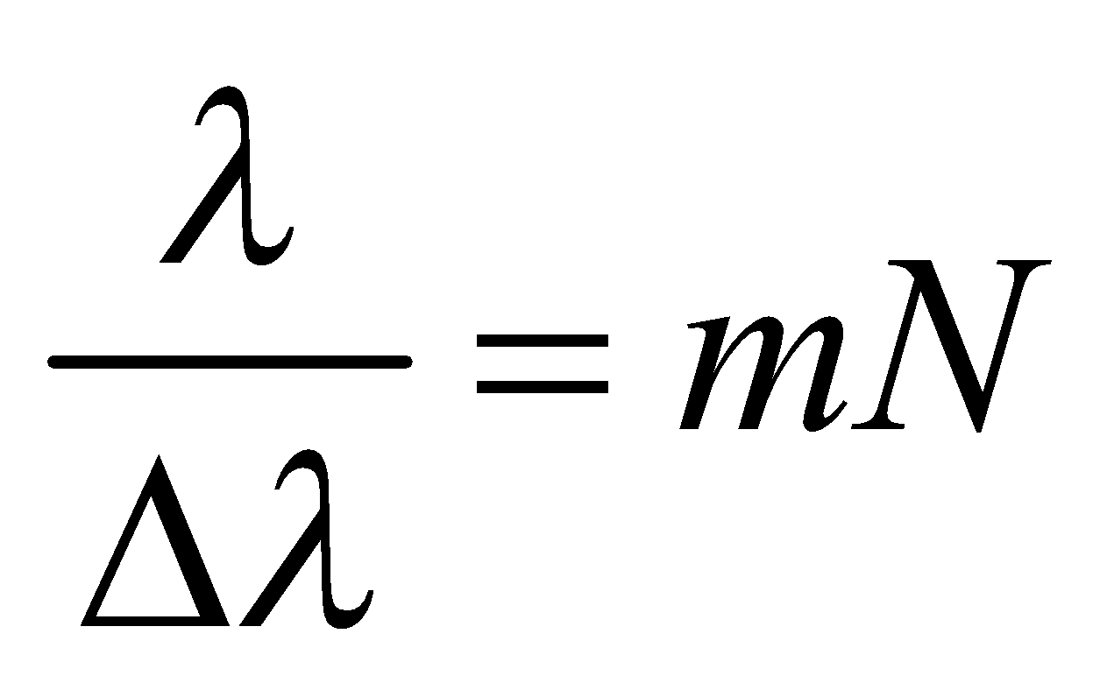

**Evaluate** The ratio of the resolving powers is

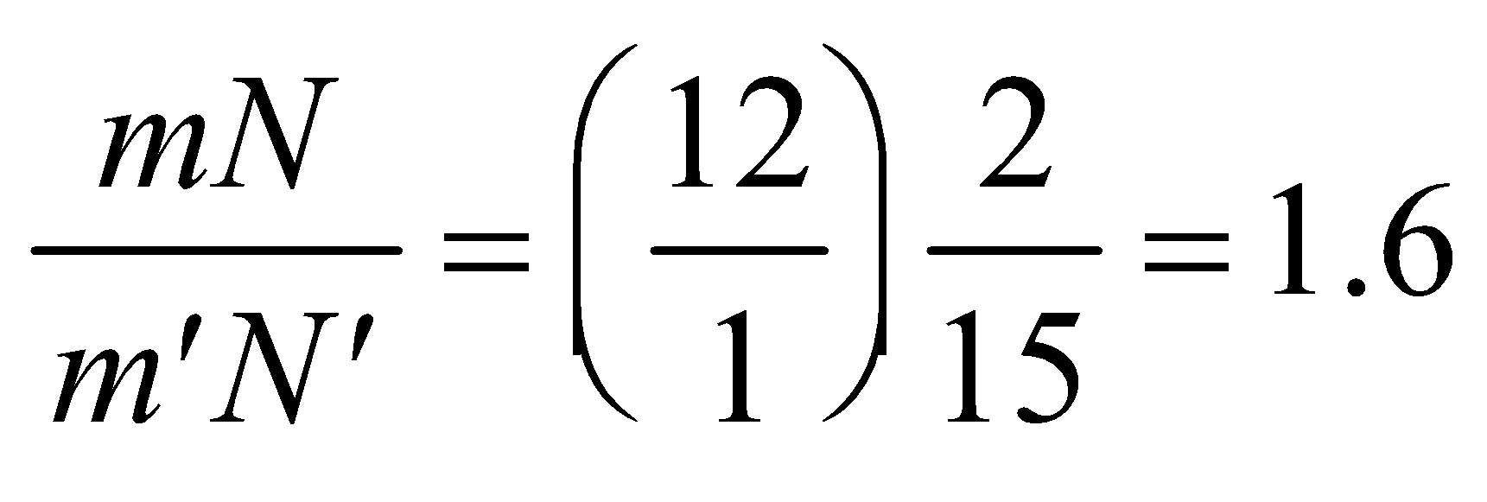

**Assess** The echelle grating with m = 12 offers about 60% greater resolving power than the grating with

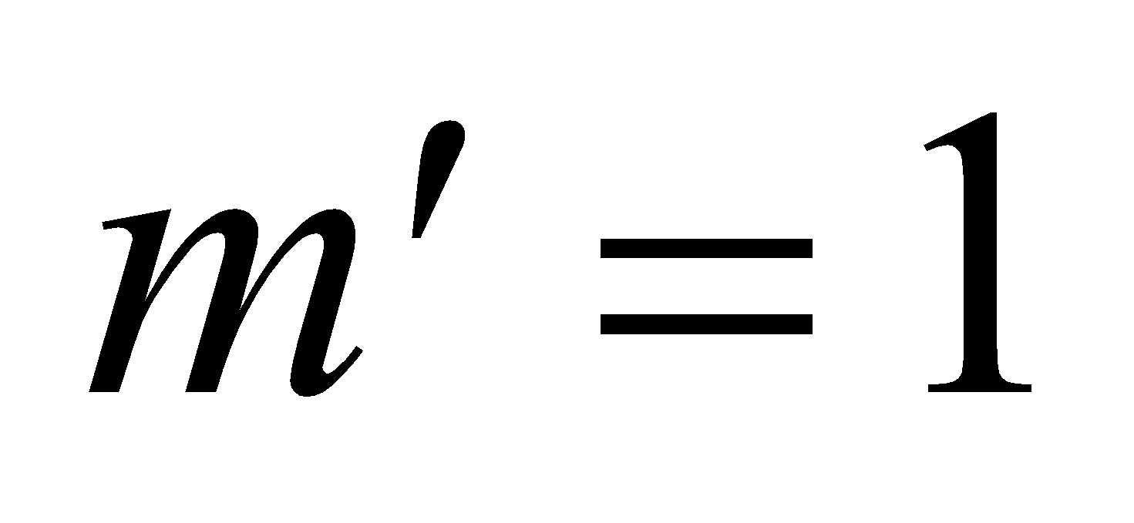.

**47. Interpret** This problem is about X-ray diffraction in a crystal. We are interested in the spacing between the crystal planes, which we can find using Bragg’s law.

**Develop** Constructive interference in X-ray diffraction is given by the Bragg condition (Equation 32.6):

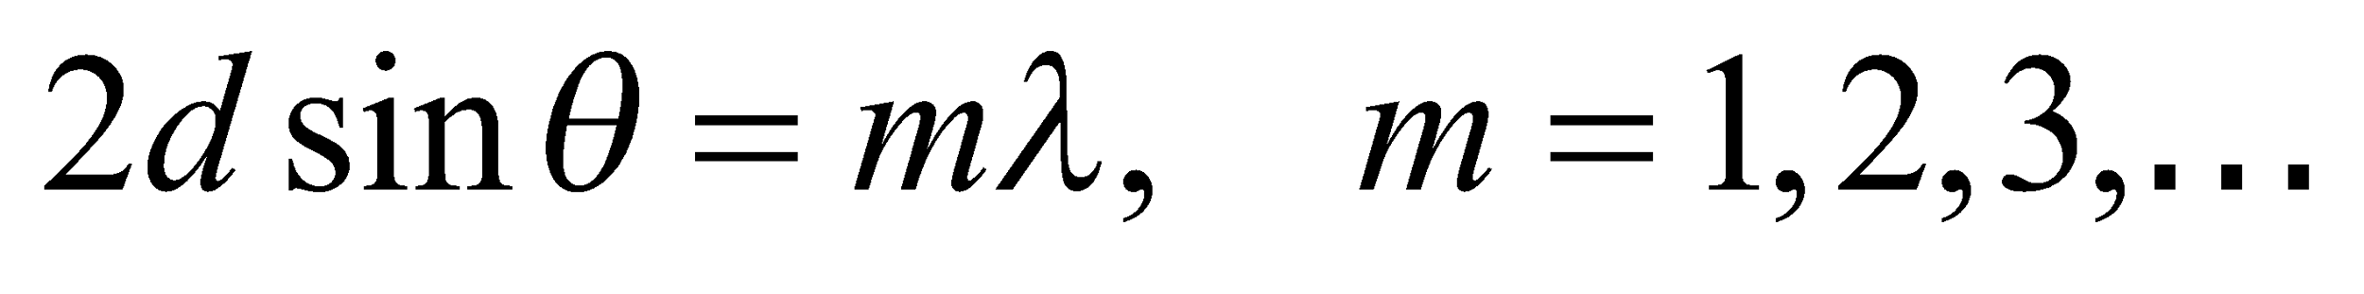

Solve this for *d* to find the spacing between crystal planes.

**Evaluate** From the Bragg condition, one finds

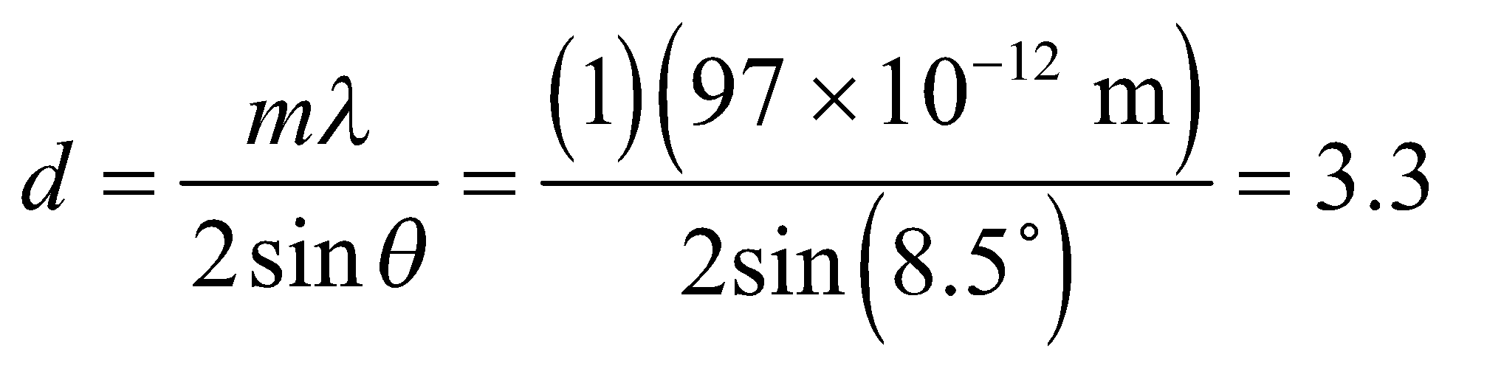Å

**Assess** The spacing between crystal planes is typically a few angstroms, so this result seems reasonable.

**48.** **Interpret** This problem involves interference from a thin film. In particular, we are to analyze a film to find the minimum thickness for which a reflectance of light in the visible regime still occurs.

**Develop** Apply Equation 32.7, which gives the condition for constructive interference from a thin film with index *n* higher than that of its environment. The minimum thickness *d*min occurs for *m* = 0, which gives

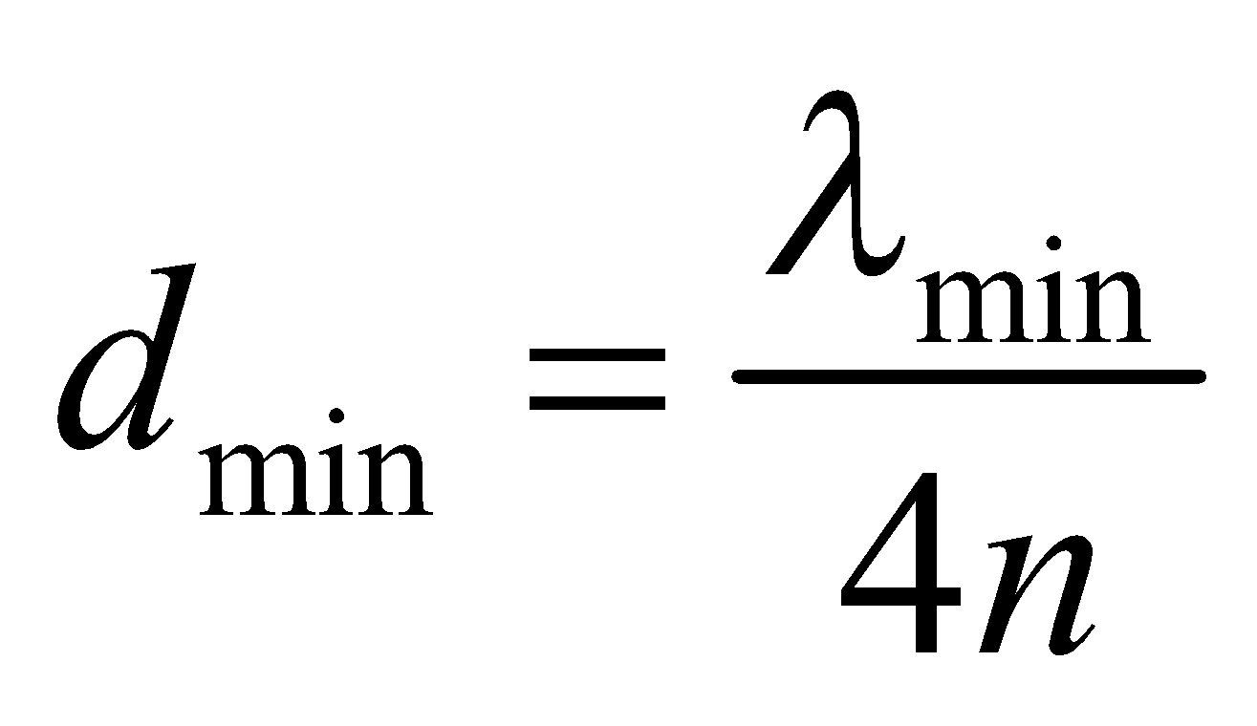

**Evaluate** The minimum wavelength that is visible to humans is normally taken to be 400 nm. Using this result and *n* = 1.33 and in this expression gives a minimum thickness of

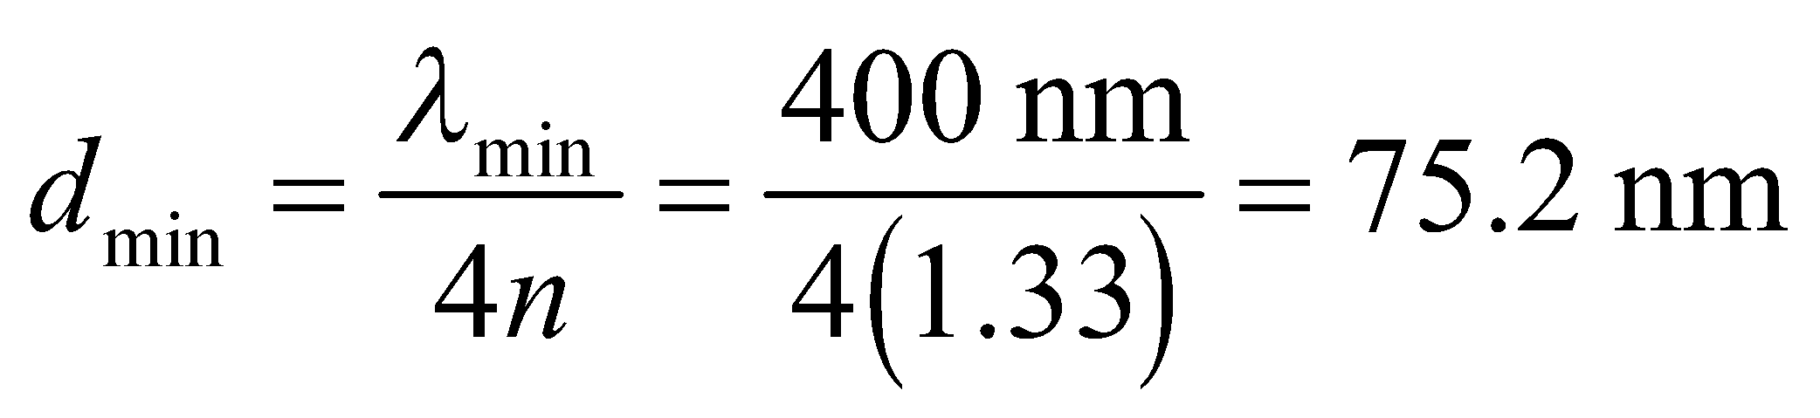

**Assess** Film thicknesses are typically around 100 nm, so the result seems reasonable because it is slightly less than 100 nm.

**49.** **Interpret** This problem involves constructive interference from a thin film. We are to find the number of times the condition for constructive interference is met for 630-nm light in a thin film that varies in thickness within the given range.

**Develop** In a thin film of oil between air and water (), there are 180° phase changes for reflection at both boundaries (i.e., for both rays 1 and 2 in Figure 32.7). These phase changes cancel each other, leaving only the film thickness to give the difference in path length. Therefore, for normally incident light, the term ½ in Equation 32.7 cancels due to a similar term on the left-hand side, leaving

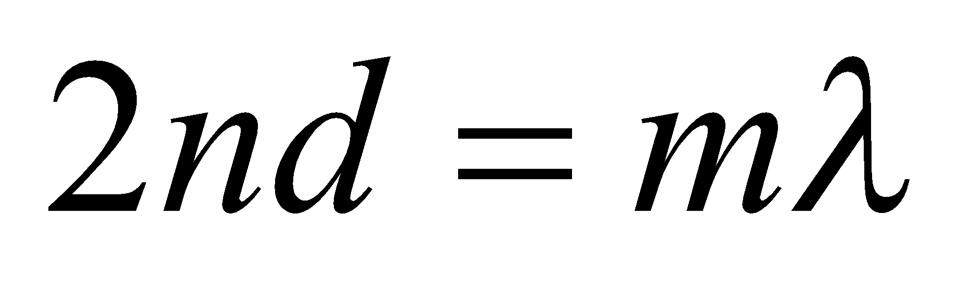

The thickness d varies in the range 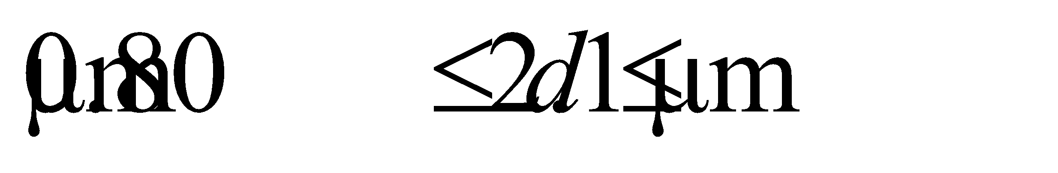, so we can find the integers *m* that satisfy this range for *λ* = 630 nm.

**Evaluate** The thickness range implies

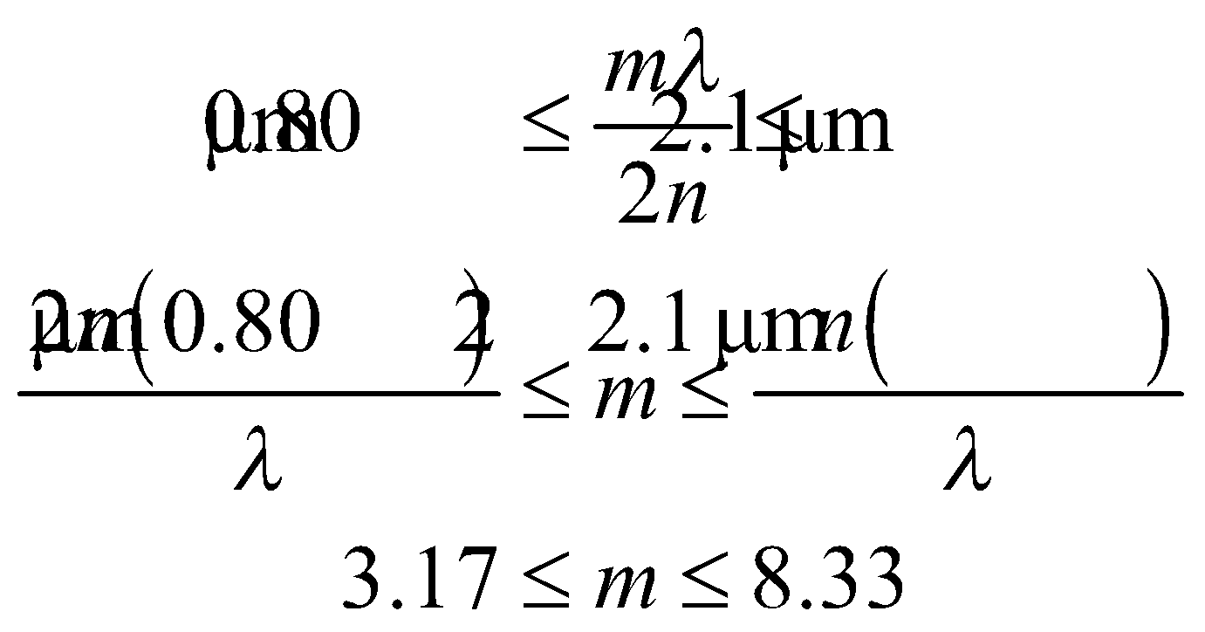

Since *m* is an integer, it can range from 4 to 8, inclusive.

**Assess** For 630 nm, this film will exhibit 5 bright fringes; for m = 4, 5, 6, 7, and 8.

**50. Interpret**  You're worried that a plate may cause constructive interference inside a microwave oven.

**Develop** The minimum thickness for enhanced reflection can be determined from Equation 32.7 by setting 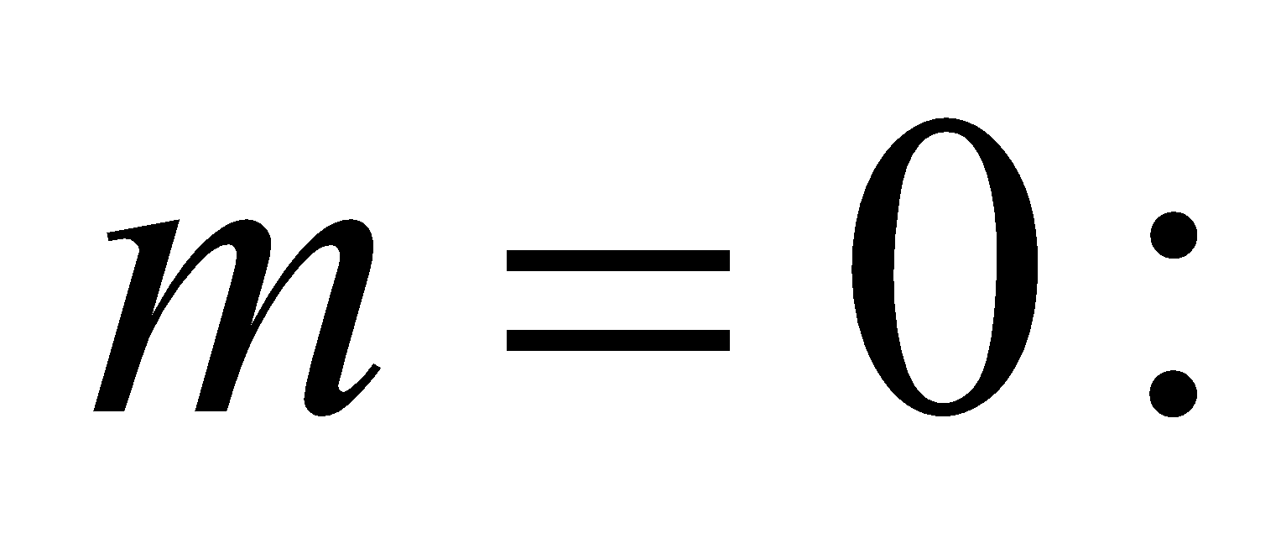 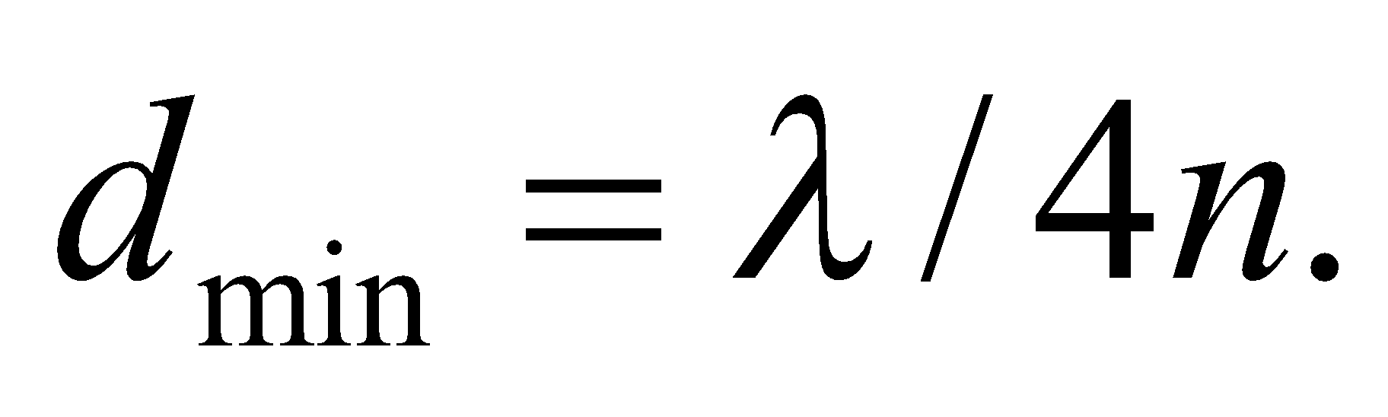

**Evaluate** In terms of the given frequency, the minimum thickness for a plastic plate to induce constructive interference is

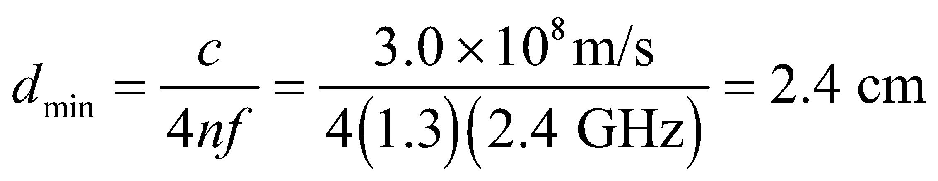

This is almost an inch thick, which is far thicker than normal plates.

**Assess** Interference often does occur inside a microwave oven, as waves bounce back and forth from one wall to the next. One might notice this by uneven heating of food coming out of the oven. The hot spots correspond to constructive interference, while the cold spots are regions where the waves destructively interfere. This is why many ovens have turntables, so that the food moves through these hot and cold spots and therefore experiences more uniform heating.

**51.** **Interpret** This problem involves constructive interference from a thin film; in this case a film of air between two glass plates. The index of air is less than that of glass, so there is a 180º phase change at the bottom interface (air-glass interface) instead of at the top interface (glass-air).

**Develop** Although the phase change occurs at the second interface, as opposed to the first interface as is assumed in deriving Equation 32.6, the net effect is the same—the path difference 2d must be an odd-integer multiple of half wavelengths. The thickness of the film varies between 0 and 0.065 mm, so we can apply Equation 32.6 to find the corresponding range of *m*.

**Evaluate** The minimum value for *m* is 0. The maximum value is

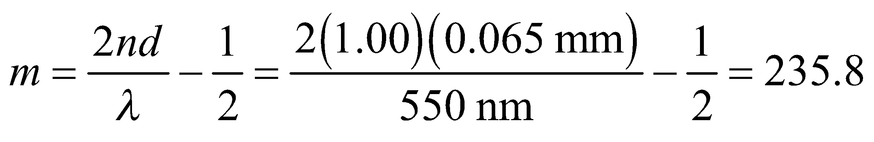

or m = 235. Thus, the observer will see 236 bright bands.

**Assess** The first bright band is at zero thickness, which corresponds to *m* = 0. This band is added to the 235 remaining bands to give the total of 236 bright bands.

**52. Interpret** This problem concerns constructive interference for normally incident light on the thin, wedge-shaped film of arbitrary medium between glass surfaces. We are to derive an expression giving the number of bright fringes that appear given that *N* bright bands are visible for air serving as the film medium.

**Develop** With *N* bright bands visible for an air wedge, the maximum value for *m* in the condition for constructive interference is *m*max = *N* – 1 (see Problem 32.56), and this corresponds to the maximum film thickness *d*max. Inserting this into Equation 32.6 and solving for the ratio *d*max/*λ* gives

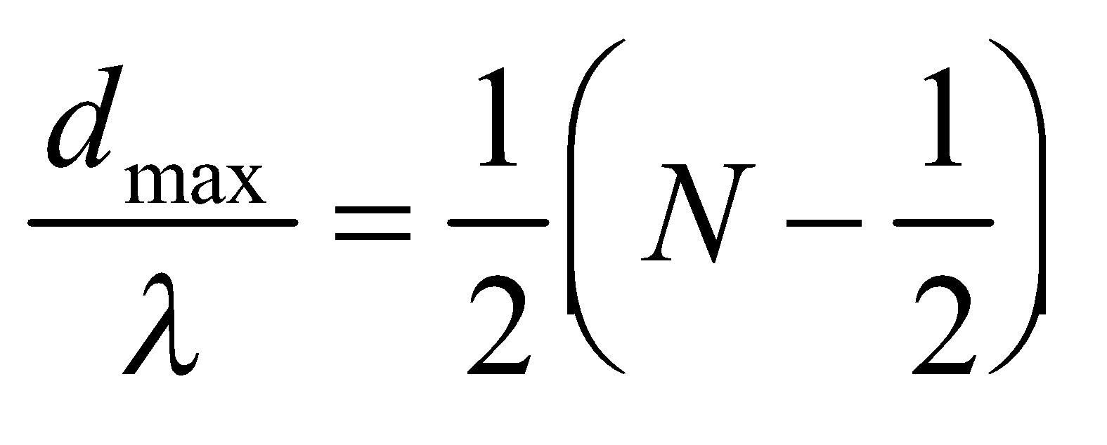

When liquid of refractive index 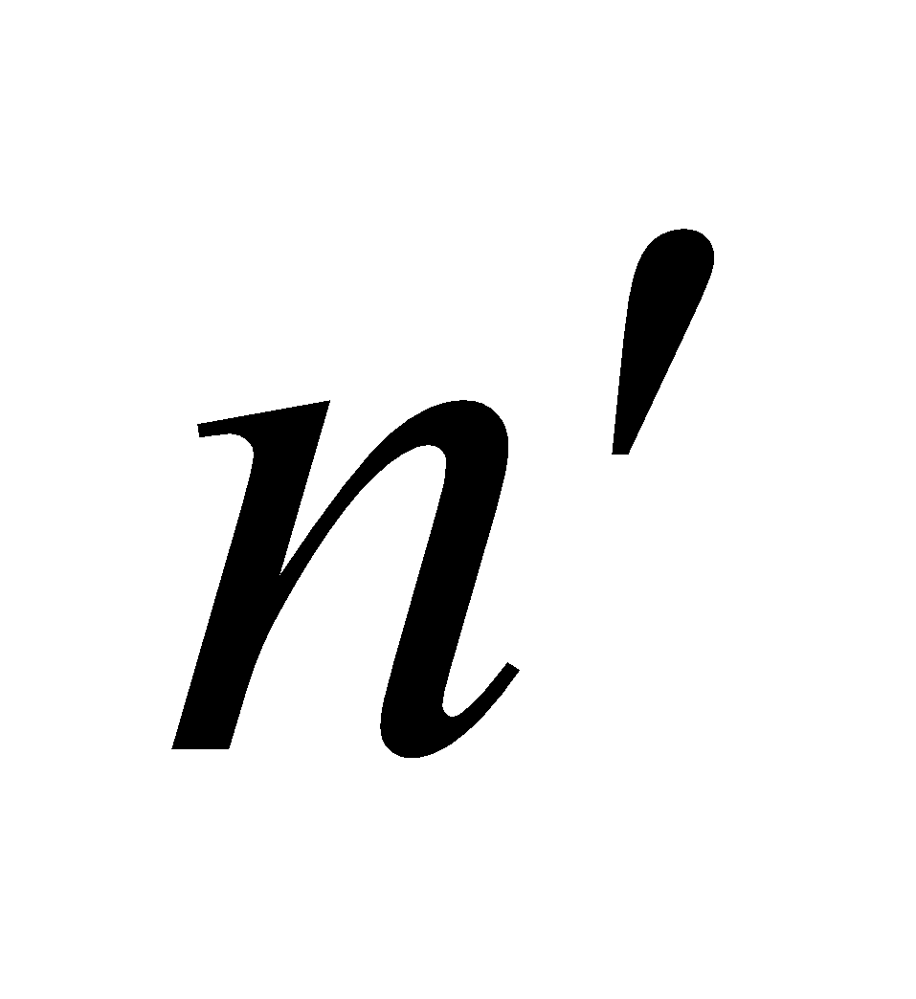 fills the wedge, there is still a 180° phase change at only one surface (regardless of whether or not 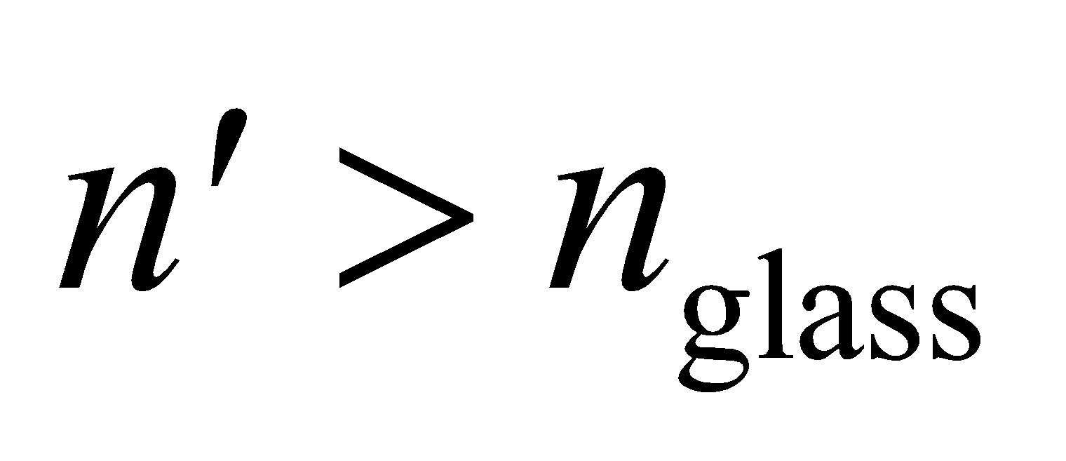). Thus, we can apply Equation 32.6, which gives

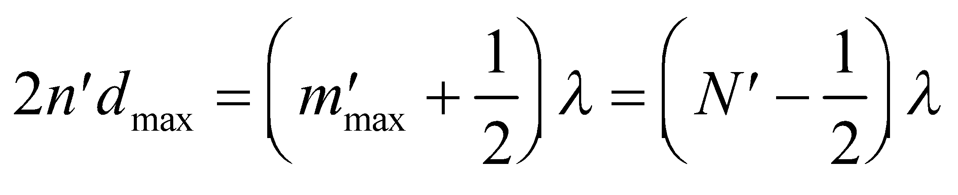

where 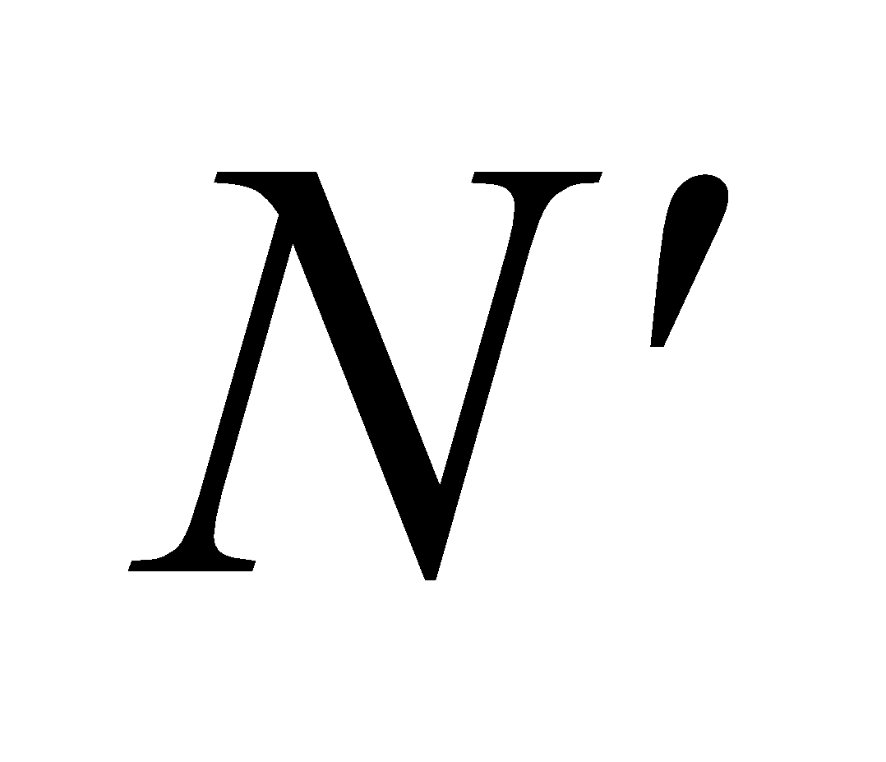 is the number of fringes in the new film. We can thus solve for  in terms of *N* and .

**Evaluate** The new number of bright fringes is thus

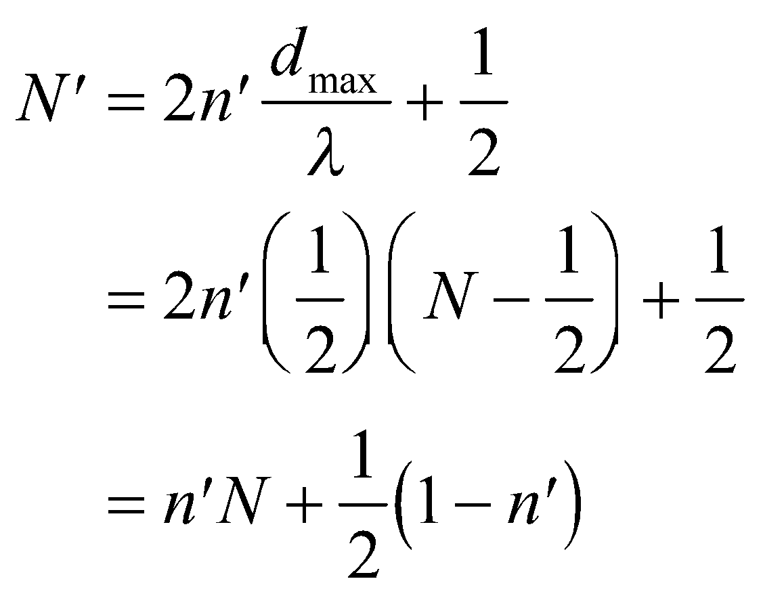

**Assess** This result is independent of the index of the enclosing material (the glass in this case).

**53.** **Interpret** We are asked to find the distance that corresponds to the passage of 530 bright fringes in an interferometer. Thus, as one arm of the interferometer moves, the path length in that arm changes, causing alternating constructive and destructive interference (or alternating bright and dark fringes) to occur at the output of the interferometer.

**Develop** In each arm of the interferometer, light must travel down and back, or twice the length of the arm (see, e.g., Figure 32.16). Thus, the path-length difference corresponding to 530 bright fringes is twice the distance moved by the mirror, and each successive fringe corresponds to the distance of one wavelength. This gives

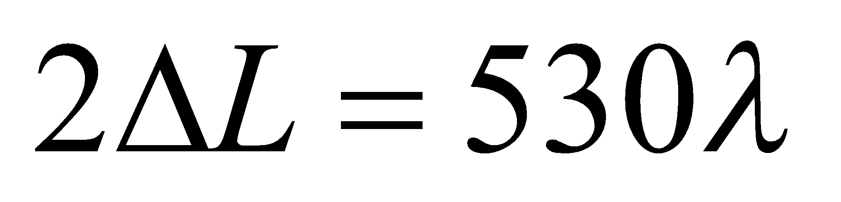

which we can solve for *ΔL*.

**Evaluate** Inserting the given quantities gives

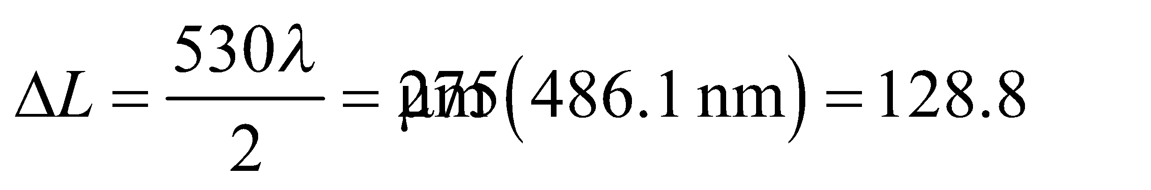

**Assess** This distance is greater than a single wavelength, which is the minimum distance this type of apparatus can detect.

**54. Interpret** This problem is similar to the previous one, except that we are given the distance moved by the interferometer and asked to find the wavelength of light used.

**Develop** Applying the same logic as for the previous problem gives

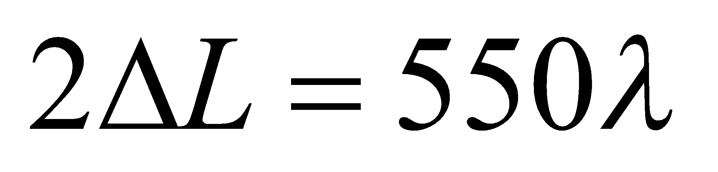

where we have used 550 because that is the number of fringes observed for this problem. The distance moved by the mirror is *ΔL* = 150 μm.

**Evaluate** The wavelength is

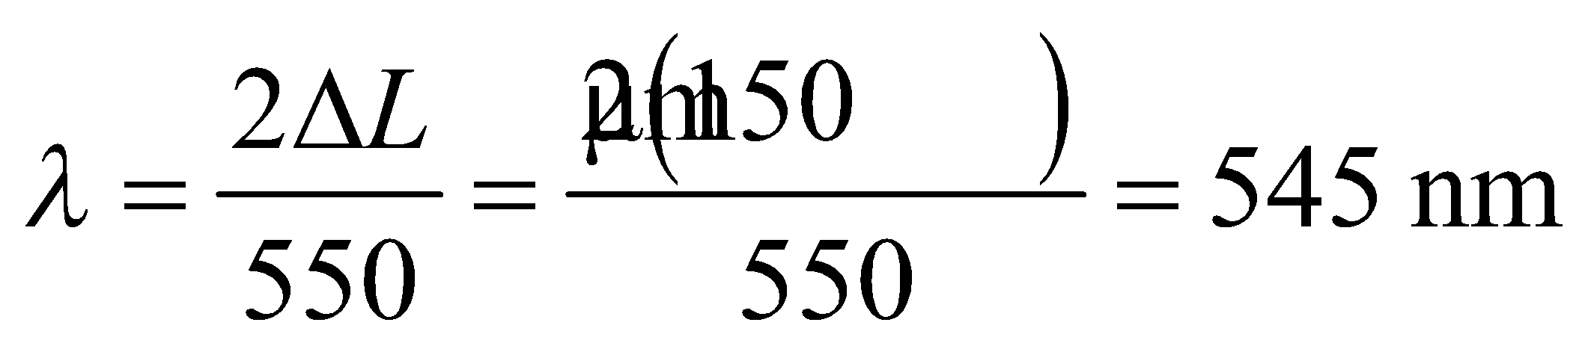

**Assess** This wavelength is in the visible spectrum and corresponds to yellow light.

**55.** **Interpret** This problem involves an interferometer, which is used to measure the refractive index of air. Initially, one arm of the interferometer contains air. This air is gradually pumped out, which reduces the index of refraction in the arm proportionally. When no air is left, 388 bright fringes have been observed at the recombination point of the interferometer. We are to calculate the index of refraction of the air.

**Develop** When the interferometer arm contains air, its length 2*L* in wavelengths is 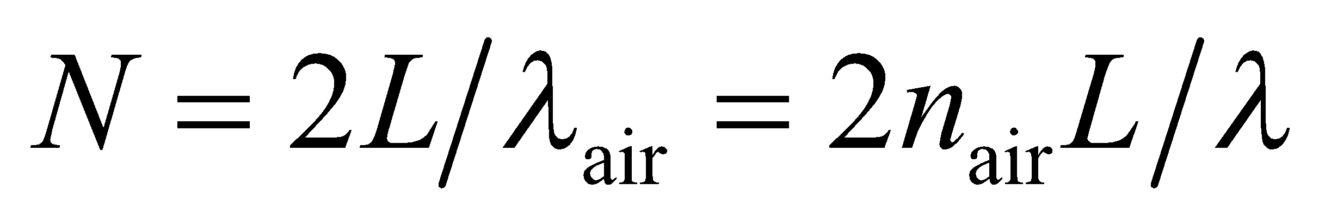, where 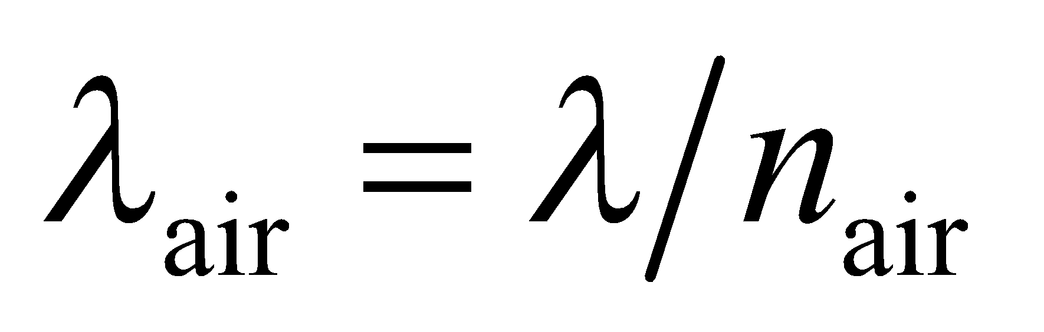is the wavelength in air and *λ* = 641.6 nm (the factor 2 arises because the light must travel down and back in the interferometer arm, so measures twice the actual length *L*). When the interferometer arm is in vacuum, its length in wavelengths becomes 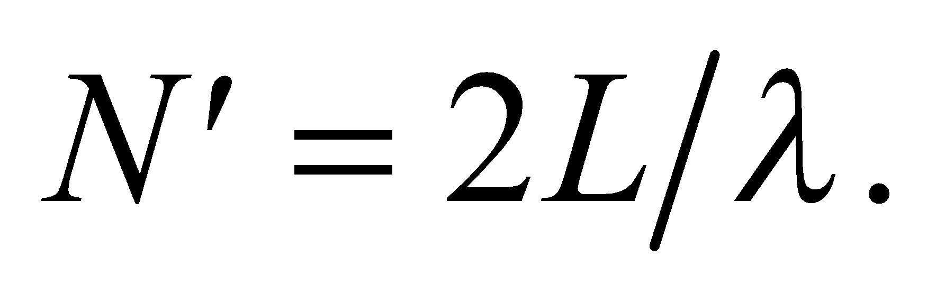

**Evaluate** The difference between the air length and the vacuum length, in number of wavelengths, gives the number of bright fringes observed. Therefore, we can solve for the index of refraction of air as follows:

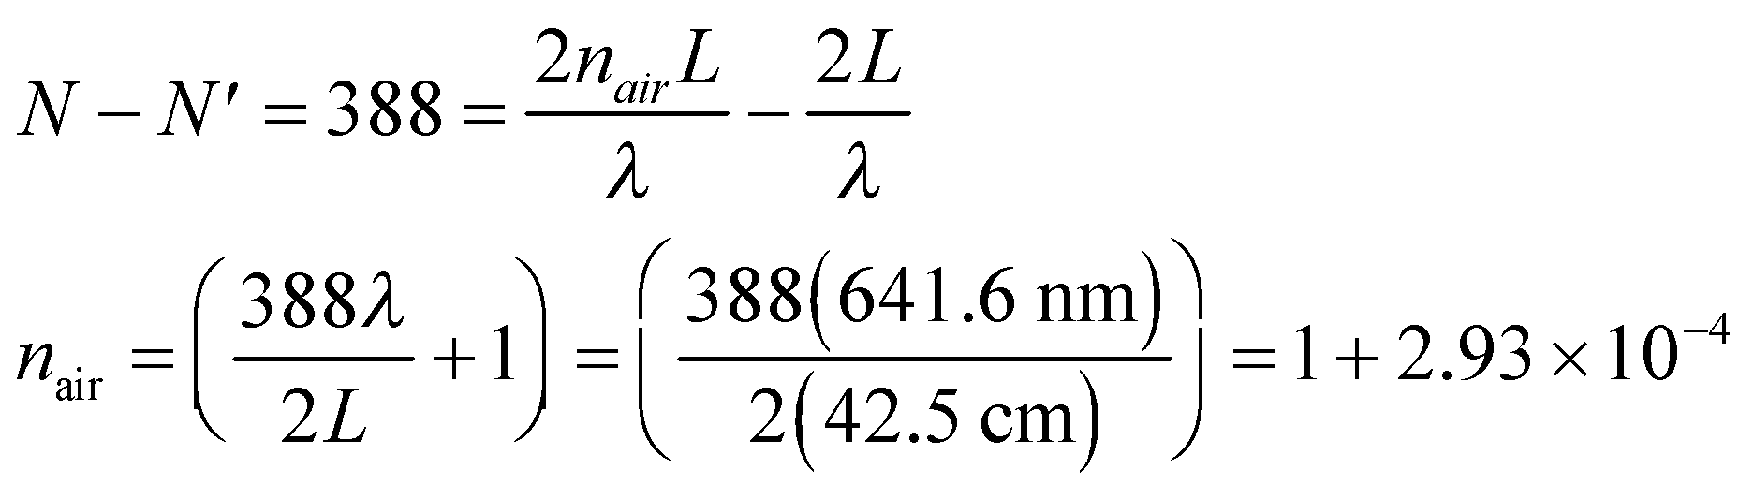

**Assess** This result agrees with published results dating from 2003.

**56. Interpret** This problem is about interference between incoming waves and reflected waves. We would like to adjust the path difference so that the interference is constructive.

**Develop** Consider the sketch of the situation below. If the incoming waves are roughly perpendicular to the wall, an additional path difference of 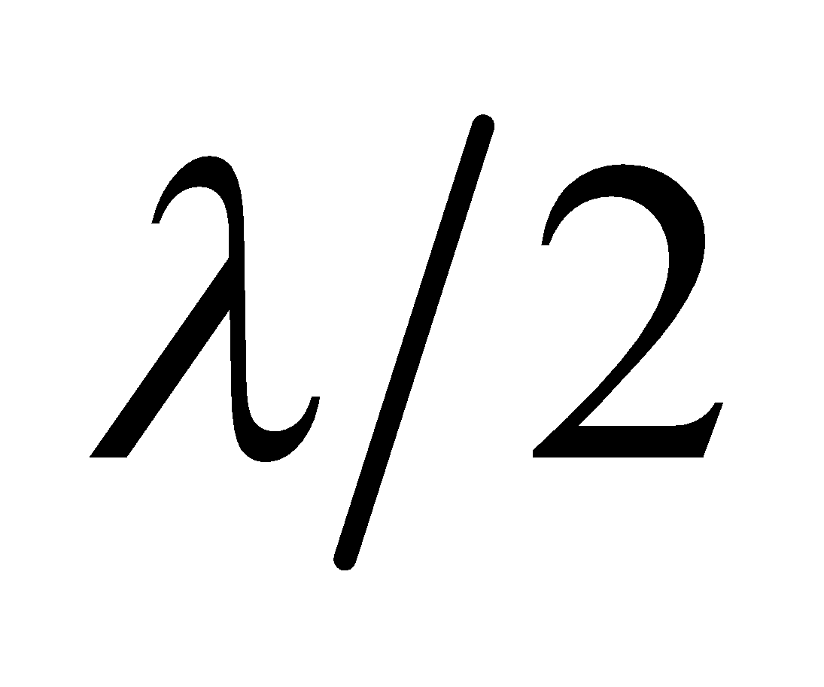 between the direct and reflected waves, corresponding to a radio receiver displacement of 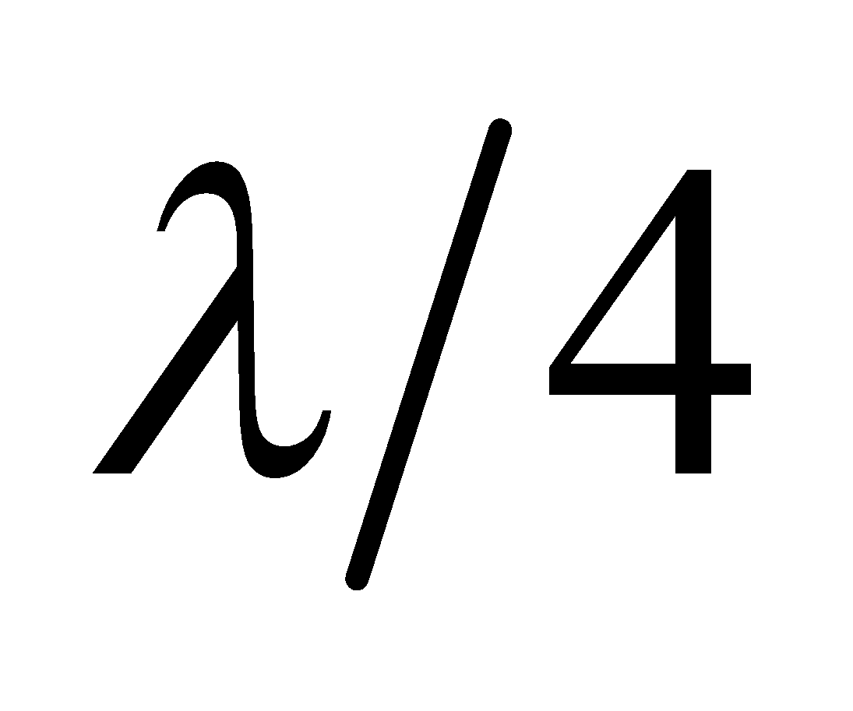 (the path difference of the waves is approximately twice the distance to the wall), will change an interference minimum into a maximum.



**Evaluate** Therefore, the distance you should move away from the wall is

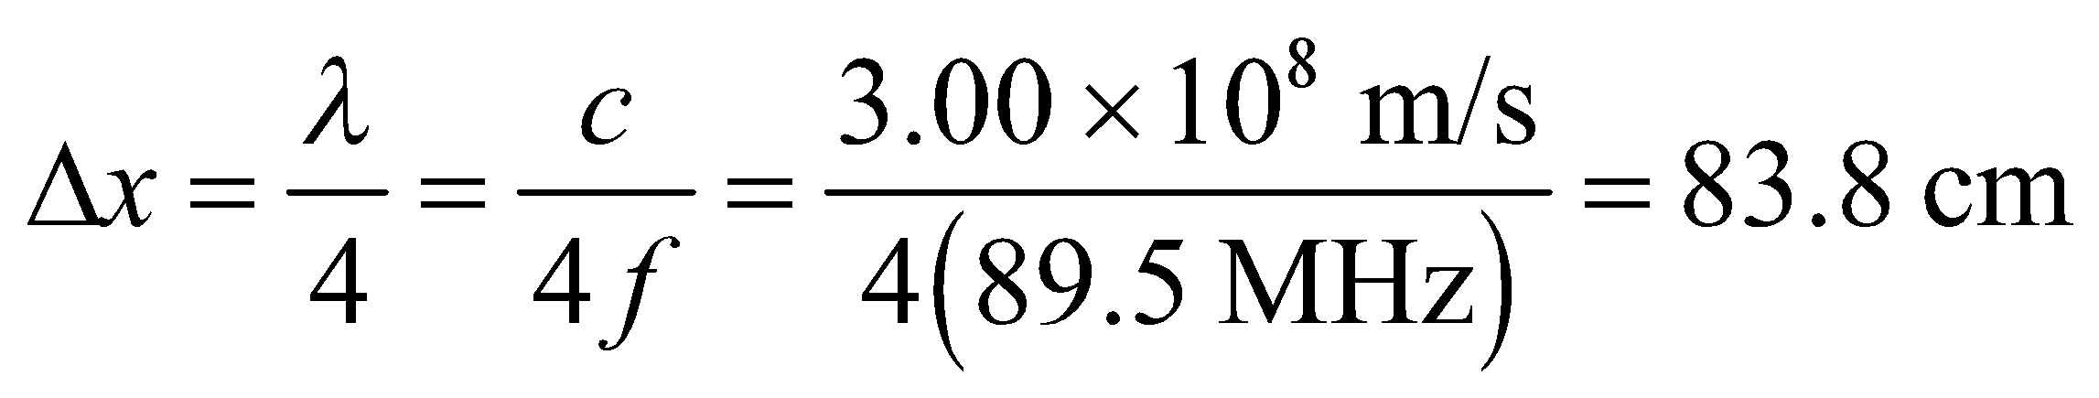

**Assess** The interference between the incoming and reflected signals is constructive when the path difference is an integer multiple of a wavelength, and destructive when it is an odd-integer multiple of a half wavelength.

**57. Interpret** This problem concerns the diffraction limit of an optical system. The optical system consists of a circular concave mirror. The system has circular symmetry, so we can use the Rayleigh criterion for circular apertures.

**Develop** To resolve a spot of 50-cm diameter at a distance of 2500 km, the necessary minimum angle to resolve is

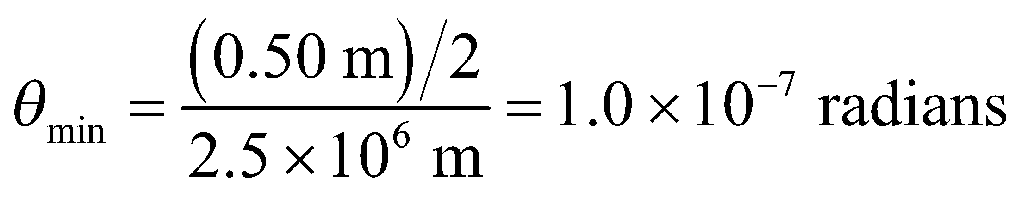

The circular mirror constitutes a circular aperture for the optical system, so the minimum resolvable source separation is given by the Rayleigh criterion for circular apertures (Equation 32.11b). We can insert *θ*min into this expression and solve for the minimum mirror diameter.

**Evaluate** The minimum mirror diameter is

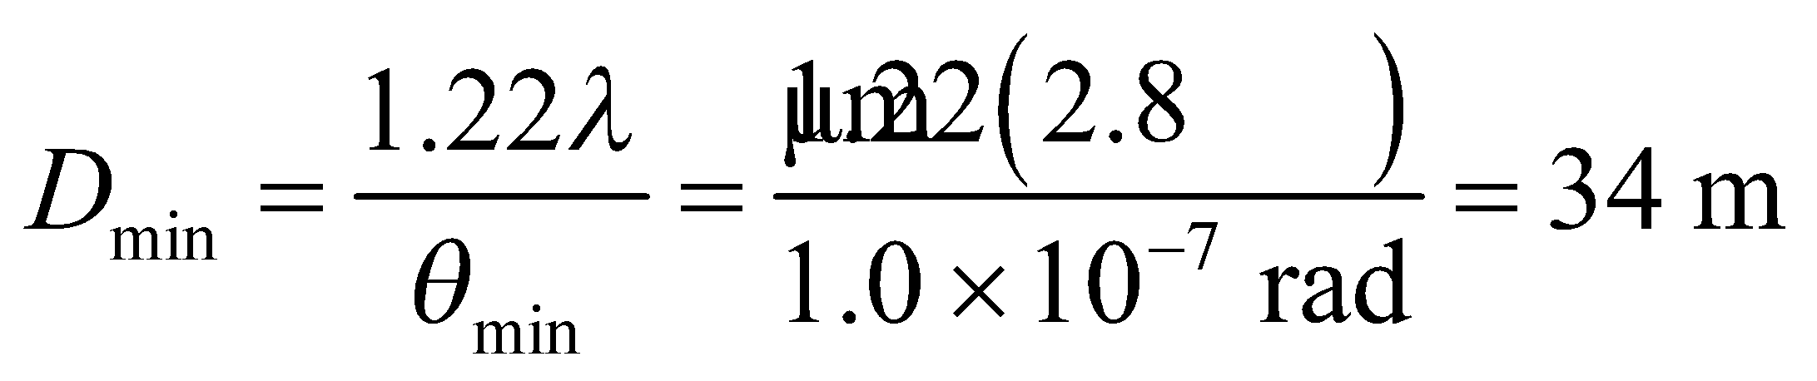

**Assess** This is a very large mirror, especially considering the wavelength for which it is to be used. Note that we use the spot radius in determining *θ*min. This is because this angle is defined using the distance from the maximum of the central peak to the first diffraction minimum (see Figure 32.7 and accompanying discussion).

**58. Interpret**  This is a problem about the diffraction limit with a circular aperture.

**Develop** If one of the Keck telescopes were diffraction-limited while observing with 550-nm light, its maximum resolution would be

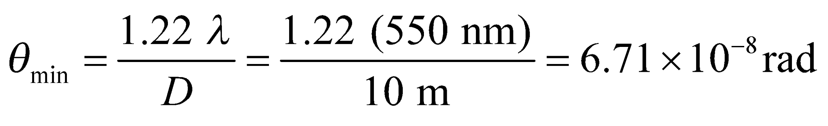

At the distance of San Francisco, resolving objects requires a separation of at least

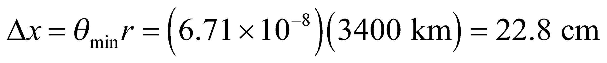

We will assume that letters that are bigger than this can be read with the telescope.

**Evaluate**  **(a)** A newspaper headline might be a few centimeters high, so it would not be possible to read anything like that with a single Keck telescope.

**(b)** A billboard may have letters that are 50 cm tall or more, so it might be possible to read the sign.

**(c)** The effective aperture is 5 times wider, so the minimum angle is reduced by a factor of 5. That means letters that are about 4.6 cm tall can be resolved, so it might be possible to read very large headlines in San Francisco from Hawaii.

**Assess** We're assuming the telescope is diffraction limited, but atmospheric turbulence would reduce the resolving power.

**59.** **Interpret** We are to find the smallest spot that can be focused by the given lens system. Because the lens is circular, we shall apply the Rayleigh criterion for circular apertures.

**Develop** The diffraction limit for a lens opening of diameter *D*, focusing light of wavelength *λ* is given by Equation 32.11b (the Rayleigh criterion for circular apertures):

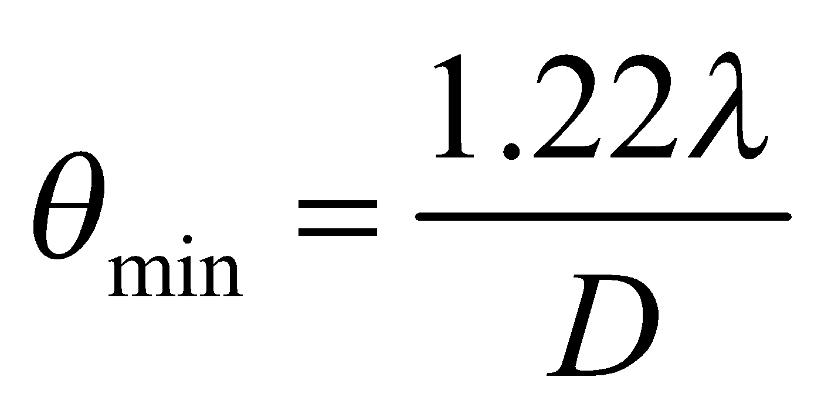

The radius of a spot, at the focal length of the lens, with this angular spread, is *r* = *fθ*min (the spot radius equals the distance between the central maximum and first minimum; see Figure 32.7 and accompanying discussion). The minimum spot diameter is therefore *d* = 2*r* = 2 *fθ*min.

**Evaluate** Inserting the given quantities gives

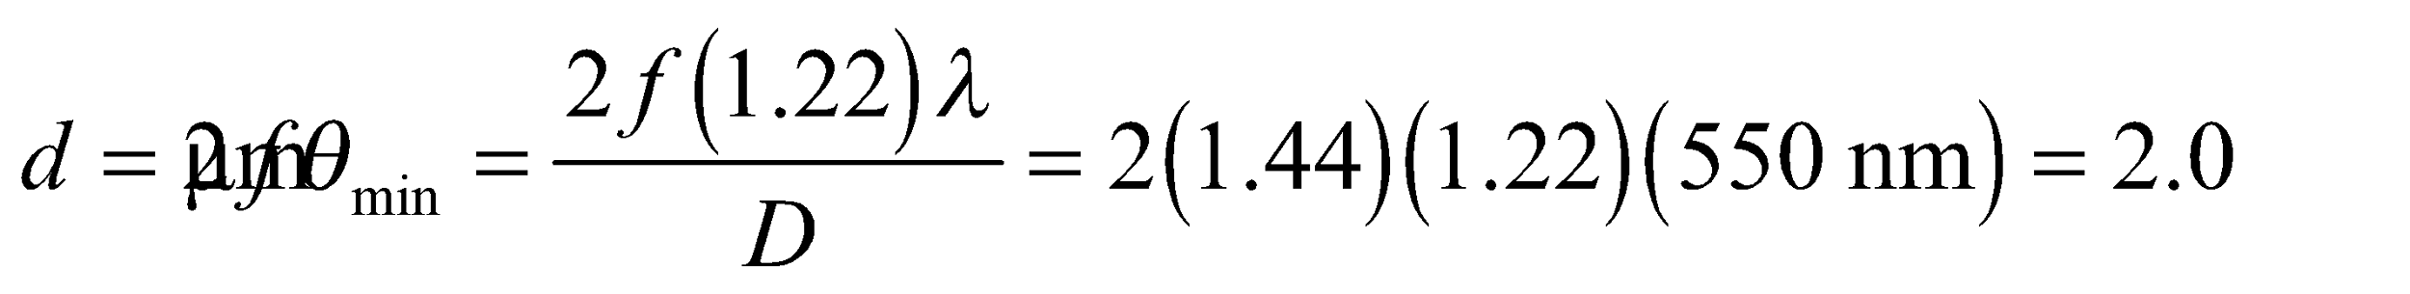

Where we have used *f*/*D* = 1.44, as given in the problem statement.

**Assess** This resolution is good enough for most commercial cameras.

**60. Interpret**  You want to estimate the size of a spy satellite given the smallest features it can resolve on the ground.

**Develop** The altitude of the satellite, *h*, is so high that the angular separation between two objects on the ground is just: 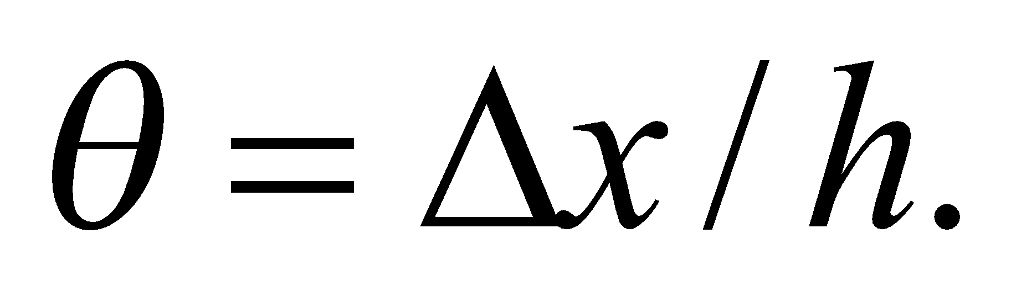 You can therefore estimate the minimum diameter of the camera's mirror or lens to be:

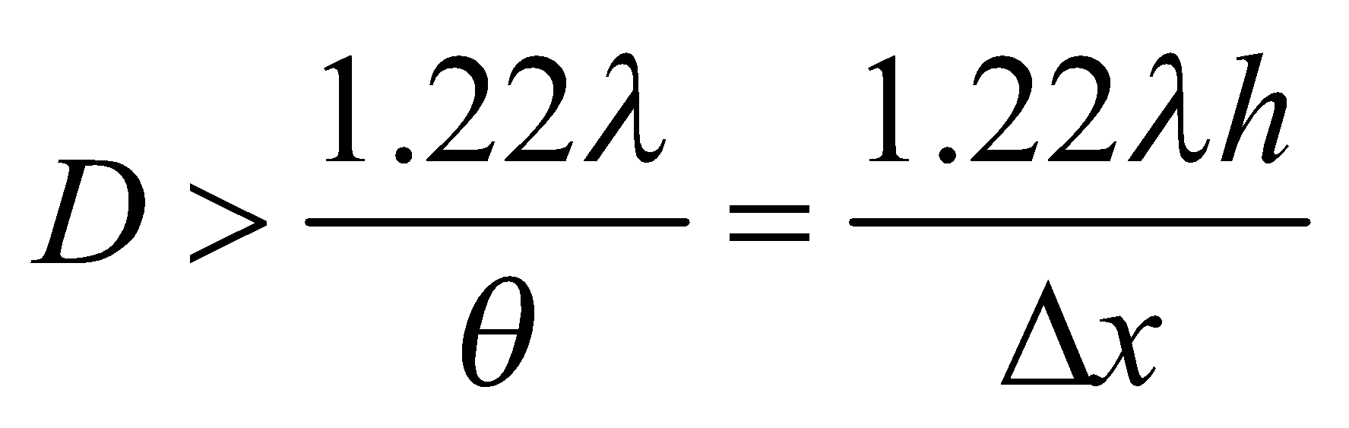

**Evaluate** Assuming 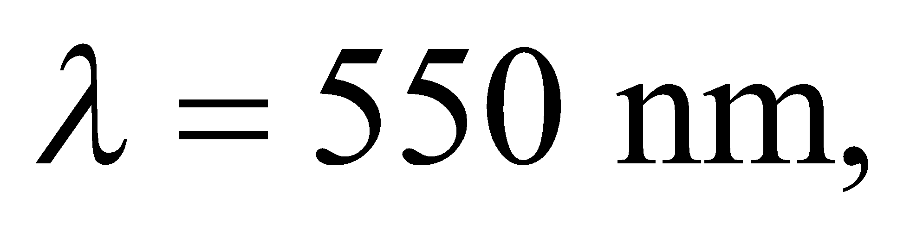the minimum diameter is

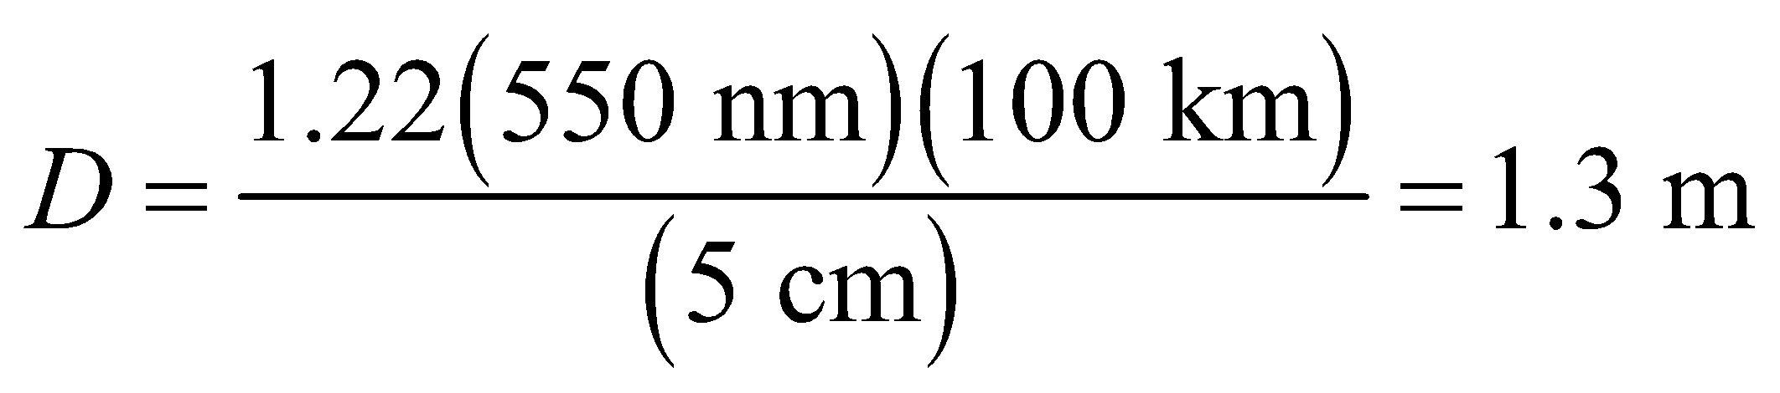

Because of the uncertainties, the most that you can probably say is that the satellite's mirror or lens is slightly more than 1-m-wide.

**Assess** Most optical systems this big use mirrors rather than lenses as the primary light collector. Lenses have chromatic aberration due to the wavelength dependence of the refractive index. Moreover, a meter-wide lens would weigh much more than a similar-sized mirror, which is a big consideration for anything going up into space.

**61. Interpret** We are to determine the largest distance at which humans can resolve a pair of automobile headlights. Because human pupils are circular, the Rayleigh criterion for circular apertures applies.

**Develop** If we use the Rayleigh criterion (Equation 32.11b for small angles) to estimate the diffraction-limited angular resolution of the eye, at a pupil diameter of 3.1 mm and with light of wavelength 550 nm, we obtain

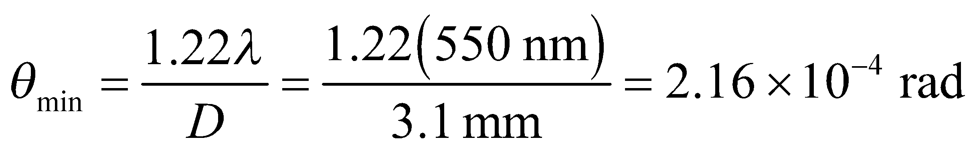

**Evaluate** This angle corresponds to a linear separation of *y* = 1.5 m at a distance of

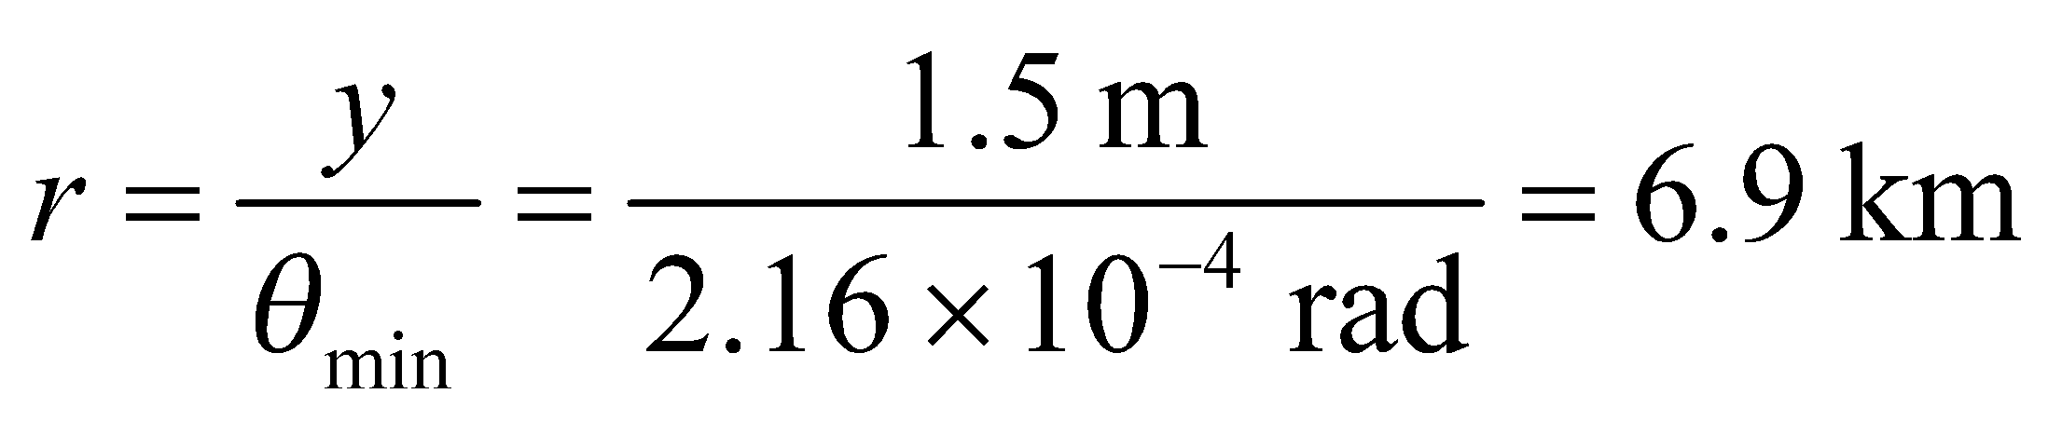

**Assess**  Actually, the wavelength inside the eye is different (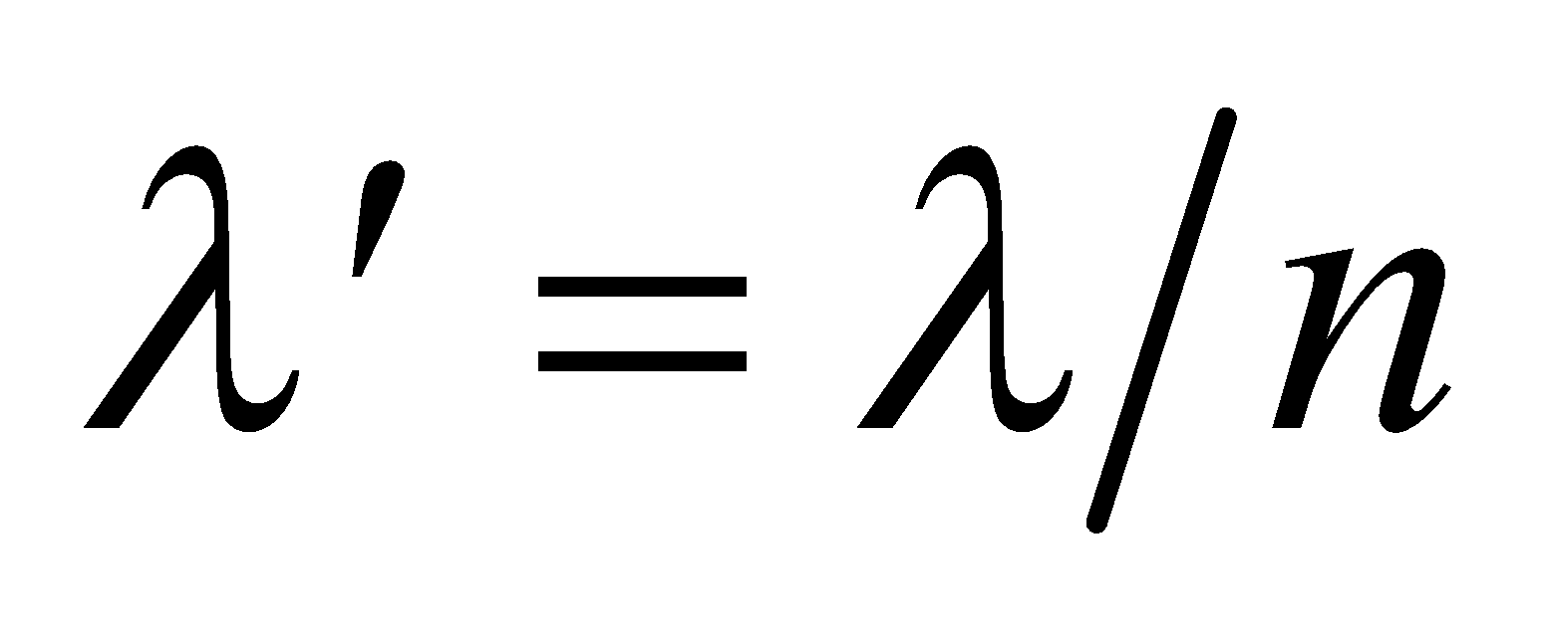) because of the average index of refraction of the eye. Even though other factors determine visual acuity, this is a reasonable ballpark estimate.

**62.** **Interpret** We are to compare the diffraction-limited resolution at 550 nm with the given limit due to atmospheric turbulence.

**Develop** Apply the Rayleigh criterion for circular apertures (Equation 32.11b), using

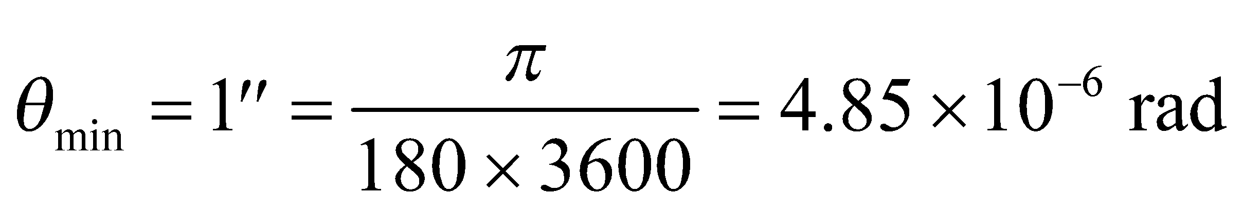

**Evaluate** The aperture satisfying the Rayleigh criterion at the given wavelength is

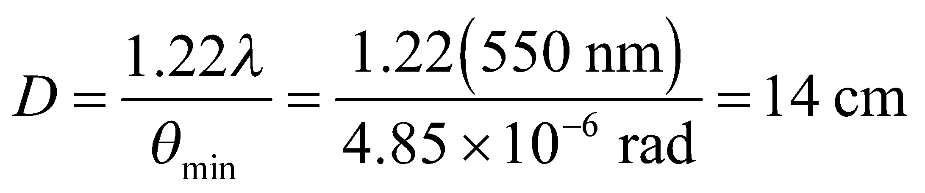

**Assess** The resolution of all larger-diameter ground-based telescopes is limited by atmospheric conditions at this wavelength.

**63. Interpret**  The question is whether a microscope using ultraviolet light can resolve crystallized proteins.

**Develop** Suppose the minimum object size that your current optical microscope can resolve is

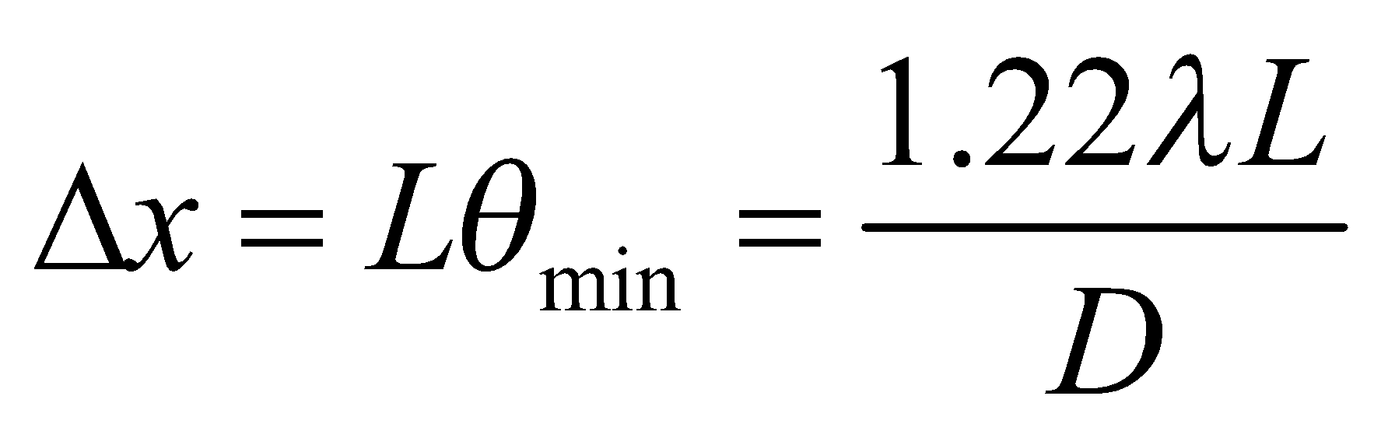

where *L* is the distance between the lens and the sample, and *D* is the microscope aperture. You can assume that the sales rep's UV microscope has roughly the same geometry, in which case 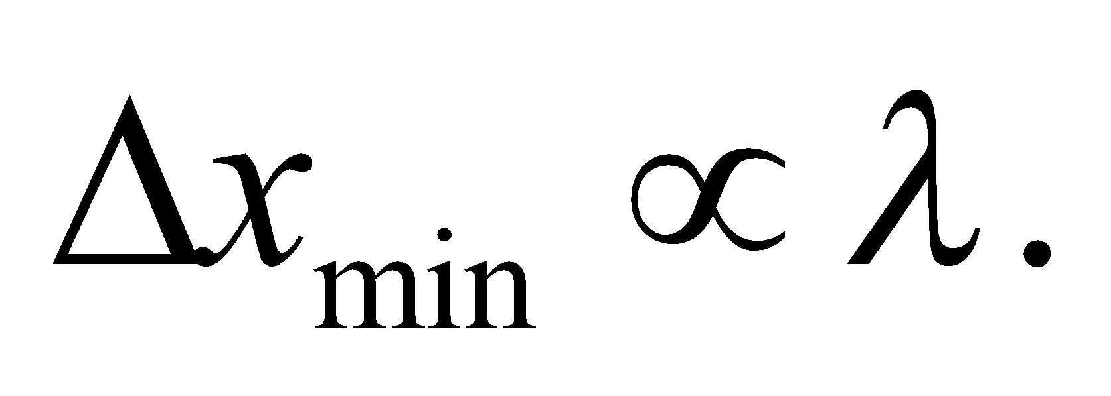

**Evaluate** You can assume your optical microscope uses the characteristic visible wavelength of 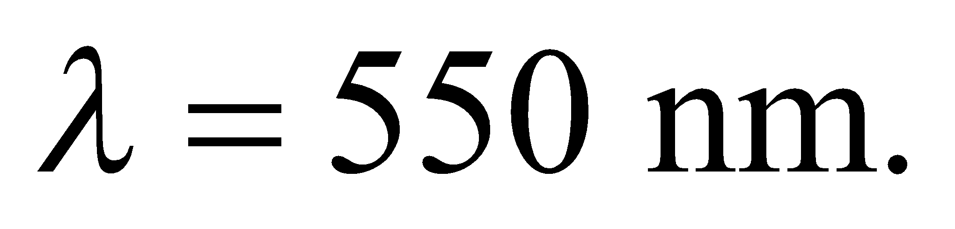 Therefore, the UV microscope using 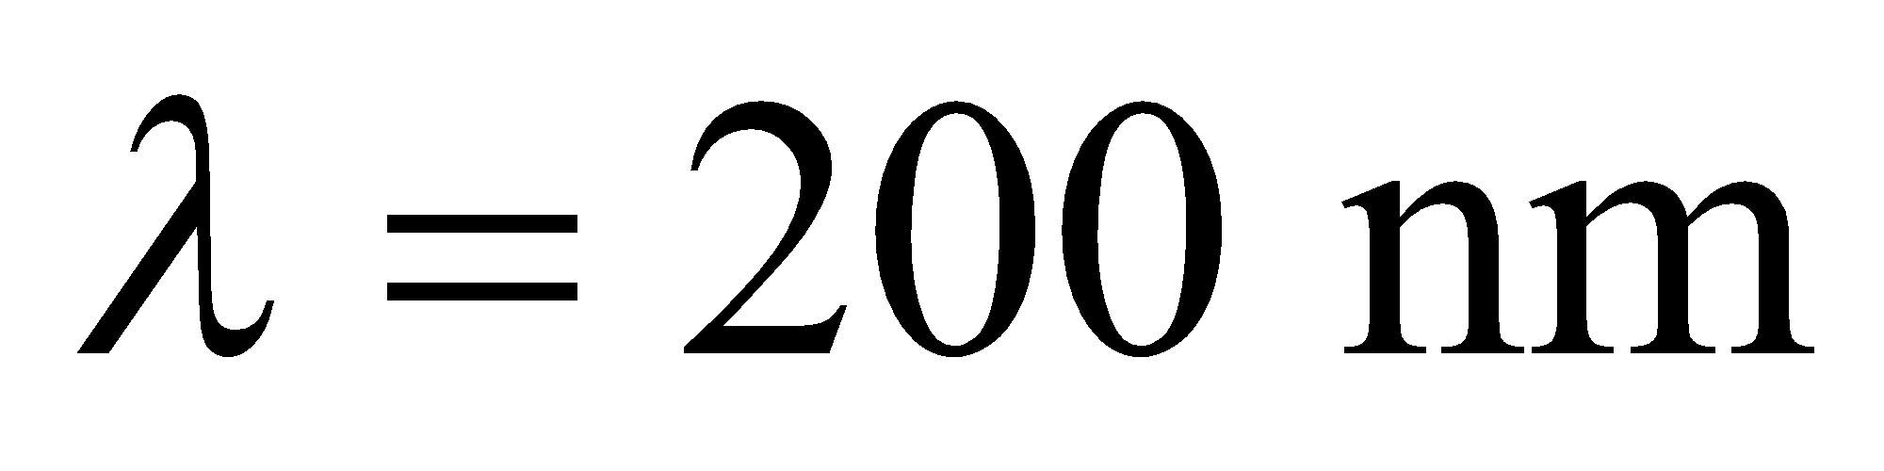will have about a factor of 2 better resolution:

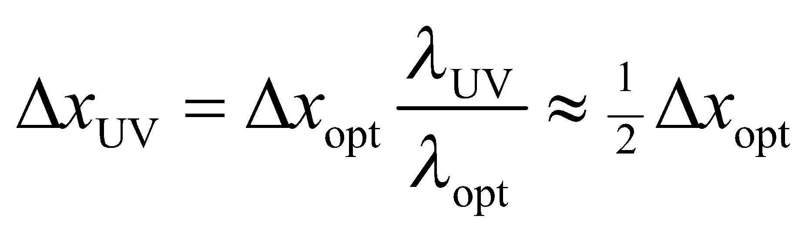

So, yes, the sales rep is apparently correct.

**Assess** In general, you can only resolve objects as big as the wavelength of the light that you are using. Proteins are typically only a few nanometers across, so most studies of crystallized proteins use x-ray diffraction with wavelengths between 0.1 and 10 nanometers.

**64.** **Interpret** We are to calculate the index of refraction of air by comparing the number of fringes in a wedge-shaped film of air trapped between two glass plates with the number of fringes with the air evacuated. The fringes are caused by alternating constructive and destructive interference as the film thickness varies along the wedge-shaped film.

**Develop** As shown in the solutions to Problems 32.51 and 32.52, the number of bright bands is the largest integer *N* less than or equal to 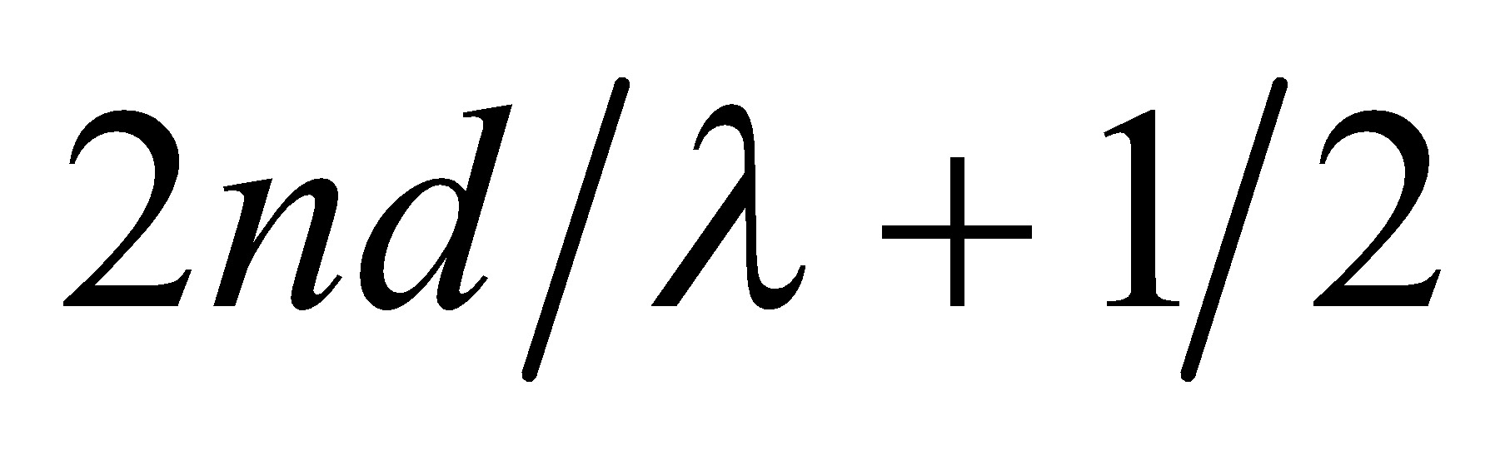, where *d* is the maximum wedge width. For air, this gives



For vacuum, this gives



Where we have used 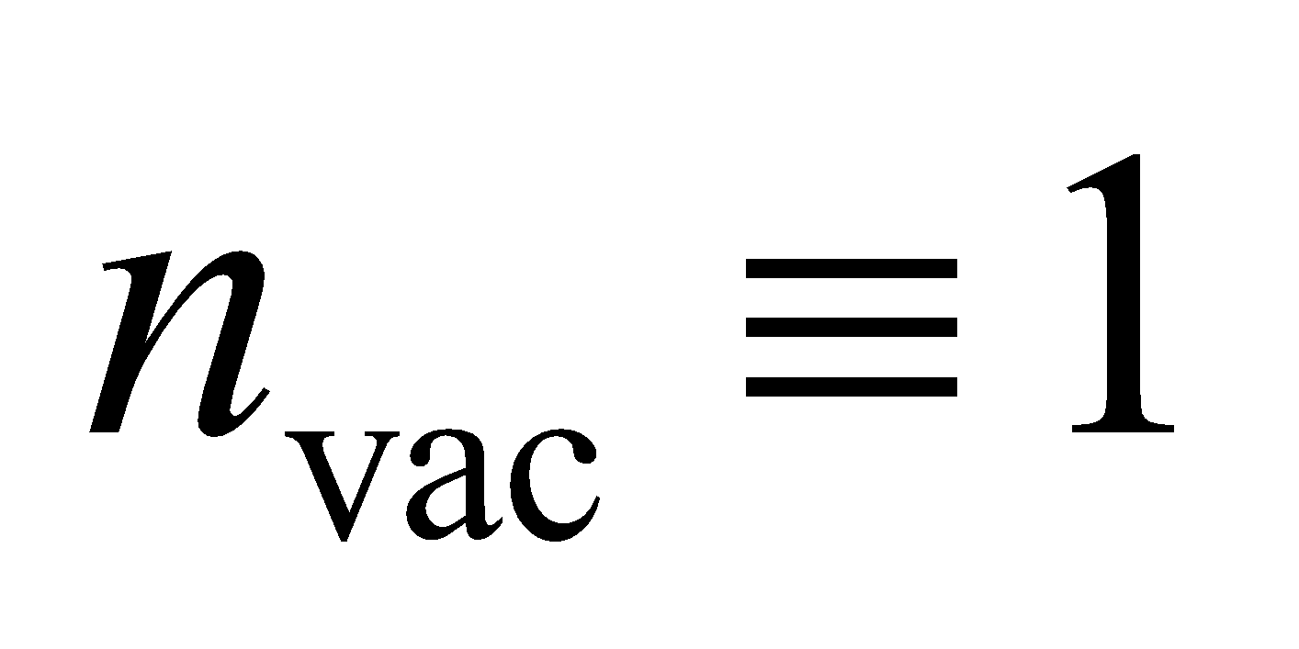.

**Evaluate** Solving this system of equations for *n*air gives

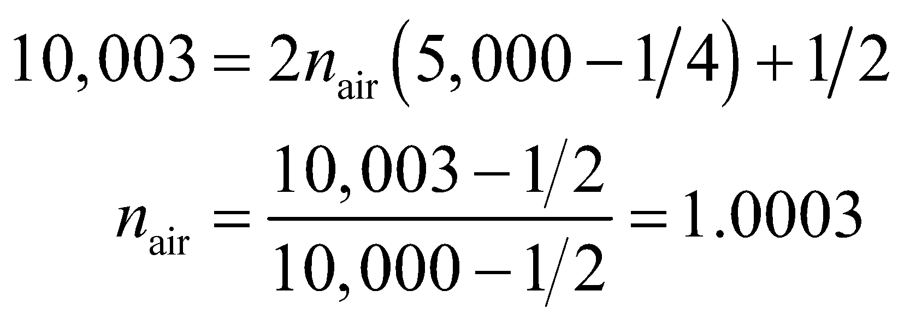

**Assess** Within the limit imposed by the precision of the data, this result agrees with published results.

**65. Interpret** We are to find an expression for the refractive index of a gas that is measured using a Michelson interferometer. We are given the difference in optical path length (i.e., the difference in the number of bright fringes) between a column of gas and an equal length of vacuum.

**Develop** The index of refraction in vacuum is defined to be unity. For light travelling through a gas, the wavelength of light depends on the gas through which it is travelling (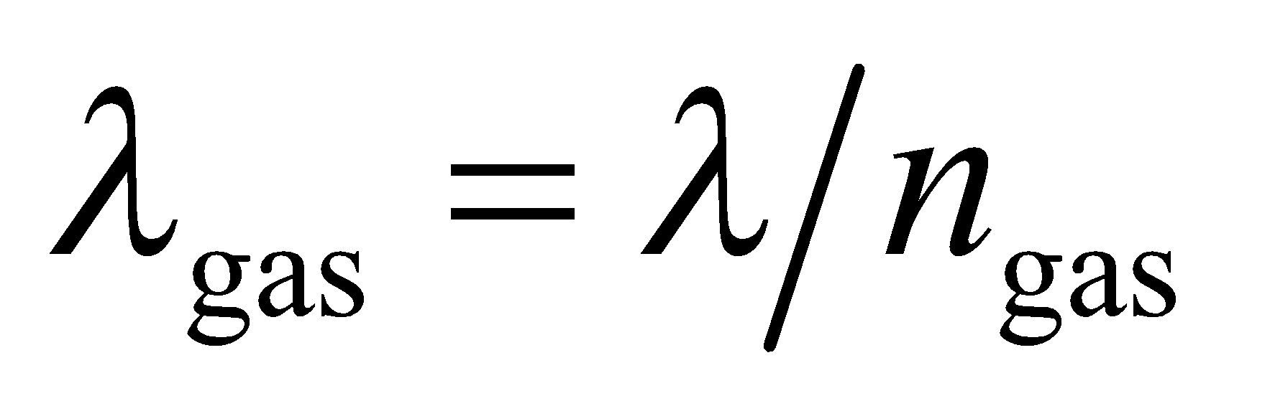; *λ* is the vacuum wavelength). Thus, there is a difference in the number of wave cycles in the enclosed interferometer arm when the

cylinder is evacuated or filled with gas. The light travels the length of the arm twice, out and back, and each cycle of difference results in one fringe shift. Thus, the number of fringes in the shift is

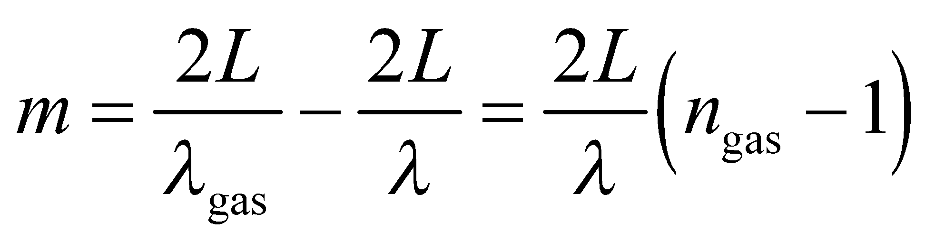

**Evaluate** From the above equation, the refractive index is

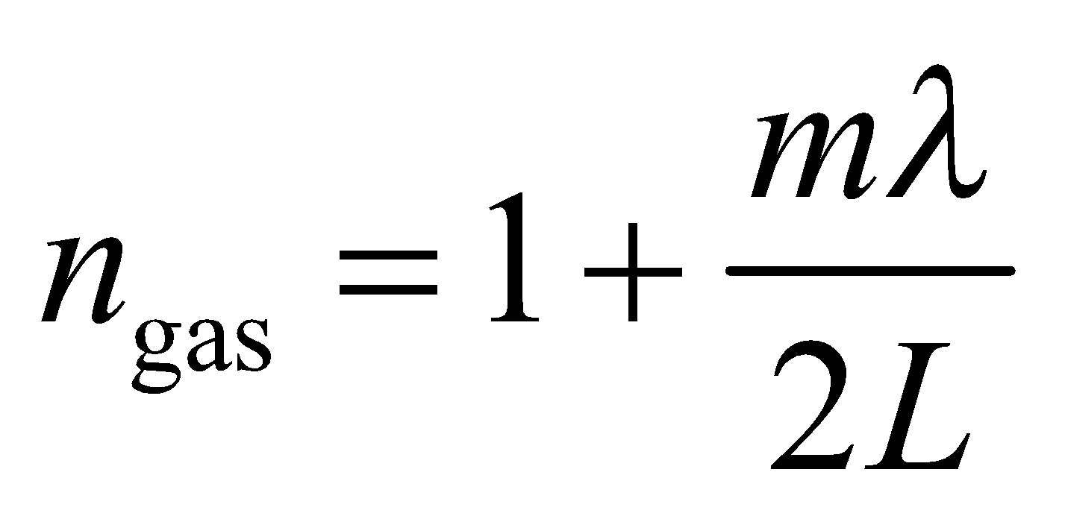

**Assess** The interferometer allows for the determination of the refractive index of a gas.

**66. Interpret** In this problem we want to verify the condition for maximum intensity when light is incident on a diffraction grating at an arbitrary angle.

**Develop** Consider the sketch below, which shows light incident on a grating at an angle *α* with respect to normal incidence. The path difference between the two rays incident on adjacent slits of the grating (*A* and *B*, with spacing *AB* = *d*) at an angle *α* with respect to the grating normal is 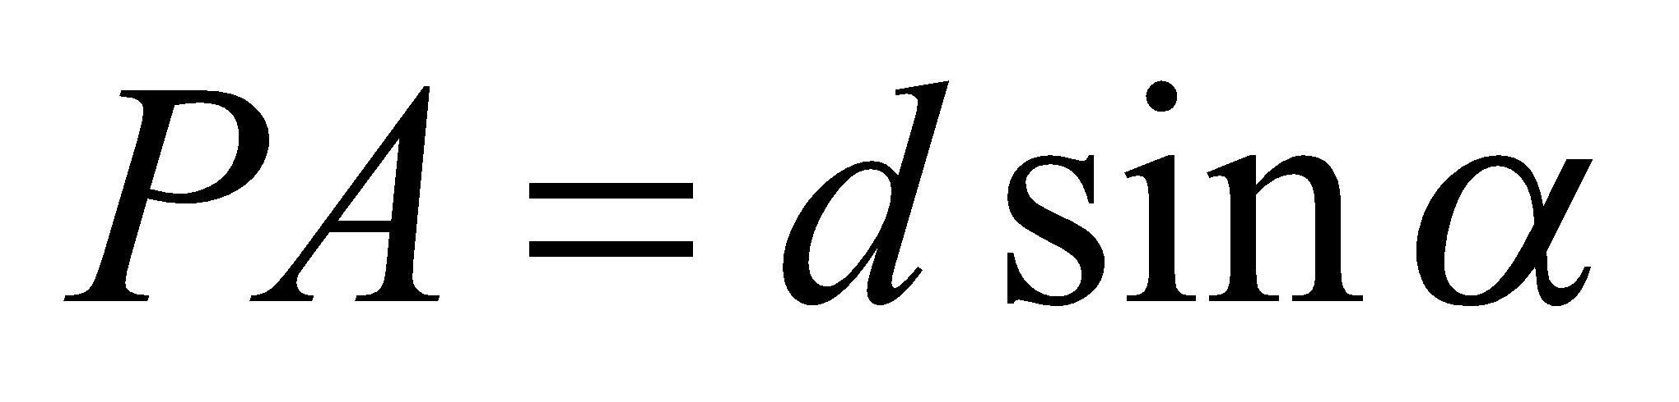. The path difference between corresponding outgoing rays making an angle *θ* on either side of the normal is 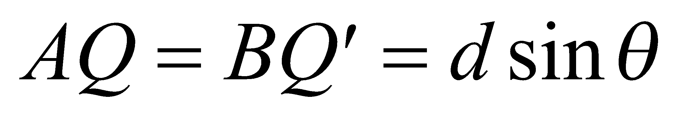. The total path difference is the sum (or difference) of these, depending on whether *θ* is on the same (or opposite) side of the normal as *α* (since we chose both angles to be positive).



**Evaluate** A maximum intensity occurs when the total path difference is an integral number of wavelengths,   
or when

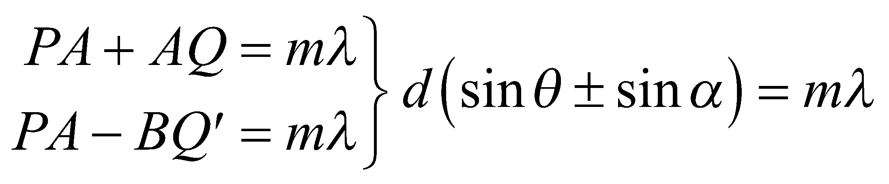

**Assess** When *α* = 0, we recover the usual condition given in Equation 32.1a.

**67. Interpret**  We are asked to derive a formula for the interference pattern from Lloyd's mirror.

**Develop** The light reflecting off the flat mirror appears to be coming from a distance *d* below the surface, as shown in the figure below. Regarded in this way, the system is like a double-slit, with a slit separation of 2*d*. However, the difference is that there will be a 180° phase change at the point where the light reflects off the mirror (see Figure 32.12).



**Evaluate** Because of the extra 180° phase change, the direct and reflected beams of light will constructively interfere when their path lengths are an odd-integer multiple of half-wavelengths: 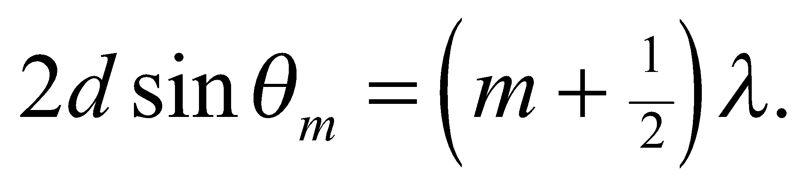 Therefore, the separation between fringes on the screen will be

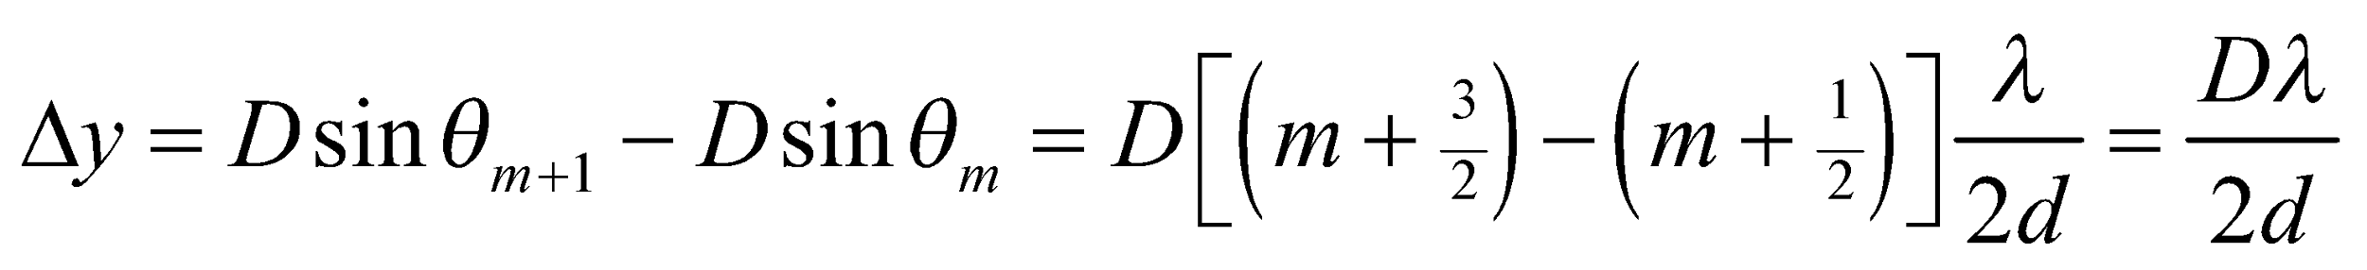

**Assess** This is the same separation between fringes as when the light is separated by two slits. All that is different is that the bright fringes in the Lloyd's mirror setup occur at the points of the dark fringes in the double-slit experiment.

**68. Interpret** We are to derive Equation 32.10 using calculus and geometry. We shall base our derivation on Figure 32.21.

**Develop** The electric field due to the light coming from a section of slit of width *dy* at position *y* in the slit will be the electric field at that portion of the slit multiplied by the phase factor. There are two contributors to the phase factor: the oscillation of the field in time and the distance the light has traveled from the section of slit. So

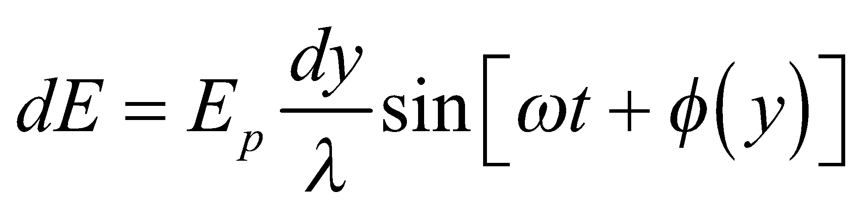

where the term 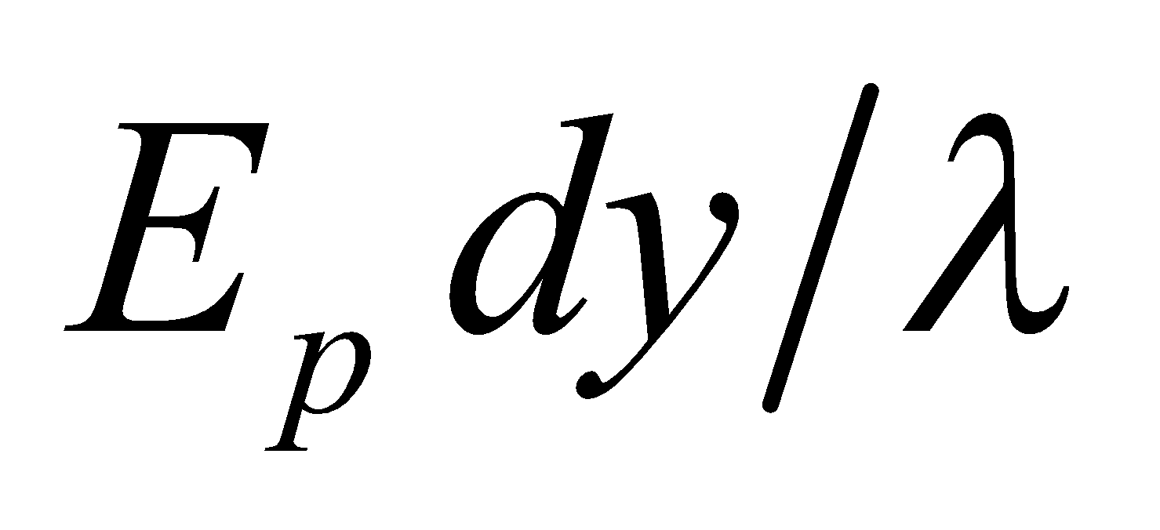 is the field originating at point *y*, and 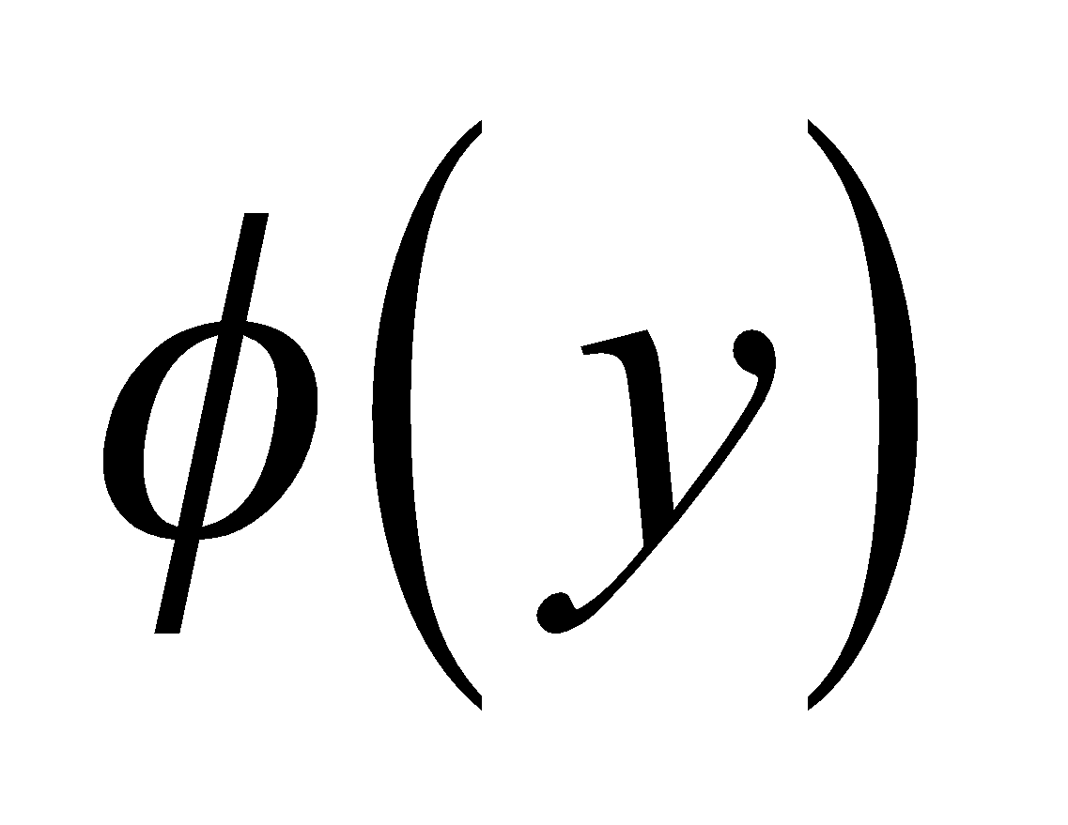 is the phase angle due to the distance. We will find  and integrate over the entire slit to derive Equation 32.10.

**Evaluate** **(a)** The path length difference *δ* for different rays in Figure 32.21, as a function of *y*, is 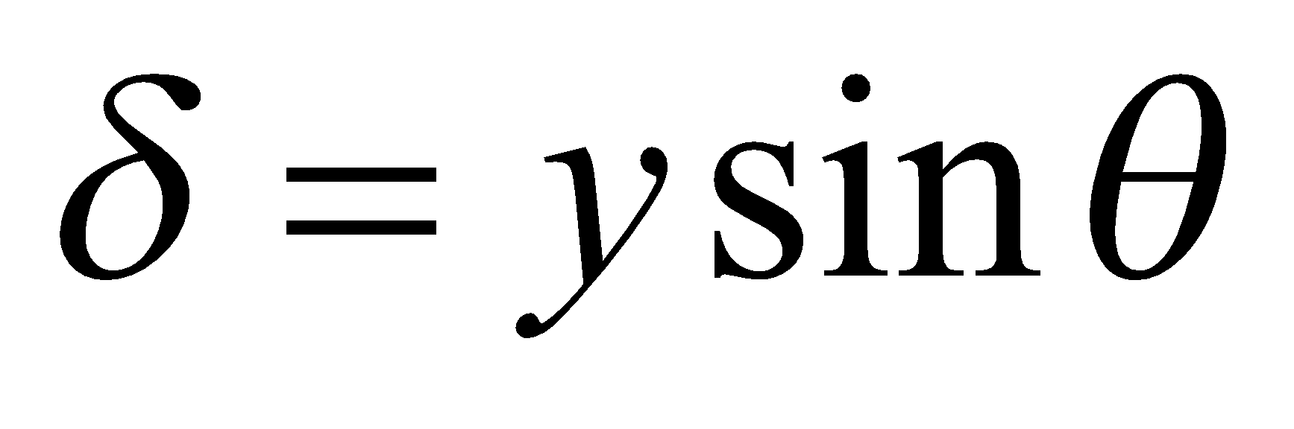.  
This path length difference is to the wavelength as the phase difference *φ* is to 2*π*, so

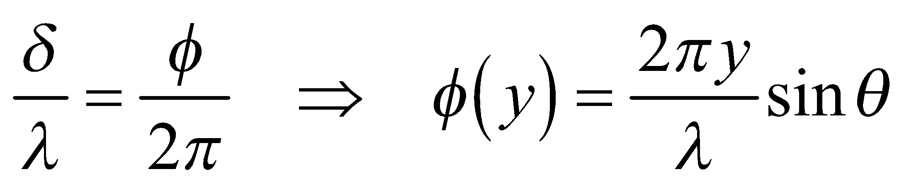

which is what we were to show.

**(b)** We integrate *dE* from 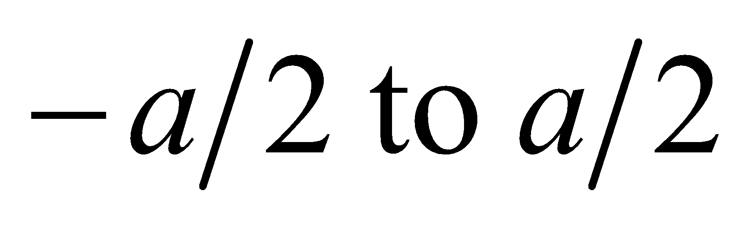:

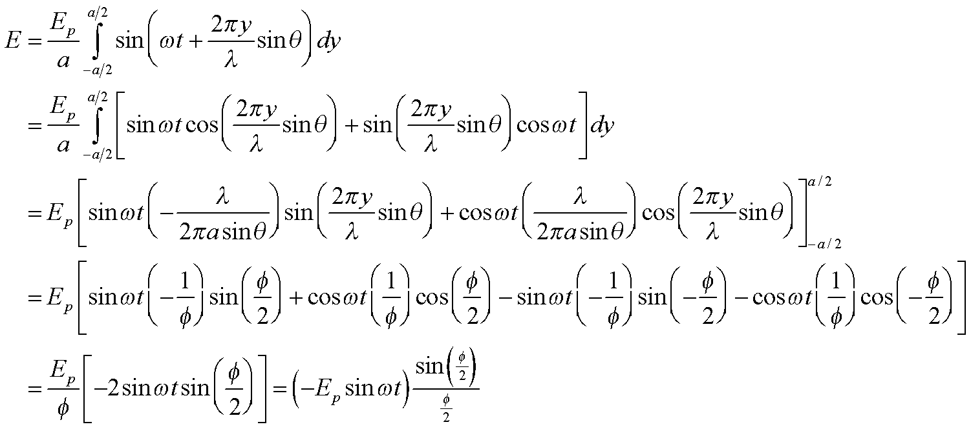

Where we have defined 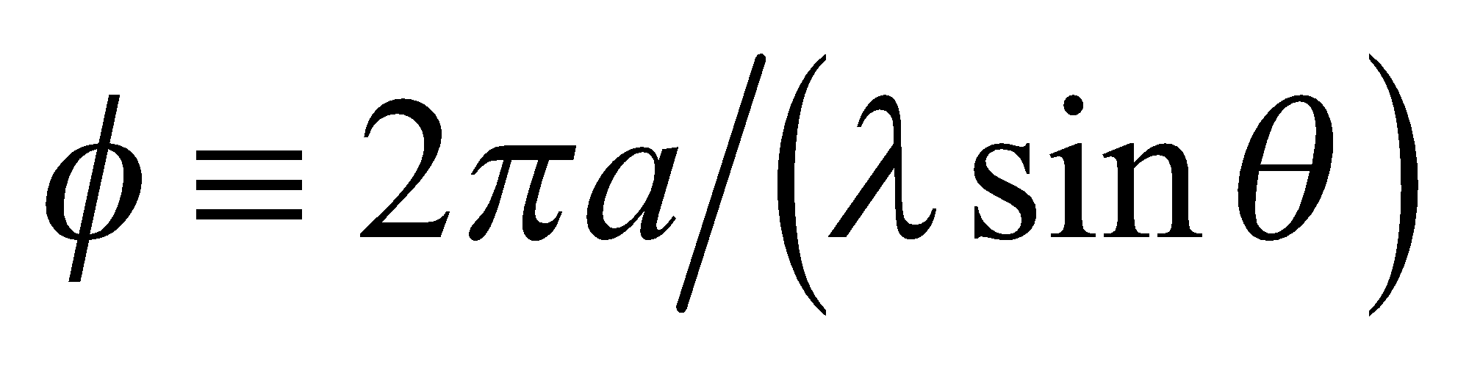. The light intensity is proportional to the square of the electric field, so

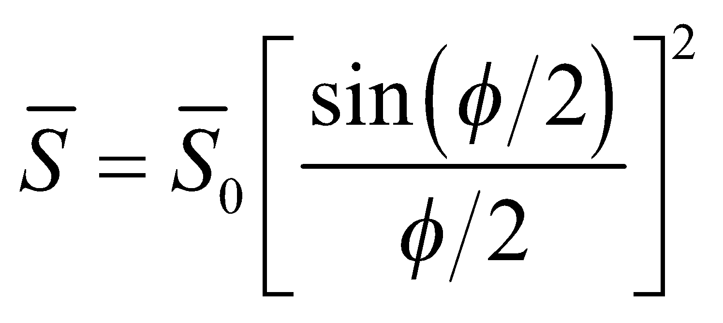.

**Assess** The function 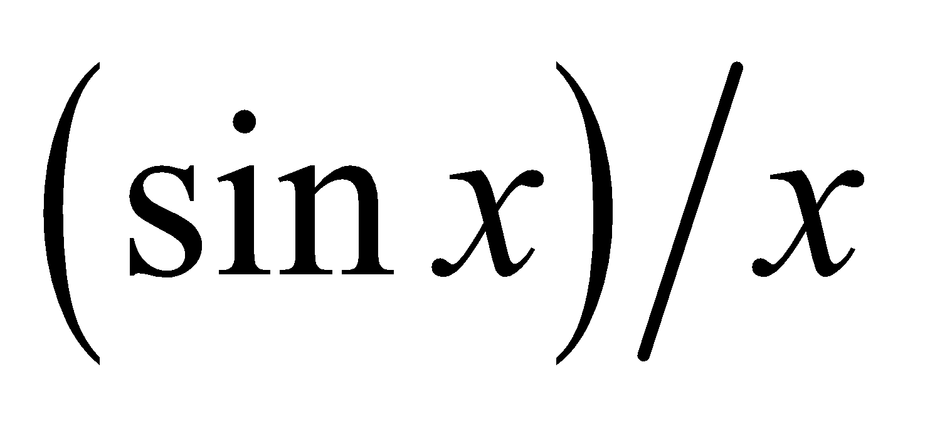is also called the “sinc” function: 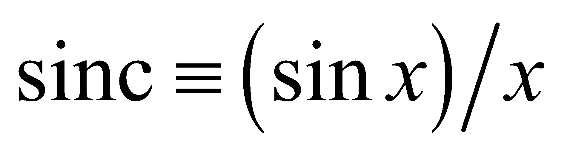. You will frequently see things written in this form in more advanced optics texts, should you have opportunity to study this field further.

**69. Interpret** In this problem we will use the Rayleigh criterion to determine what angular spacing can be allowed between communications satellites. With this value of angle, we can find the number of satellites allowed in geosynchronous orbit before their signals begin to overlap.

**Develop** The Rayleigh criterion for circular apertures (Equation 32.11b) is 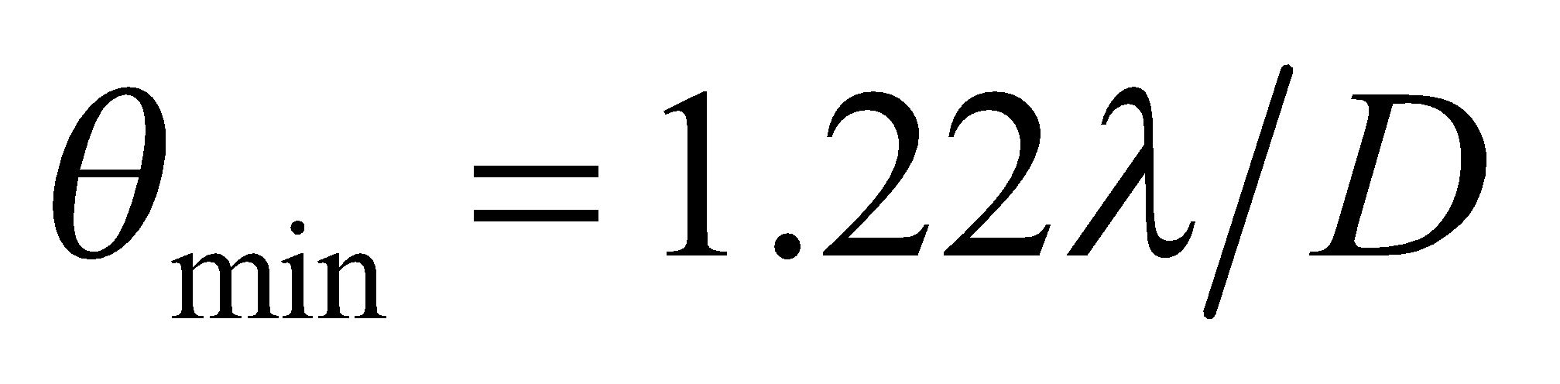, where the wavelength is

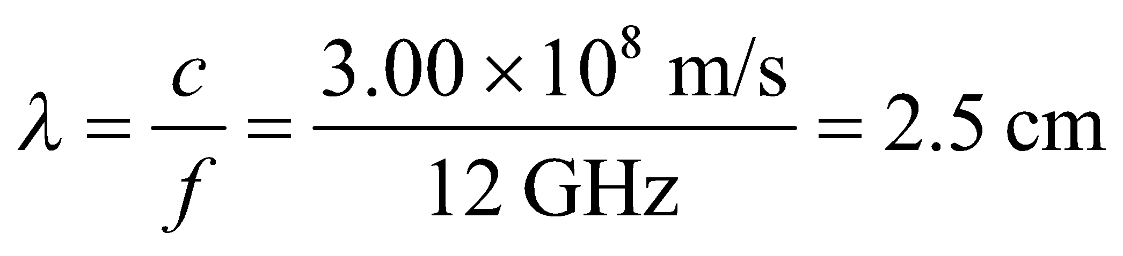

and the diameter of the satellite receiver is *D* = 45 cm. The number of satellites that can fit in a circle, with this angular spacing between satellites, is 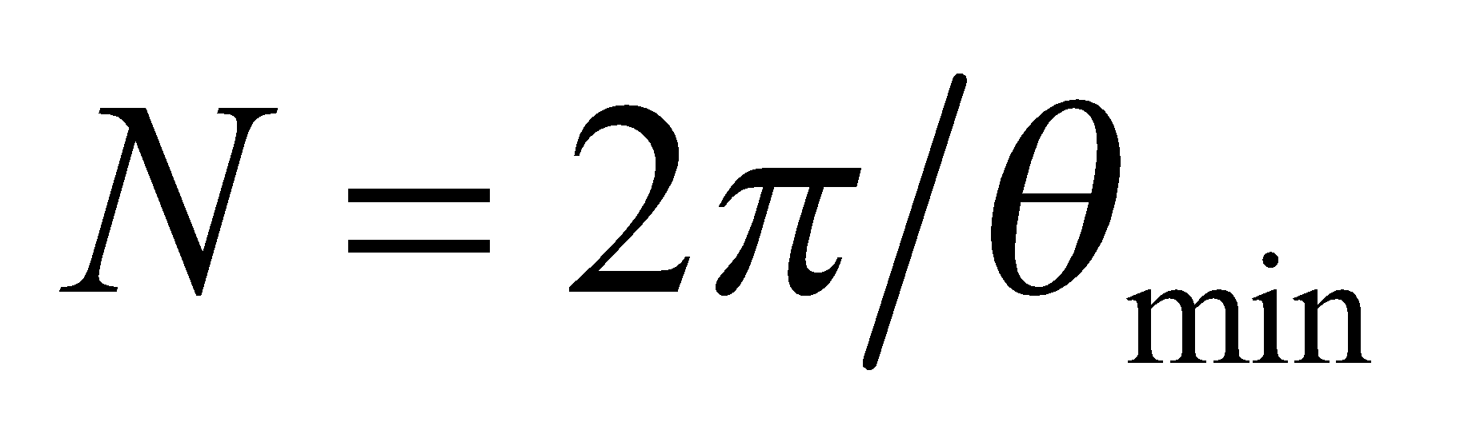.

**Evaluate** The maximum number of satellites is

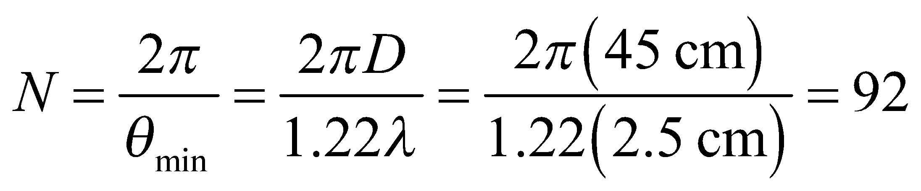

when rounded down to the nearest integer.

**Assess** This seems rather low, but calculating 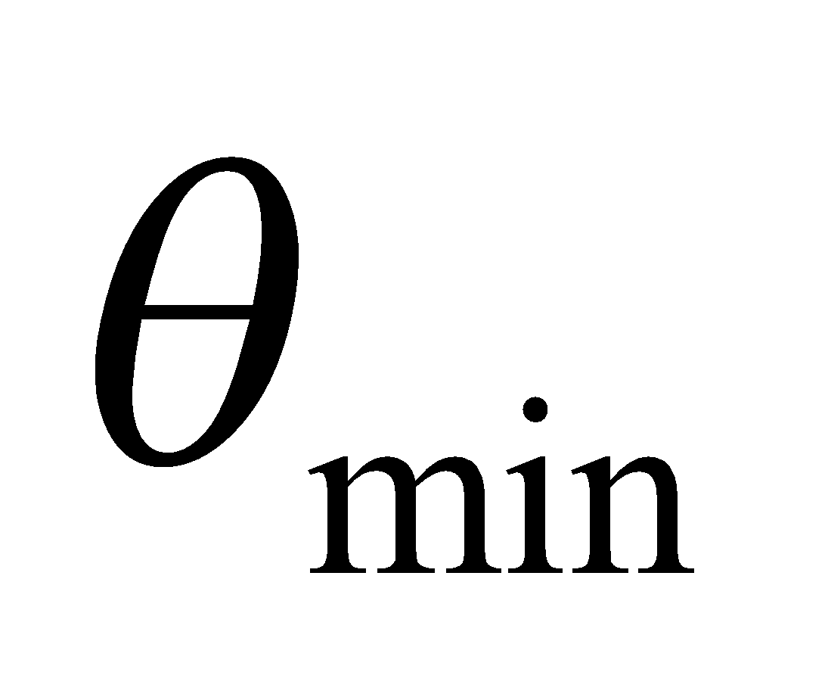 directly gives us an angle of 3.9°, which is consistent. We can pack more in by using shorter wavelengths or larger antennae.

**70. Interpret**  You are trying to estimate the thickness of an oil spill from the interference pattern that you measure in reflected light.

**Develop** Some of the light reflects off of the air-oil interface, where it experiences a 180° phase change, since the index of refraction is going from lower 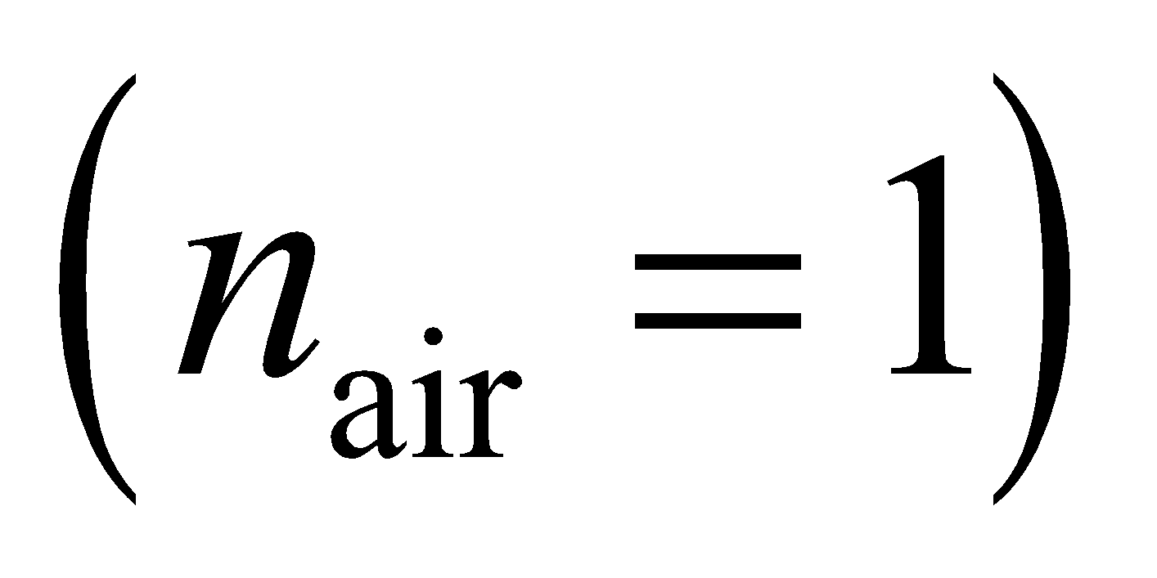 to higher 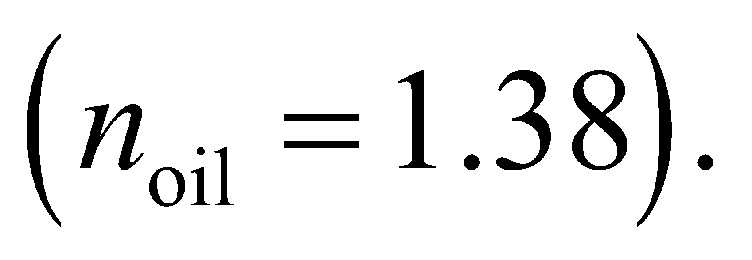 Some of the light also reflects off of the oil-water interface, but here there is no 180° phase change, since the index of refraction is going from higher 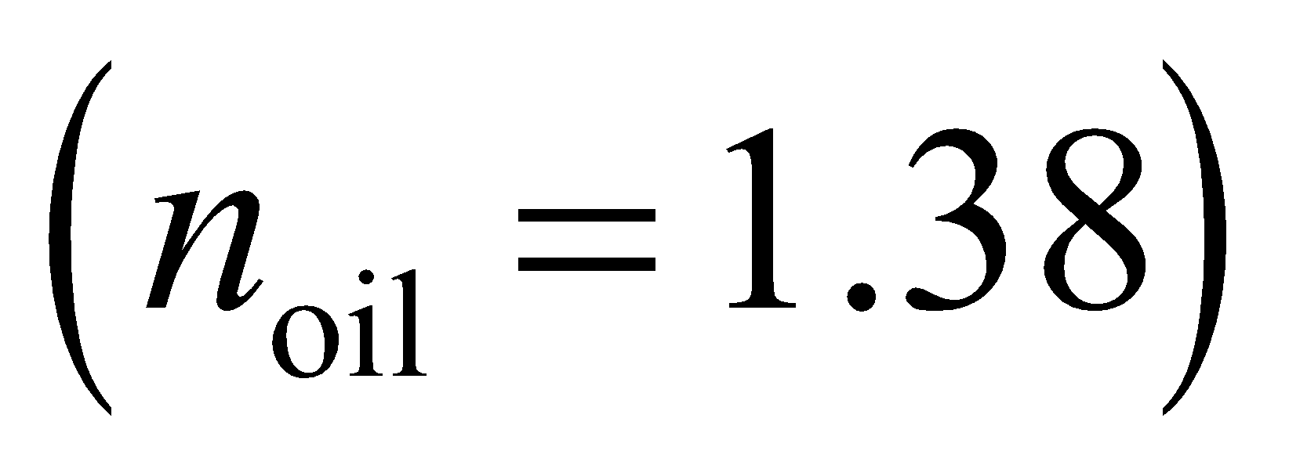 to lower 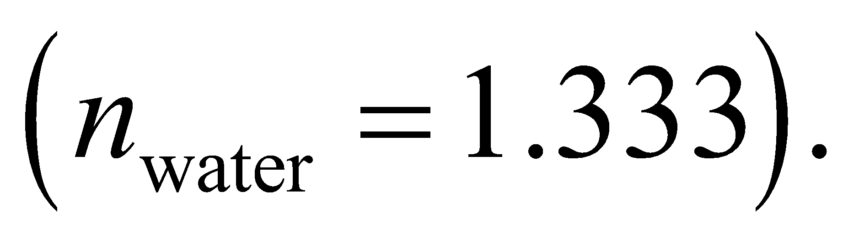 Therefore, the situation is the same as in Figure 32.12, and constructive interference will occur when 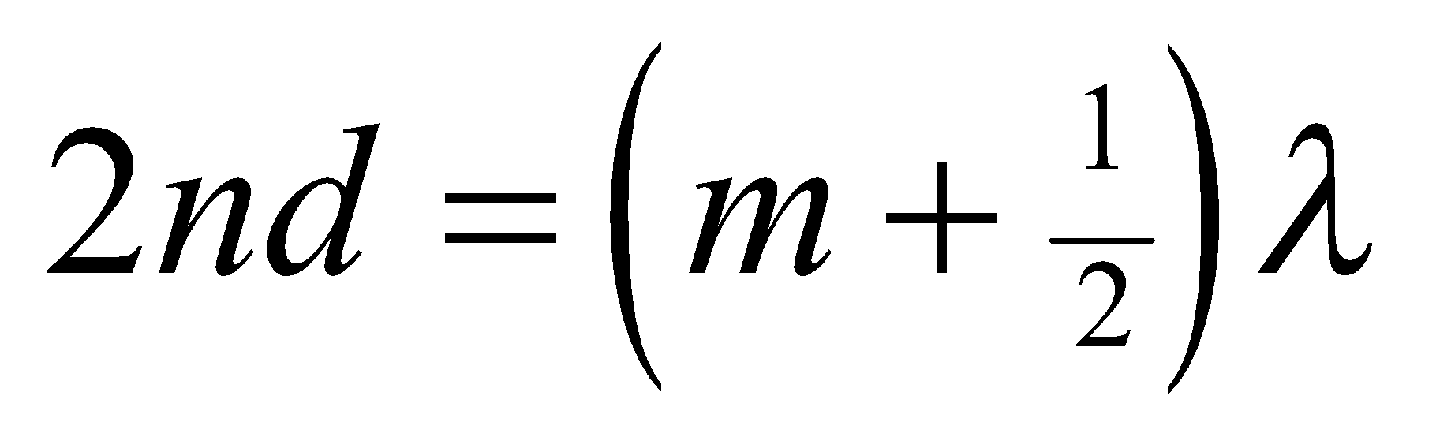 (Equation 32.7).

**Evaluate** If the brightest wavelength in reflection is 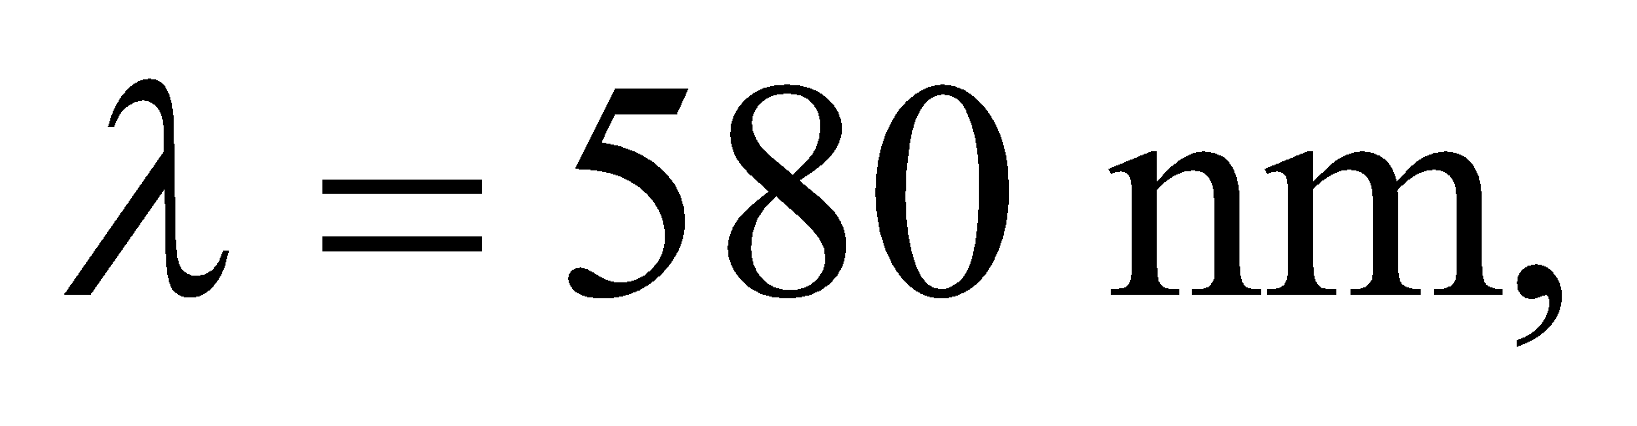 and you assume this corresponds to 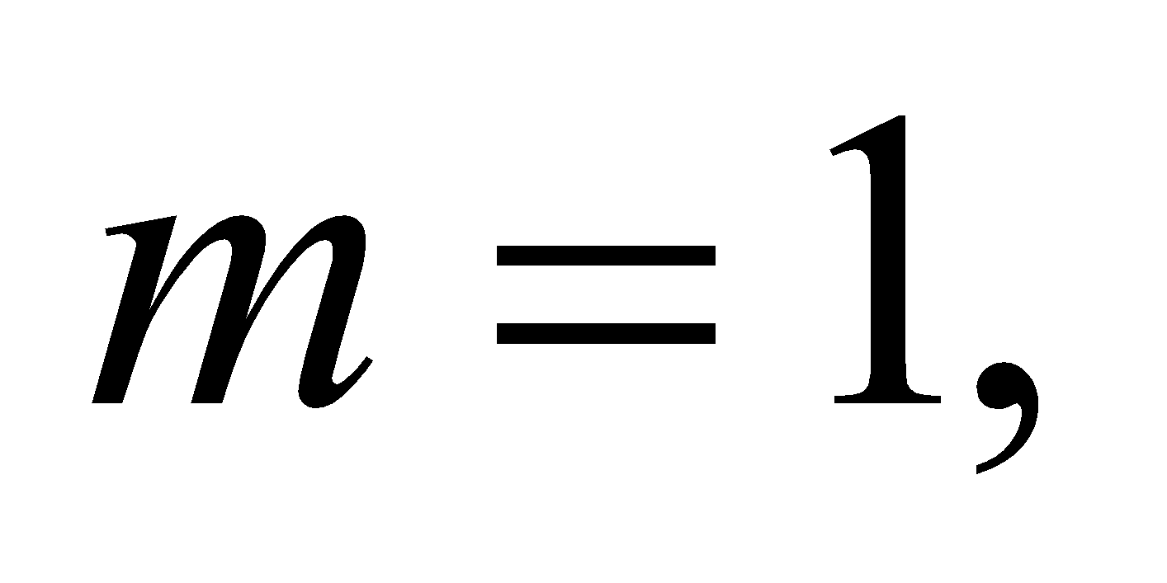 then the oil film's thickness must be

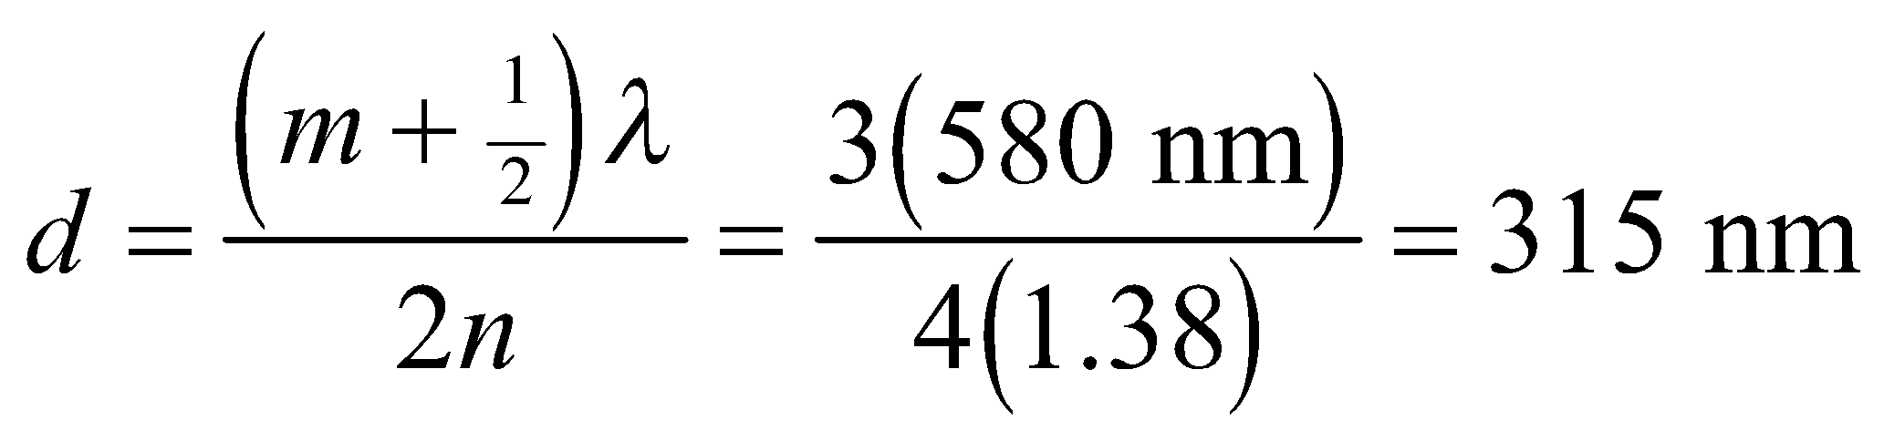

**Assess** This might seem too thin, but it's a reasonable thickness for an oil spill. At this thickness, one can estimate how much area a gallon of oil would cover:

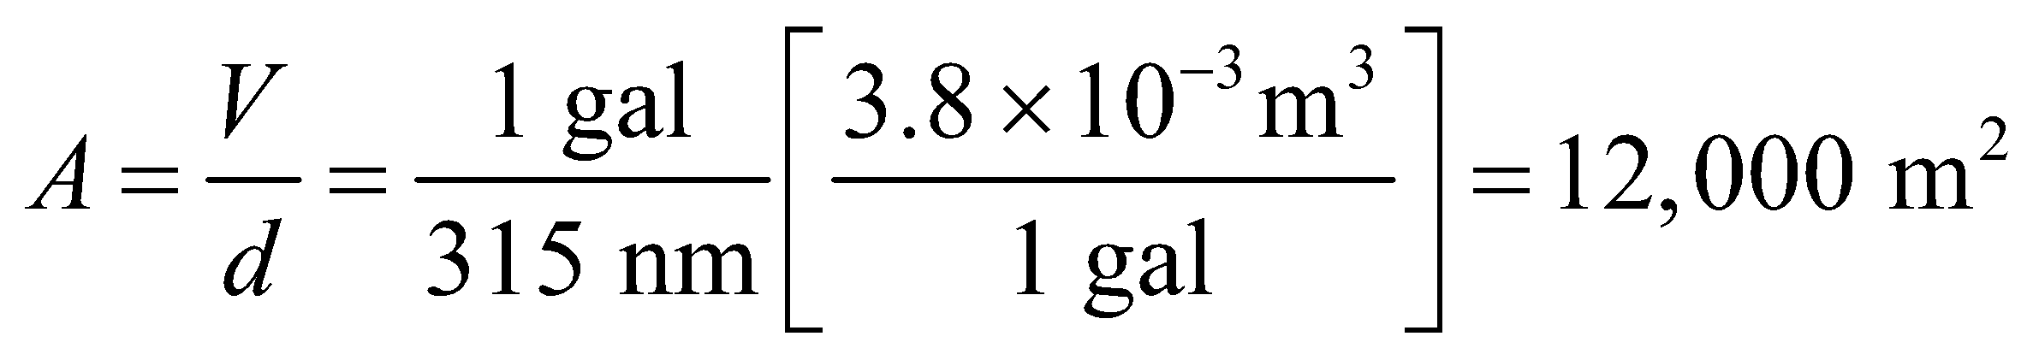

This is about 3 football fields!

**71. Interpret**  We explore how interferometry can increase angular resolution in astronomy.

**Develop** We are told that interfering the signal of two telescopes will give the resolution of a single telescope with aperture equal to the distance between the two telescopes, i.e. 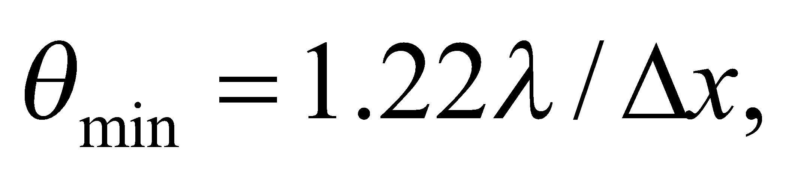 where 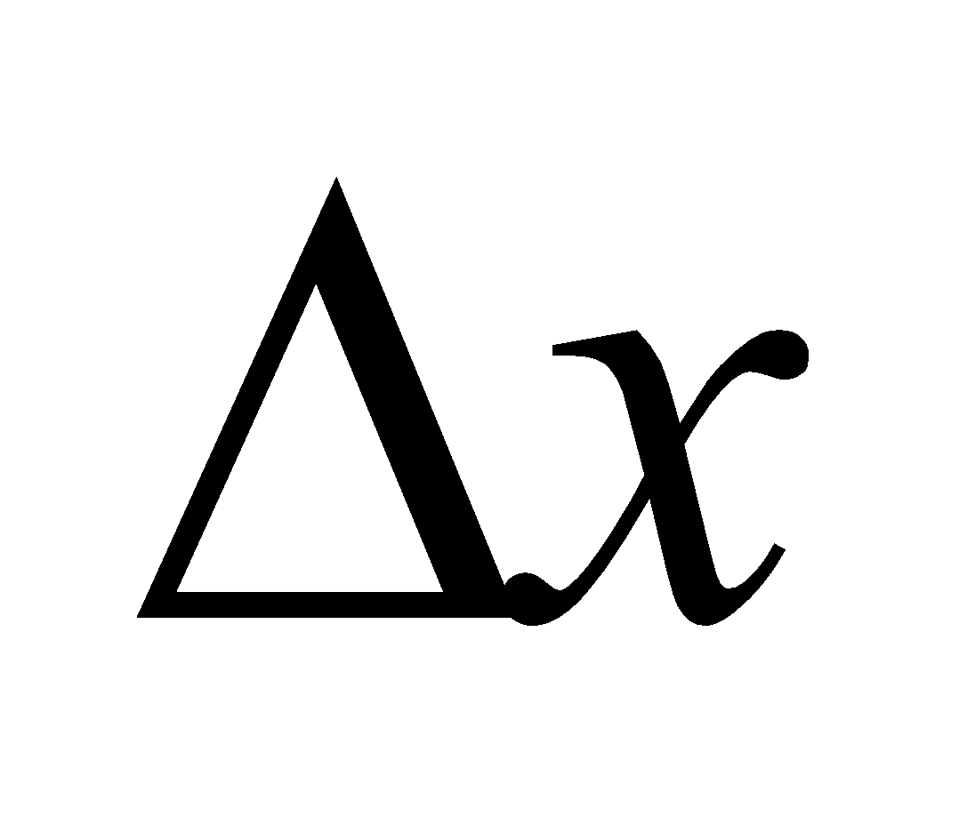is the telescope separation.

**Evaluate** Doubling the distance between the two telescopes should reduce by half the minimum angular separation that can be resolved.

The answer is (c).

**Assess** Astronomers use arrays of radio telescopes with individual elements separated by 10s of meters to 1000s of kilometers. The largest arrays can obtain milliarcsecond angular resolution, which is less than a millionth of a degree.

**72. Interpret**  We explore how interferometry can increase angular resolution in astronomy.

**Develop** The amount of light collected will be proportional to the sum of the areas of the individual telescopes.

**Evaluate** Doubling the distance between the two telescopes does not have any effect on the areas of the telescopes, so there will be no change in the light-collecting power.

The answer is (a).

**Assess** Interferometry does not generally allow astronomers to see objects fainter than can be observed with a single telescope. It only gives them better angular resolution of relatively bright objects in the sky. To see deeper into space, the telescope collecting area has to be increased.

**73.** **Interpret** We explore how interferometry can increase angular resolution in astronomy.

**Develop** For a point source directly above an interferometer, the light path to each telescope will be the same.

**Evaluate** The phase difference is proportional to the path length difference, which in this case is zero. Therefore, the electromagnetic waves will be in phase.

The answer is (a).

**Assess** This answer is independent of the telescope separation or the wavelength being observed. The signals from a source on the bisector between two telescopes will always be in phase. It's a bit like the fact that the zeroth 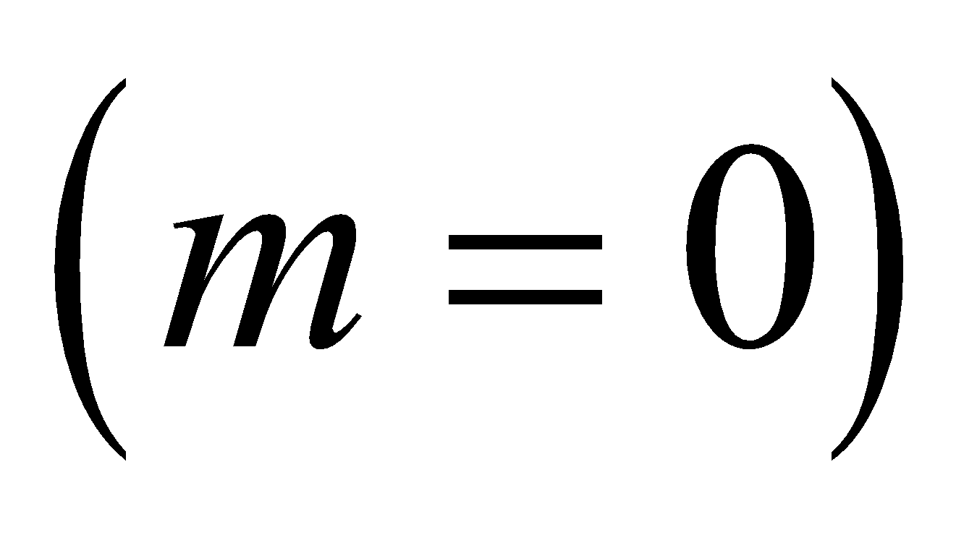 order of a double-slit is always a bright fringe, since the path lengths from the two slits are equal along the bisector between them.

**74. Interpret** We explore how interferometry can increase angular resolution in astronomy.

**Develop** In this case, the path length difference to each telescope will be 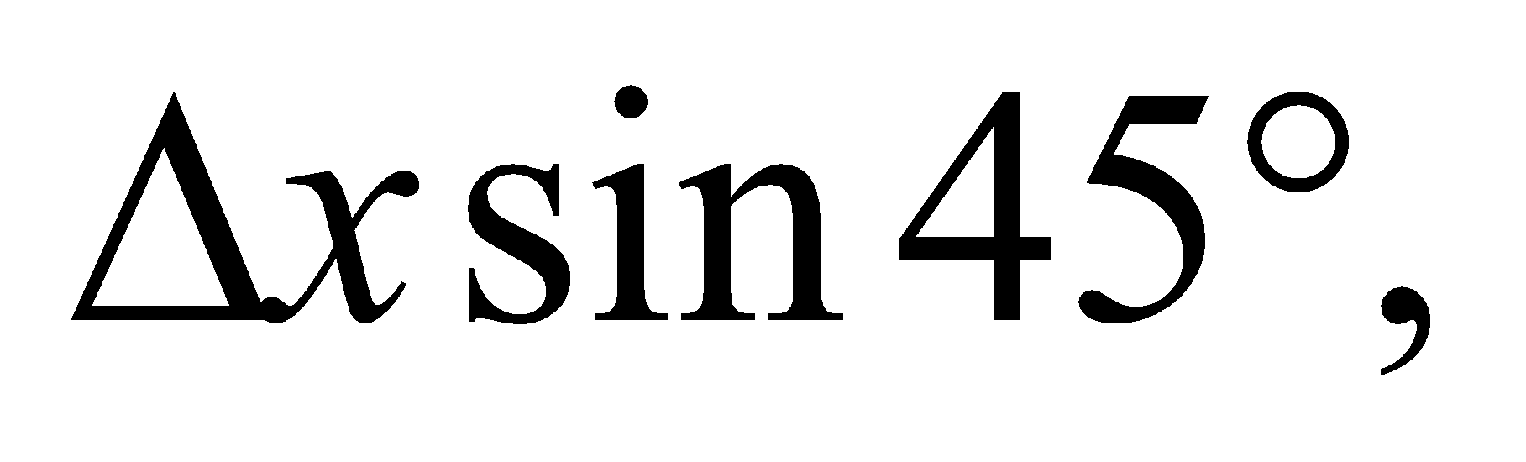 where is the telescope separation. This leads to a phase difference in the electromagnetic wave signals received by each telescope:

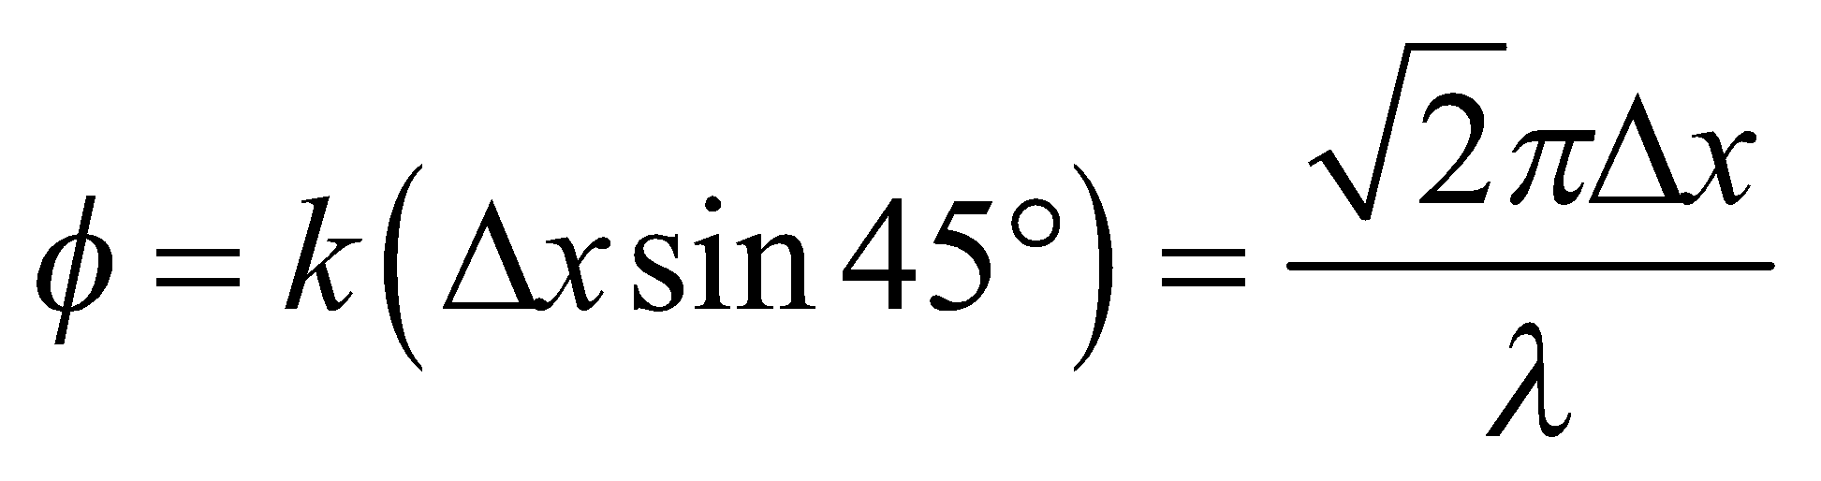

where we have used 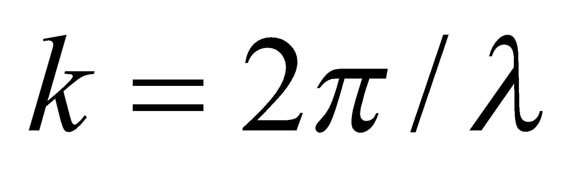 and 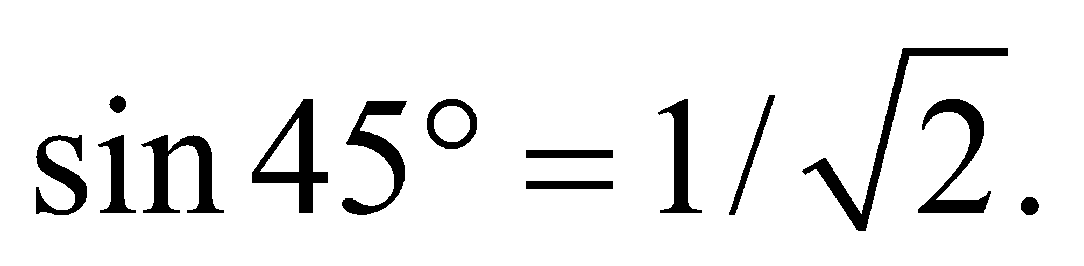

**Evaluate** Without knowing the separation and the wavelength, we can't say what the phase difference is.

The answer is (d).

**Assess** If the radio telescopes can receive multiple wavelengths, then it is likely that the two signals will be in phase (constructively interfere) for some wavelengths and 180° out of phase (destructively interfere) for others. Note too, that as the Earth rotates, the angle at which the source is located will change, so even at a fixed wavelength, the relative phase difference (and resultant interference pattern) will be changing with time.